Supplemental Table 1. Prevalence of Different Components in Chinese Patients with APS1 (n=25)
Components | Prevalence (%)
Classic triad
Hypoparathyroidism | 23 (92)
Chronic mucocutaneous candidiasis | 19 (76)
Addison’s disease | 18 (72)
Any of two | 11 (44)
All three | 12 (48)
Other endocrinopathies
Hypothyroidism | 9 (36)
Primary amenorrhea | 2 (8)
Diabetes mellitus type 1 | 2 (8)
Ectodermal dysplasia
Enamel dysplasia and nail dystrophy | 7 (28)
Hair loss | 10 (40%)
Ocular manifestations
Keratitis | 4 (16)
Retinitis pigmentation | 2 (8)
Hematological diseases
Myeloproliferative disease | 1 (4)
Pure red cell aplasia | 1 (4)
Other less common complications
Intestinal malabsorption | 3 (12)
Japanese encephalitis | 2 (8)
Pernicious anemia | 1 (4)
Renal tubular acidosis | 1 (4)
Asplenia | 1 (4)
Autoimmune hepatitis | 1 (4)
Ankylosing spondylitis | 1 (4)
Abbreviation: APS1: Autoimmune Polyendocrine Syndrome Type 1.

Supplemental Table 2. Mutations of the AIRE Gene in Chinese Patients with APS1.
Domain | Cases | Location in AIRE | Nucleotide alteration | Amino acids change | Heterozygosity | Reported outside China
HSR/CARD | 4 | Exon 1 | c.T38C | p.L13P | Het | Yes
HSR/CARD | 14 | Exon 1 | c.47C>G | p.T16R | Het | No
HSR/CARD | 22 | Exon 1 | c.55G>A | p.A19T | Het | No
HSR/CARD | 7 | Exon 2 | c.A206C | p.Q69P | Hom | No
HSR/CARD | 2 | Exon 2 | c.A269G | p.Y90C | Hom | yes
NLS | 16 | Exon 3 | c.463G>A | p.G155S | Hom | No
NLS | 1 and 15 | Exon 4 | c.484dupC | p.K161fs | Hom | No
SAND | 24 | Exon 5 | c.622G>T | p.G208W | Het | No
SAND | 8 | Exon 5 | c.623G>T | p.G208V | Het | No
SAND | 22 | Exon 6 | c.769C>T | p.R257X | Het | Yes
SAND | 6 | Exon 6 | c.737delC | p.A246fs | Het | No
PHD1 | 6 | Exon 8 | c.C922T | p.L308F | Het | No
Entire gene | 25 | - | - | - | Het | Yes
Intron | 25 | IVS11 | +1G>A | - | Het | No

Abbreviation: APS1: Autoimmune Polyendocrine Syndrome Type 1. GenBank accession number of AIRE: NM_000383. HSR: Homogeneously Staining Region; CARD: Caspase Recruitment Domain; NLS: Nuclear Localization Signal; PHD: Plant Homeodomain; Het: Heterozygous; Hom: Homozygous; “-” indicates that data are not available.
CARD/HSR, amino acids 1–105; SAND: amino acids 181–280; two plant homeodomain (PHD) fingers type zinc fingers (amino acids 296–343 and 434–475); four LXXLL domains that are found on coactivators of nuclear receptors (amino acids 7–11, 63–67, 414–418, and 516–520) and a nuclear localization signal (amino acids 100–189).

Supplemental figure 1. Clinical spectrum and genotype in each patient with APS1 in China.

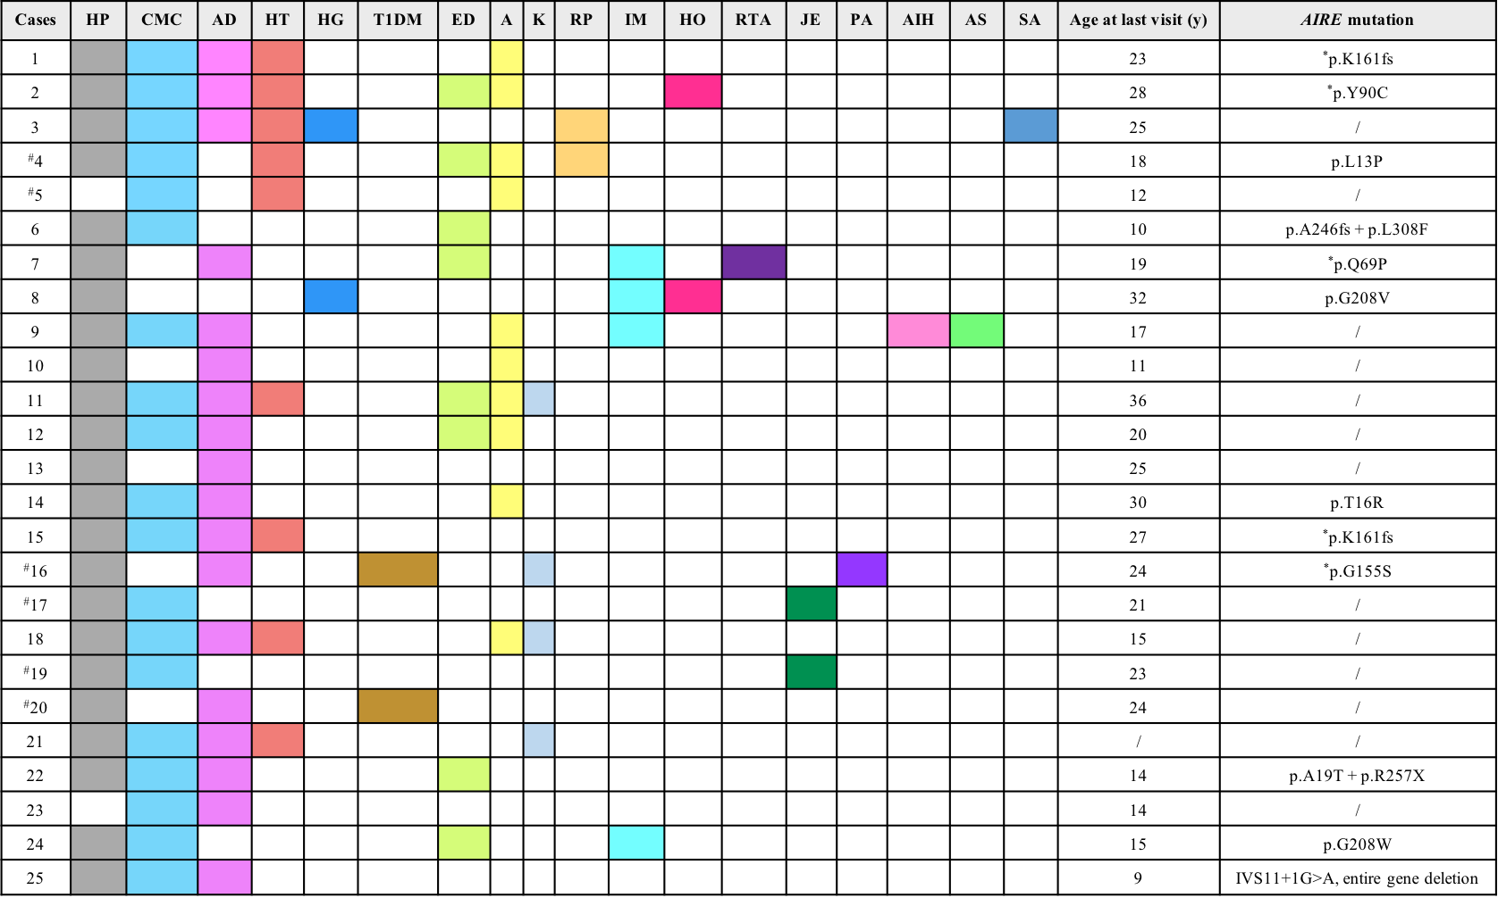
Abbreviation: APS1: autoimmune polyendocrine syndrome type 1; HP: hypoparathyroidism; CMC: chronic mucocutaneous candidiasis; AD: Addison’s disease; HT: hypothyroidism; HG: hypergonadotropic hypogonadism; T1DM: type 1 diabetes mellitus; ED: ectodermal dysplasias, including enamel dysplasia and nail dystrophy; A: alopecia; K: keratitis; RP: retinitis pigmentosa; IM: intestinal malabsorption; HO: hematopathy; RTA: renal tubular acidosis; JE: Japanese encephalitis; PA: pernicious anemia; AIH: autoimmune hepatitis; AS: ankylosing spondylitis; SA: asplenia.
#: Case 4 and case 5, case 16 and case 17, case 19 and case 20 were siblings, respectively. *: homozygous mutations. The parents of cases 7 and 12 were consanguineous marriages. Cases 1 to 13 were from our center, and cases 14 to 25 were from reported literature. GenBank accession number of AIRE: NM_000383.

