Additional file 1
Table S1 – Residual α-glucosidase activity
Patient | α-glucosidase activity  in cultured fibroblasts (nmol/h/mg)
1 | NA
2 | 7.8
3 | NA
4 | 11.9
5 | 15.4
6 | 8.6
7 | 3.4
8 | 9.1
9 | 8.4
10 | 8.7
11 | 0.7
12 | 11.0
13 | 2.8
14 | 17.9
15 | 13.3
16 | 13.0
17 | NA
18 | 6.2
19 | NA
20 | 11.6
21 | 6.0
22 | 0.4
nmol/h/mg: nanomol per hour per milligram; NA: data not available

Table S2 - Infusion Associated Reactions (IARs)
IAR symptoms | Number of IARs (%) | Number of patients with IAR (%)*
Nausea | 23 (21.6) | 2 (50)
Dizziness | 15 (14.1) | 2 (50)
Exanthema (localized) | 11 (10.4) | 2 (50)
Urticaria (localized) | 10 (9.4) | 3 (75)
Urticaria (generalized) | 10 (9.4) | 2 (50)
Itching (localized) | 7 (6.6) | 1 (25)
Coughing | 6 (5.7) | 2 (50)
Itching (generalized) | 6 (5.7) | 1 (25)
General malaise | 5 (4.7) | 1 (25)
Sweating | 4 (3.8) | 2 (50)
Exanthema (generalized) | 3 (2.8) | 3 (75)
Hyperthermia | 2 (1.9) | 2 (50)
Dyspnea | 2 (1.9) | 1 (25)
Headache | 1 (0.9) | 1 (25)
Local angioedema | 1 (0.9) | 1 (25)
Total | 106 (100) | 4 (100)
Total infusions with IARs | 59
IAR: infusion associated reaction; * patients may have experienced more than one symptom during the course of an IAR.

Table S3 - Scores on the motor domain of the Bayley scales of infant development-II for patient 1
Time from start of ERT (years) | Raw score | Development index | SD-score
0.23 | 60 | <55 | <-3.0
0.54 | 78 | 60 | -0.7
1.0 | 89 | 75 | -1.7
1.26 | 97 | 87 | -0.9
1.53 | 98 | 81 | -1.3
1.76 | 102 | 91 | -0.6
ERT: enzyme replacement therapy; SD: standard deviation.

Table S4 - Standardized infusion protocol
 | Speed of infusion (ml/h) | Duration (min)
Step 1 | 5 | 30
Step 2 | 20 | 30
Step 3 | 88 | 30
Step 4 | 250 | Rest
ml/h: milliliters per hour; min: minutes.
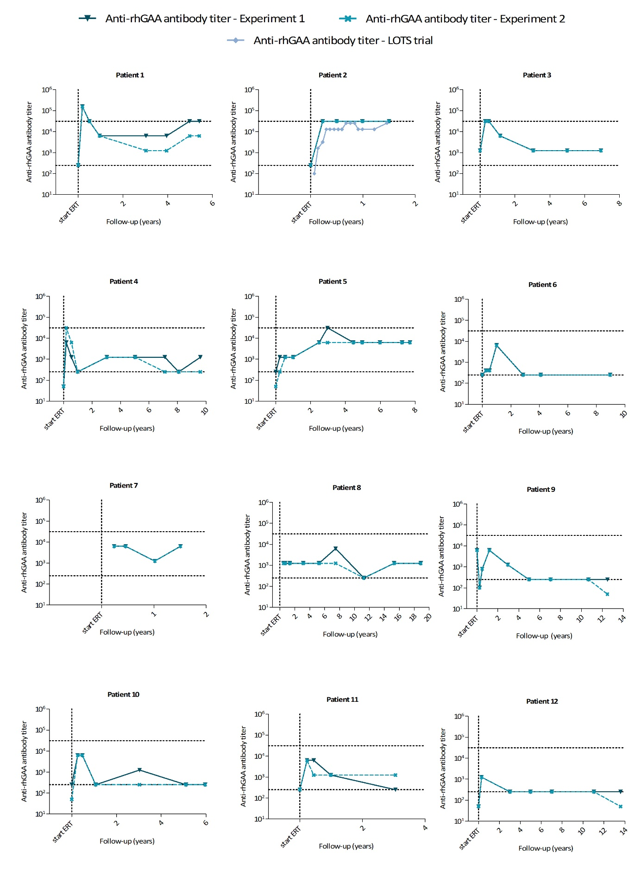
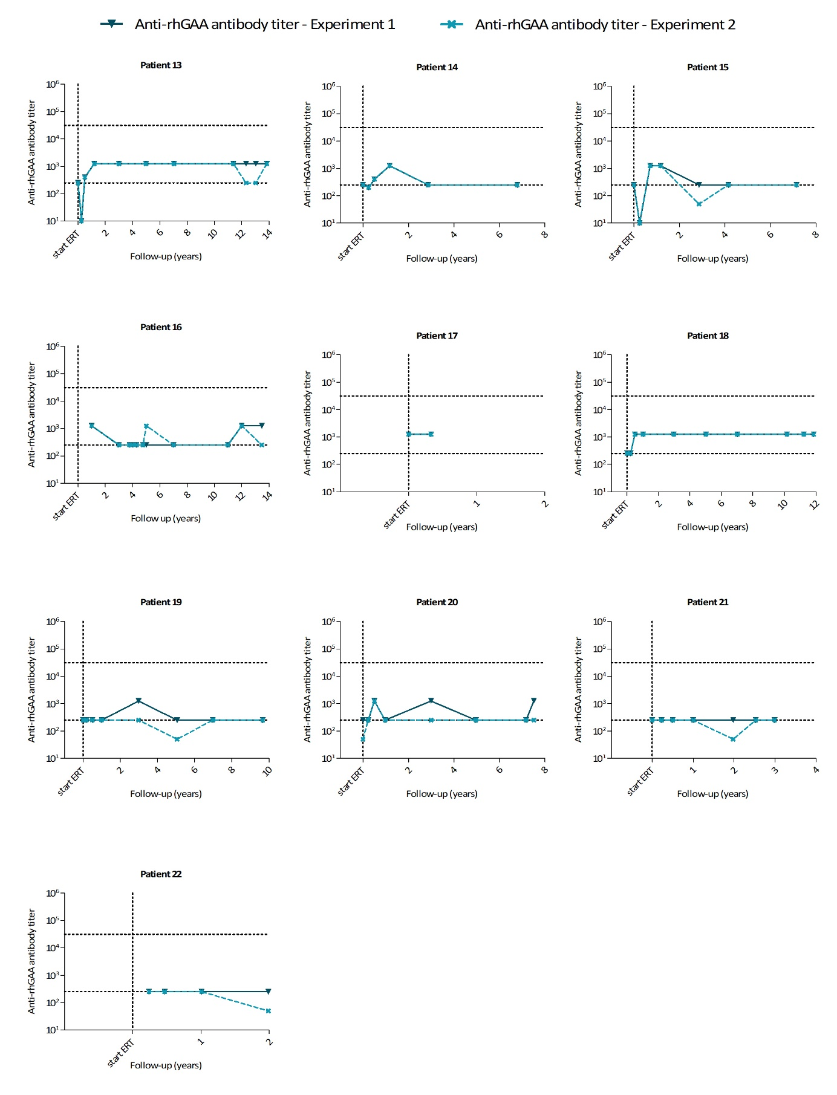

Figure S1 - Anti-recombinant human acid α-glucosidase (anti-rhGAA) antibody titer course in Experiment 1 and Experiment 2. Each graph represents an individual patient. For each patient, the anti-rhGAA antibody titer measured in Experiment 1 and Experiment 2 are shown. For patient 2, anti-rhGAA antibody titers obtained during the Late-Onset Treatment Study (LOTS, van der Ploeg 2010) are shown as well.

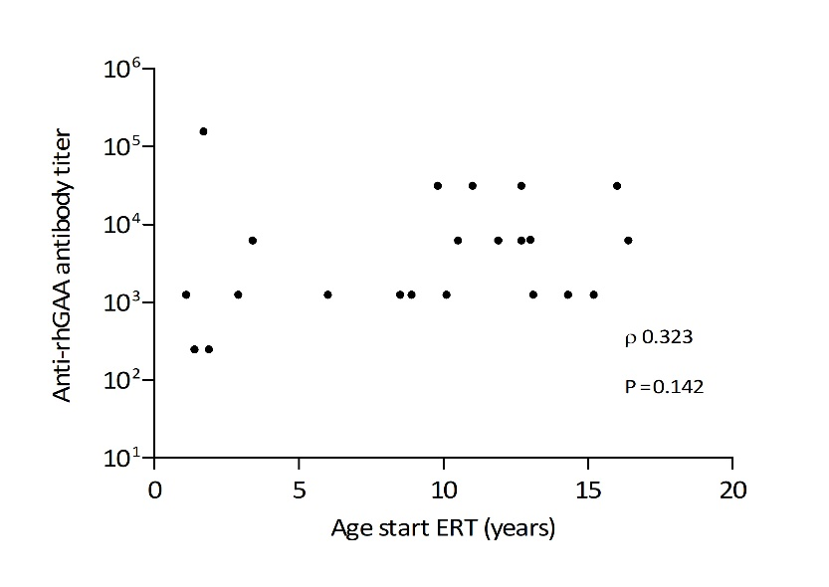
Figure S2 – Correlation between the age at start of ERT and peak anti-rhGAA antibody titers. Correlation analysis showed no significant correlation (Spearman ρ = 0.323, p=0.142).

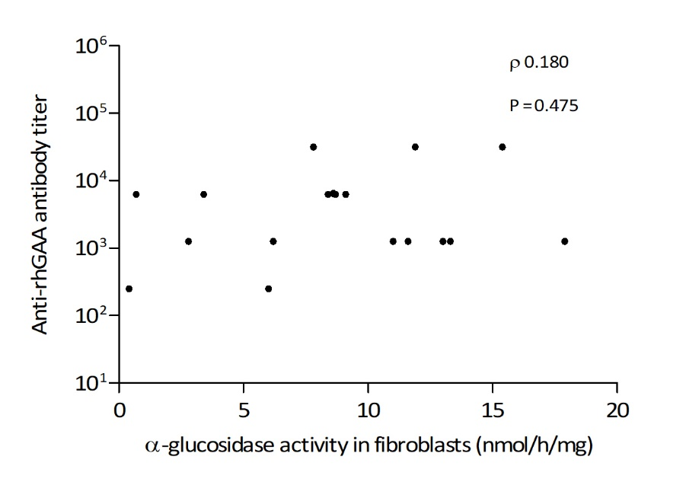

Figure S3 Correlation between residual a-glucosidase activity and peak anti-rhGAA antibody titers. Correlation analysis showed no significant correlation (Spearman ρ = 0.180, p=0.475).

