Additional file
Figures
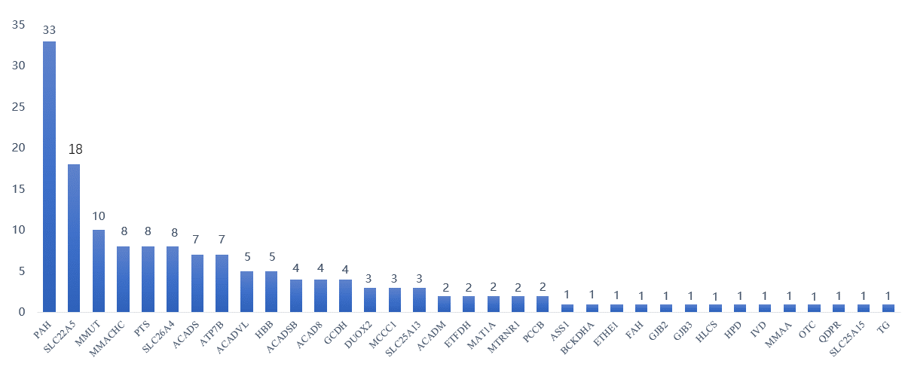
Number of mutations
Fig S1. Mutation frequencies in 35 genes from the validation cohort

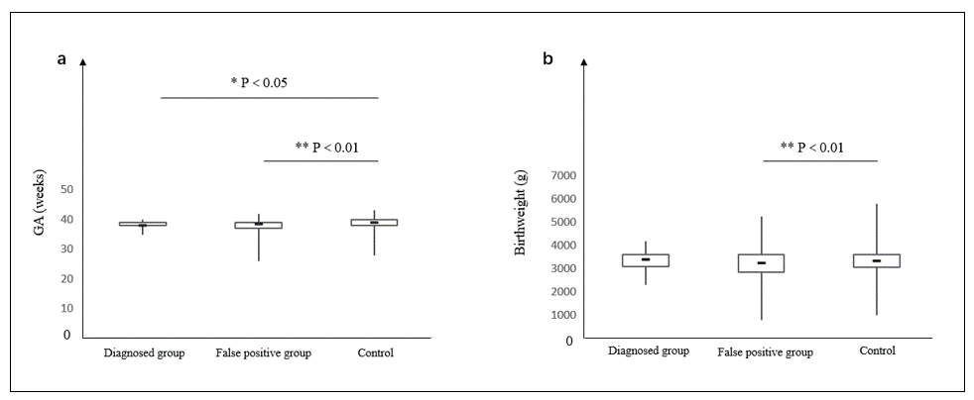
Fig. S2 Gestational age and birth weight in each group. (a) Gestational age in weeks and (b) Birth weight in grams for diagnosed newborns, false positives newborns and normal control.

Tables
Table S1. The list of 74 disorders included in NBGS
NO. | Diseases
Inherited metabolic diseases screened by MS/MS
1 | Methylmalonic aciduria, MMA
2 | Propionic acidemia, PA
3 | Glutaric acidemia I, GA1
4 | Holocarboxylase synthetase deficiency
5 | Biotinidase deficiency
6 | 3-Hydroxy-3-Methylglutaryl-Coenzyme A Lyase deficiency
7 | Isovaleric acidemia, IVA
8 | 3-Methylcrotonyl-coenzyme A carboxylase deficiency, MCCD
9 | Malonyl-CoA decarboxylase deficiency, MCD deficiency
10 | 3-methylglutaconic aciduria type I
11 | Ethylmalonic encephalopathy, EE
12 | Isobutyryl-CoA dehydrogenase deficiency, IBDD
13 | Maple syrup urine disease, MSUD
14 | Tyrosinemia
15 | Hyperphenylalaninemia，HPA
16 | Hyperhomocysteinemia, HCY
17 | Non-ketotic hyperglycinemia, NKH
18 | Primary hypermethioninemia
19 | Argininemia
20 | Argininosuccinic aciduria
21 | Carbamoyl phosphate syntetase I deficiency
22 | N-acetylglutamate synthase deficiency, NAGSD
23 | Ornithine transcarbamylase deficiency
24 | Citrullinemia type Ⅰ, CTLN1
25 | Citrin deficiency
26 | Hyperornithinemia-hyperammonemia-homocitrullinuria syndrome, HHHS
27 | Ornithine transcarbamylase deficiency
28 | Very long-chain acyl-CoA dehydrogenase deficiency, VLCAD
29 | Long-chain 3-hydroxyl-CoA dehydrogenase deficiency, LCHAD
30 | Mitochondrial trifunctional protein deficiency, MTPD
31 | Short chain 3-hydroxyacyl-CoA dehydrogenase deficiency, SCHADD
32 | Medium chain acyl-CoA dehydrogenase deficiency, MCADD
33 | Short-chain acyl-CoA dehydrogenase deficiency, SCADD
34 | Glutaric acidemia II, GA2
35 | Beta-ketothiolase deficiency, BKD
36 | Carnitine palmitoyltransferase II deficiency, CPTII
37 | Primary carnitine deficiency, PCD
38 | Carnitine palmitoyltransferase I deficiency, CPT1 deficiency
39 | Carnitine-acylcarnitine translocase deficiency, CACT deficiency
Non-MS/MS screened disorders
40 | Glucose-6-phosphate dehydrogenase deficiency
41 | Congenital Hypothyroidism, CH
42 | Hereditary fructose intolerance, HFI
43 | X-linked adrenoleukodystrophy, X-ALD
44 | Mucopolysaccharidosis
45 | Globoid cell leukodystrophy, GLD
46 | Gaucher disease, GD
47 | Fabry disease
48 | Niemann-Pick disease
49 | Beta-thalassemia
50 | Hemophilia B，HB
51 | Glycogen storage disease
52 | Growth hormone deficiency, GHD
53 | Vitamin D-dependent rickets
54 | X-linked dominant hypophosphatemia, XLH
55 | Cartilage-hair hypoplasia, CHH
56 | Spinal muscular atrophy，SMA
57 | Galactosemia
58 | Crigler-najjar syndrome，CNS
59 | Progressive familial intrahepatic cholestasis, PFIC
60 | Nephroblastoma, NB
61 | Retinoblastoma, RB
62 | Non-syndromic hearing loss, NSHL
63 | Mitochondrial encephalomyopathy, lactic acidosis and stroke-like episodes，MELAS
64 | Severe combined immune deficiency, SCID
65 | Autoimmune enteropathy, AIE
66 | X-linked recessive chronic granulomatous disease, X-CGD
67 | X-linked agammaglobulinemia, XLA
68 | Wiskott-Aldrich syndrome, WAS
69 | Dihydropyrimidine dehydrogenase deficiency
70 | Purine drug toxicity
71 | Inborn errors bileacid synthesis, IEBAS
72 | Wilson disease, WD
73 | Congenial disorders od glycosylation, CGD
74 | Sitosterolemia

Table S3. Genetic analysis and clinical data of NBGS negative/ C-NBS true positive newborns
Cases | Disorders | Gene | NBGS panel | IEM panel | Biochemical results | BW GA  (grams) (weeks)
1 | Phenylalanine hydroxylase deficiency | PAH | c.688G>A | c.688G>A  c.617A>G (VUS) | Phe=153, PHE/TYR=1.66 | 2850 | 38+0
2 | Phenylalanine hydroxylase deficiency | PAH |  | c.463C>T(VUS) c.526C>T | Phe=121, PHE/TYR=1.9 | 3520 | 40+0
3 | Phenylalanine hydroxylase deficiency | PAH | c.1174T>A | c.739G>T(VUS) c.1174T>A | Phe=138, PHE/TYR=1.6 | 3600 | 39+2
4 | Congenital hypothyroidism | DUOX2 | c.1588A>T | / | TSH=55 | 3530 | 38+2
5 | Congenital hypothyroidism | DUOX2 | ND | / | TSH=14.8 | 3570 | 39+5
6 | Congenital hypothyroidism | DUOX2 | ND | / | TSH=34 | 2840 | 37+1
7 | Congenital hypothyroidism | DUOX2 | ND | / | TSH=59 | 3460 | 39+2
8 | Primary systemic carnitine deficiency | SLC22A5 | c.1400C>G | c.1400C>G  c.780 797del | C0=8.20 | 3100 | 38+6
9 | Primary systemic carnitine deficiency | SLC22A5 | c.1400C>G | c.137C>T(LP)  c.1400C>G | C0=5.01 | 4190 | 40+2
10 | Primary systemic carnitine deficiency | SLC22A5 | c.51C>G | c.51C>G  c.388G>A | C0=4.61 | 3600 | 38+5
11 | Primary systemic carnitine deficiency | SLC22A5 | c.51C>G | c.51C>G  c.674C>T (VUS) | C0=7.57 | 3400 | 38+4
12 | Maple syrup urine disease | BCKDHA | c.1309_1310del | c.712G>A  c.1309_1310del | LEU+ILE+PRO-OH=2562.69，LEU=2562，VAL=914 | 4150 | 39+3
13 | Short-chain acyl-CoA dehydrogenase deficiency | ACADS | 682G>A | c.209A>C(VUS) c.682G>A |  | 3400 | 38+6
14 | Short-chain acyl-CoA dehydrogenase deficiency | ACADS | c.682G>A | c.682G>A  c.360+1G>A (VUS) |  | 3250 | 38+4
15 | Very long-chain acyl-CoA dehydrogenase deficiency | ACADVL | ND | c.919A>T  c.1054A>G | Multiple long chain acylcarnitine elevated | 3640 | 39+5
16 | Tyrosinemia | TAT | ND | c.890G>T  c.480+1G>A | TYR=625.60 | 3700 | 39+4
17 | Ornithine transcarbamylase deficiency | OTC | ND | c.931G>A |  | 3600 | 39+0
(“ND” indicates the newborns identified no mutation by NBGS; “/” indicates the newborns were not detected by other genetic analysis; BW, birth weight (in grams); GA, gestational age (in weeks))

Table S4. Genetic analysis and clinical data of NBGS negative/ primary C-NBS positive newborns in the lost to followed-up subgroup
NO. | Biochemical result | BW  (g) | GA  (weeks) | Conditions | NBGS panel | IEM panel  gene (mutations)
1 | Cit=2.78  Recheck | 2900 | 38+6 | Carbamoyl phosphate syntetase I deficiency | No mutation | CPS1  (c.3405-1G>T/ c.3075T>A)
2 | C50H=0.89 | 2350 | 39+5 | 2-methylbutyryl-CoA dehydrogenase deficiency | No mutation | ACADSB  (c.1165A>G/ c.1165A>G)

Table S5. NBGS result of 29 C-NBS false positive and C-NBS negative newborns with variants related to non-metabolic disorders
NO. | The category of diseases | gene | Genotype | Cases
1 | Mitochondrial non-syndrome  hearing loss | MT-RNR1 | 4*[1496C>T]; 13*[ 1557A>G]; | 17
2 | Hearing loss | GJB2 | [c.235delC/ c.176_191del] | 1
3 | ΔMitochondrial encephalomyopathy | MT-TL1 | 6*[3224A>G] | 6
4 | ΔHepatolenticular degeneration | ATP7B | [c.3859G>A/ c.3859G>A]; [c.2333G>A/ c.3532A>G] | 2
5 | ΔPoor metabolism of thiopurines 2 | NUDT15 | AD: 2*[c.37_42del] | 2
6 | Δ X-linked dominant hypophosphatemic rickets/osteomalacia | PHEX | [c.1482dup/ c.1482dup] | 1
Total |  |  |  | 29
(AD: autosomal dominant; “Δ” indicates the diseases not included in previous newborn screening but screened positive by NBGS panel)

Table S6. The list of 77 genes in which one or more variants were detected
SLC22A5 | DUOXA2 | MAT1A | ACAT1 | RMRP | AGL | NPC1
DUOX2 | SLC25A13 | GBA | SMPD1 | PCCB | ETFA | UGT1A1
GJB2 | PTS | BCKDHA | SLC25A15 | HLCS | GCH1 | GALNS
ACADS | ABCG5 | GAA | GALT | ASL | HADHB | IDUA
ATP7B | MMACHC | GALE | BTD | CBS | HPD | LMBRD1
PAH | ACADM | DPYD | GCDH | IL7R | MLYCD | MMAB
SLC26A4 | G6PC | GALC | MTR | ABCD4 | MMAA | NAGLU
ASS1 | GJB3 | PMM2 | TPO | MTHFR | QDPR | NAGS
MMUT | MCCC1 | BCKDHB | ALDOB | NPC2 | RAG1 | OAT
HBB | CPT2 | CYP27B1 | ADA | PYGL | SLC37A4 | PCBD1
ACADVL | ETFDH | SLC25A20 | ARG1 | TG | HMGCS2 | TSHR

Table S7. The list of 5 genes associated with susceptibility to certain conditions of carriers
Gene | OMIM-ID | Inheritance | OMIM phenotype ID | OMIM-Phenotype
MTR | 156570 | AR | 601634 | {Neural tube defects, folate-sensitive, susceptibility to}
TG | 188450 | . | 608175 | {Autoimmune thyroid disease, susceptibility to, 3}
GBA | 606463 | AD | AD,Mu | 127750 | 168600 | {Lewy body dementia, susceptibility to} |  {Parkinson disease, late-onset, susceptibility to}
MTHFR | 607093 | AR |  AD |  AD | 601634 | 181500 | 188050 | {Neural tube defects, susceptibility to} |  {Schizophrenia, susceptibility to} |  {Thromboembolism, susceptibility to}
CPT2 | 600650 | AD,AR | 614212 | {Encephalopathy, acute, infection-induced, 4, susceptibility to}
(The “.” represents the inheritance is unclear)

