Additional file 2
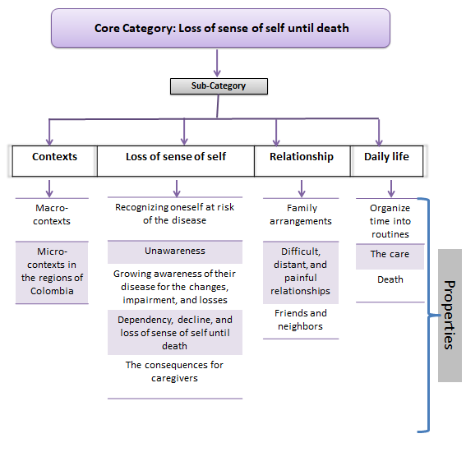
Figure the core category, subcategories, and their properties.

