Additional File 1
Supplemental Table S1: Demographics and Baseline Characteristics [15]
 | Study Participant*
 | 1 | 2 | 3 | 4 | 5
 | Male | Female | Female | Male | Male | Mean (SD)
ASMD Symptom onset age (years) | 2 | 1 | 6 | 0 | 12 | 4.2 (4.9)
ASMD Diagnosis age (years) | 2 | 2 | 12 | 8 | 12 | 7.2 (5.0)
Age at first olipudase alfa infusion (years) | 31 | 32 | 47 | 28 | 22 | 32.6 (9.4)
Spleen Volume (MN)ª | 14.49 | 17.92 | 7.41 | 16.07 | 7.96 | 12.77 (4.81)
Liver Volume (MN)ª | 2.23 | 2.20 | 1.21 | 1.76 | 1.29 | 1.74 (0.48)
DL_{CO} (% predicted)^{b} | 43.7 | 48.0 | 77.0 | 43.0 | 80.0 | 58.3(18.5)
Total cholesterol: high-density lipoprotein ratio^{c} | 14.7 | 10.6 | 5.5 | 15.0 | 6.4 | 10.4 (4.5)
ASMD = acid sphingomyelinase deficiency; DL_{CO}=lung diffusion of carbon monoxide
*Note that colors match the colors used in line graphs of individual data
ª MN, multiples of normal calculated assuming normal spleen volume (L) is 0.2% body weight (kg), and normal liver volume (L) is 2.5% body weight (kg)
^{b} Normal DLco >80%; Mildly reduced >60% to ≤ 80%; Moderately reduced 40-60%; Severely reduced < 40%
c Ratios >5 may indicate higher atherogenic risk

Supplemental Figure S1. Infusion associated reactions (IARs). The number of IARs over time is indicated for 6-month intervals of olipudase alfa treatment. The proportion of individuals with at least 1 IAR during the time interval is shown below the graph.

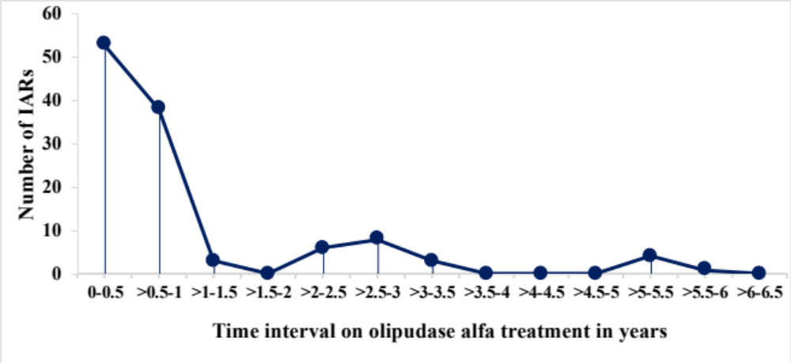

Supplemental Figure S2. Assessment of interstitial lung disease by high-resolution computed tomography (HRCT). Individual HRCT scores over time.
A. Interstitial lung disease (ILD) scores.
B. Ground glass appearance (GGA) scores.
Scoring is based on a 4-point system where 0 = No disease; 1 = Mild (affecting 1-25% of the lung volume); 2 = Moderate (affecting 26-50% of the lung volume); 3 = Severe (affecting 51-100% of the lung volume).

A.
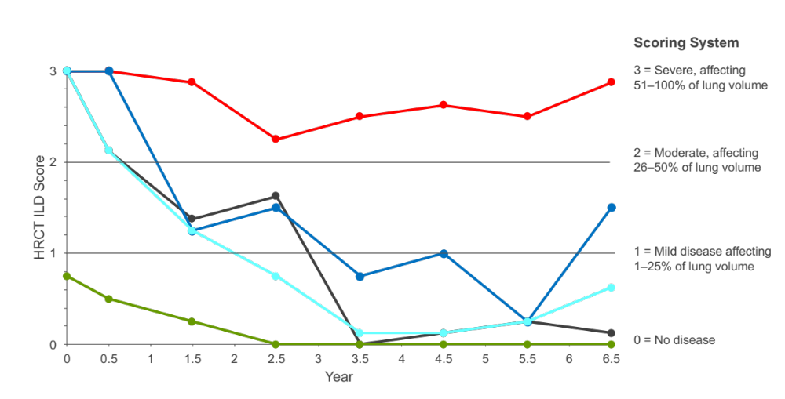

B.
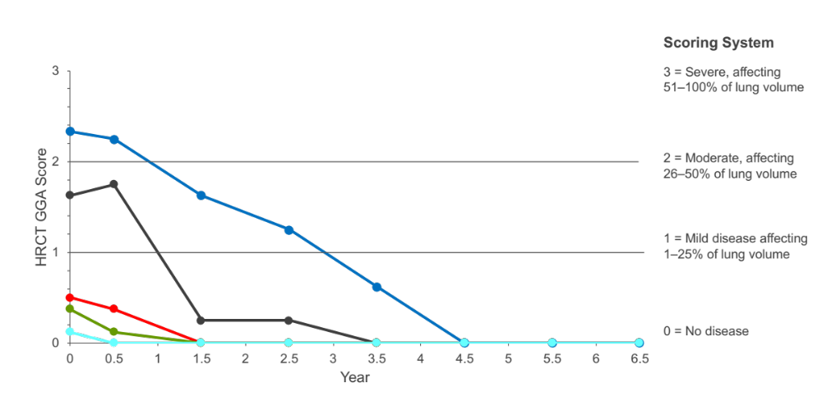

Supplemental Figure S3. Individudal responses for derived percent predicted values for ung spirometry values over time.
A. Forced vital capacity (FVC).
B. Forced expiratory volume in 1 second (FEV1).
C. Total lung capacity (TLC).

A.
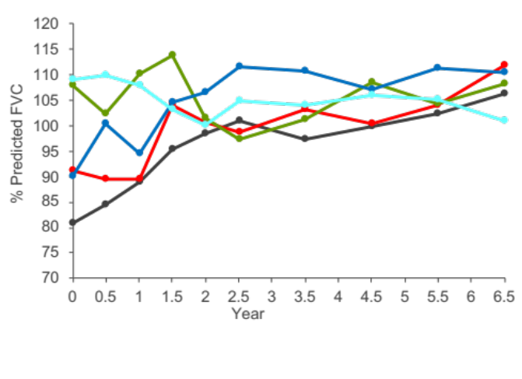
B.
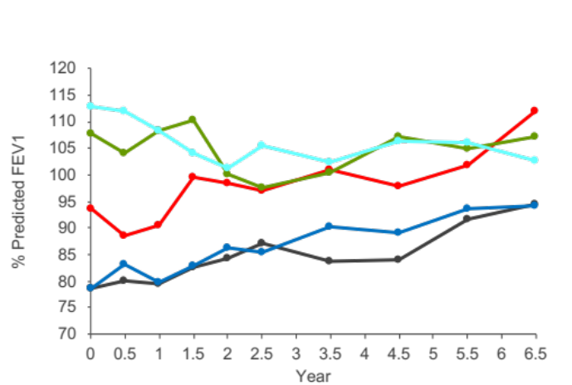
C.
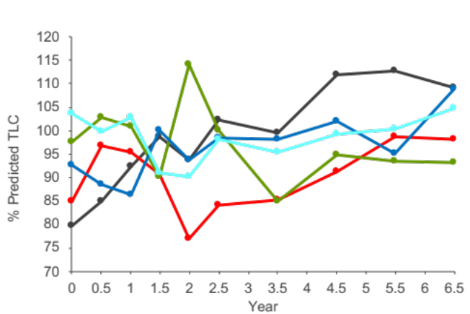
Supplemental Figure S4. Mean ± SD pre-infusion plasma lyso-sphingomyelin levels (A) and mean serum chitotriosidase activity (B) over time. The upper limit of normal for lyso-sphingomyelin in plasma was 10µg/L, and normal chitotriosidase serum levels were ≤ 181 nmol/hr/mL (indicated by horizontal dotted lines). Chitotriosidase values for two individuals heterozygous for the null CHIT mutation known to result in inactive enzyme were doubled.

A.
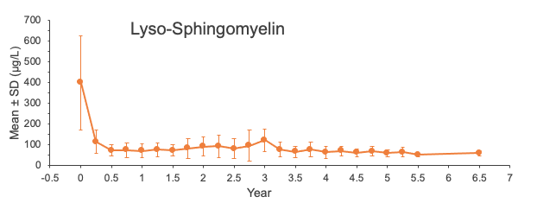

B.
