Supplementary Material

Figure S1. Regional heat map of healthcare provider locations for all 192 patients based on the NPI Registry Practice by 5-digit zip code

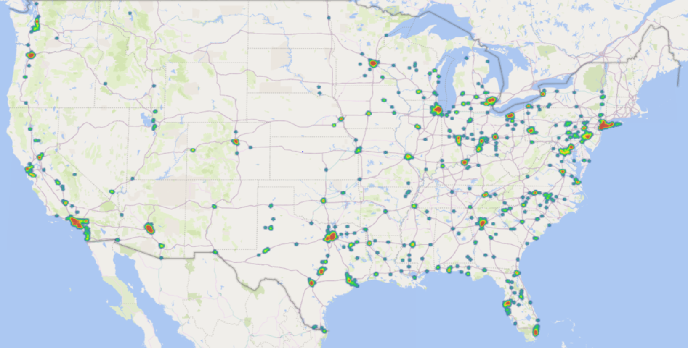

Table S1. Codes for planned vs unplanned hospitalization
Rules, with normal birth deliveries removed from consideration:
Unplanned hospitalization = any occurrence of one of the below codes.
Planned hospitalization = all other inpatient events.
Code | Description | Type
31500 | Intubation, endotracheal, emergency procedure | CPT
31603 | Tracheostomy, emergency procedure; transtracheal | CPT
31605 | Tracheostomy, emergency procedure; cricothyroid membrane | CPT
99281, 99282, 99283, 99284, 99285, 99288, 4084F | * | CPT
G0380, G0381, G0382, G0383, G0384 | * | HCPCS
G9752 | Emergency surgery | HCPCS
R40.2112 | Coma scale, eyes open, never, at arrival to emergency department | ICD10
R40.2122 | Coma scale, eyes open, to pain, at arrival to emergency department | ICD10
R40.2132 | Coma scale, eyes open, to sound, at arrival to emergency department | ICD10
R40.2142 | Coma scale, eyes open, spontaneous, at arrival to emergency department | ICD10
R40.2212 | Coma scale, best verbal response, none, at arrival to emergency department | ICD10
R40.2222 | Coma scale, best verbal response, incomprehensible words, at arrival to emergency department | ICD10
R40.2232 | Coma scale, best verbal response, inappropriate words, at arrival to emergency department | ICD10
R40.2242 | Coma scale, best verbal response, confused conversation, at arrival to emergency department | ICD10
R40.2252 | Coma scale, best verbal response, oriented, at arrival to emergency department | ICD10
R40.2312 | Coma scale, best motor response, none, at arrival to emergency department | ICD10
R40.2322 | Coma scale, best motor response, extension, at arrival to emergency department | ICD10
R40.2332 | Coma scale, best motor response, abnormal, at arrival to emergency department | ICD10
R40.2342 | Coma scale, best motor response, flexion withdrawal, at arrival to emergency department | ICD10
R40.2352 | Coma scale, best motor response, localizes pain, at arrival to emergency department | ICD10
R40.2362 | Coma scale, best motor response, obeys commands, at arrival to emergency department | ICD10
R40.2442 | * | ICD10
*Conditions, procedures, and hospitalizations are composed of 777 unique ICD-9/10 codes, 888 CPT/HCPCS and ICD-10 procedure codes, aggregated into appropriate groupings.

