SUPPLEMENTARY MATERIALS
Table S1. GD treatments codes used: Healthcare Common Procedure Coding System [HCPCS] and National Drug Code [NDC].
Treatment | Healthcare Common Procedure Coding System [HCPCS] | National Drug Code [NDC]
Cerezyme/Imiglucerase | J1785 or J1786 | 58468198301, 58468466301 or 54868198301
Eliglustat/Cerdelga |  | 58468022002 or 58468022001
Taliglucerase alfa/Elelyso | C9294 or J3060 | 00069010601
Velaglucerase alfa/ VPRIV | J3385 or C9271 | 54092070102 or 54092070104

Table S2. Demographics of the “highly suspected population” (threshold >0.95) with GD identified by the age- and prevalence-based algorithms compared with those identified using the clinical diagnostic algorithm as having suspected GD, and those diagnosed with GD.
 | Age-based  N=1073 | Prevalence-based  N=1793 | Clinical diagnostic algorithm N=20743 | Entire diagnosed GD cohort N=815
Age at index (years)
Mean (SD) | 36 (20) | 52 (21) | 61 (19) | 44 (22)
Min | 0 | 0 | 0 | 0
Median (Q1-Q3) | 37 (20-49) | 56 (38-69) | 64 (51-76) | 45 (27-60)
Max | 84 | 88 | 88 | 87
Age in class
0–9 | 109 (10.2%) | 47 (2.6%) | 282 (1.4%) | 62 (7.6%)
10–19 | 148 (13.8%) | 97 (5.4%) | 442 (2.1%) | 62 (7.6%)
20–29 | 145 (13.5%) | 155 (8.6%) | 1175 (5.7%) | 105 (12.9%)
30–39 | 165 (15.4%) | 176 (9.8%) | 1333 (6.4%) | 117 (14.4%)
40–49 | 258 (24.0%) | 241 (13.4%) | 1673 (8.1%) | 119 (14.6%)
50–59 | 94 (8.8%) | 315 (17.6%) | 3436 (16.6%) | 130 (16.0%)
60–69 | 79 (7.4%) | 339 (18.9%) | 4279 (20.6%) | 118 (14.5%)
70–79 | 70 (6.5%) | 270 (15.1%) | 4688 (22.6%) | 76 (9.3%)
80–89 | 5 (0.5%) | 153 (8.5%) | 3435 (16.6%) | 26 (3.2%)
Race
African American | 63 (5.9%) | 68 (3.8%) | 2623 (12.6%) | 30 (3.7%)
Asian | 6 (0.6%) | 4 (0.2%) | 349 (1.7%) | 2 (0.2%)
Caucasian | 850 (79.2%) | 1507 (84.0%) | 16316 (78.7%) | 672 (82.5%)
Other/Unknown | 154 (14.4%) | 214 (11.9%) | 1455 (7.0%) | 111 (13.6%)
Ethnicity
Hispanic | 101 (9.4%) | 110 (6.1%) | 1133 (5.5%) | 38 (4.7%)
Not Hispanic | 838 (78.1%) | 1480 (82.5%) | 18183 (87.7%) | 664 (81.5%)
Unknown | 134 (12.5%) | 203 (11.3%) | 1427 (6.9%) | 113 (13.9%)
Region
Midwest | 304 (28.3%) | 451 (25.2%) | 10004 (48.2%) | 198 (24.3%)
Northeast | 374 (34.9%) | 786 (43.8%) | 2334 (11.3%) | 373 (45.8%)
South | 259 (24.1%) | 316 (17.6%) | 5970 (28.8%) | 153 (18.8%)
West | 91 (8.5%) | 183 (10.2%) | 1696 (8.2%) | 66 (8.1%)
Other/Unknown | 45 (4.2%) | 57 (3.2%) | 739 (3.6%) | 25 (3.1%)
Death
0 | 976 (91.0%) | 1553 (86.6%) | 14589 (70.3%) | 772 (94.7%)
1 | 97 (9.0%) | 240 (13.4%) | 6154 (29.7%) | 43 (5.3%)
Coverage (years)
Mean (SD) | 7 (4) | 8 (3) | 8 (4) | 6 (4)
Min | 0 | 0 | 0 | 0
Median (Q1-Q3) | 7 (3-10) | 9 (5-11) | 8 (5-11) | 7 (3-9)
Max | 12.75 | 12.75 | 12.75 | 12.75
Look-back period (years)
Mean (SD) | 3 (2) | 4 (2) | 3 (2) | 3 (3)
Min | 0 | 0 | 0 | 0
Median (Q1-Q3) | 2 (1-5) | 3 (2-6) | 3 (2-6) | 2 (0-5)
Max | 11.47 | 11.47 | 11.47 | 12.36
Look-back period
at least 6 months | 815 (76.0%) | 1627 (90.7%) | 17593 (84.8%) | 574 (70.4%)
at least 12 months | 747 (69.6%) | 1495 (83.4%) | 16552 (79.8%) | 513 (62.9%)
at least 18 months | 743 (69.2%) | 1493 (83.3%) | 16549 (79.8%) | 452 (55.5%)
at least 24 months | 594 (55.4%) | 1353 (75.5%) | 13683 (66.0%) | 404 (49.6%)
at least 36 months | 333 (31.0%) | 781 (43.6%) | 8621 (41.6%) | 325 (39.9%)
Number of distinct symptoms
Mean (SD) | 6 (4) | 5 (3) | 7 (3) | 5 (4)
Min | 0 | 0 | 0 | 0
Median (Q1-Q3) | 5 (3-8) | 5 (3-7) | 6 (4-9) | 4 (2-7)
Max | 24 | 24 | 24 | 19
Rare disease history
0 | 1073 (100.0%) | 1793 (100.0%) | 20742 (100.0%) | 815 (100.0%)
1 | 0 (0%) | 0 (0%) | 1 (0%) | 0 (0%)

Table S3. Clinical characteristics of the “highly suspected population” (threshold >0.95) identified by the age- and prevalence-based algorithms compared with those identified using the clinical diagnostic algorithm as having suspected GD, and those diagnosed with GD.
Features | Age-based  N=1073 |  |  | Prevalence-based  N=1793 |  |  | Clinical diagnostic algorithm  N=20743 |  |  | Entire diagnosed GD cohort N=815
 | N (%) | Age at 1st event; years, mean (SD) |  | N (%) | Age at 1st event; years, mean (SD) |  | N (%) |  | Age at 1st event; years, mean (SD) | N (%) |  | Age at 1st event; years, mean (SD)
Organomegaly
Hepatomegaly | 196 (18.3%) | 29 (19) |  | 288 (16.1%) | 47 (22) |  | 880 (4.2%) |  | 57 (18) | 136 (16.7%) |  | 35 (22)
Splenomegaly | 589 (54.9%) | 35 (18) |  | 762 (42.5%) | 48 (21) |  | 1526 (7.4%) |  | 56 (19) | 278 (34.1%) |  | 39 (21)
Ventriculomegaly | 0 (0%) |  |  | 1 (0.1%) |  |  | 4 (0%) |  | 57 (38) | 2 (0.2%) |  | 74 (0)
Anemia
Anemias | 903 (84.2%) | 37 (19) |  | 1616 (90.1%) | 53 (20) |  | 20245 (97.6%) |  | 60 (19) | 642 (78.8%) |  | 43 (21)
Blood disorder
Coagulation defects | 84 (7.8%) | 51 (22) |  | 89 (5.0%) | 55 (19) |  | 1139 (5.5%) |  | 62 (18) | 31 (3.8%) |  | 49 (25)
Pancytopenia | 102 (9.5%) | 37 (20) |  | 120 (6.7%) | 55 (21) |  | 1433 (6.9%) |  | 63 (17) | 33 (4.0%) |  | 43 (25)
Thrombocytopenia | 600 (55.9%) | 39 (19) |  | 940 (52.4%) | 56 (20) |  | 18162 (87.6%) |  | 62 (19) | 364 (44.7%) |  | 43 (22)
Bone disorder
Arthralgia | 36 (3.4%) | 43 (16) |  | 61 (3.4%) | 56 (16) |  | 948 (4.6%) |  | 63 (16) | 19 (2.3%) |  | 48 (18)
Arthrogryposis | 19 (1.8%) | 43 (24) |  | 32 (1.8%) | 57 (20) |  | 614 (3.0%) |  | 63 (16) | 9 (1.1%) |  | 68 (11)
Avascular necrosis | 40 (3.7%) | 37 (18) |  | 30 (1.7%) | 49 (20) |  | 130 (0.6%) |  | 62 (17) | 31 (3.8%) |  | 48 (18)
Bone density disorders | 204 (19.0%) | 54 (16) |  | 273 (15.2%) | 65 (15) |  | 3924 (18.9%) |  | 71 (12) | 234 (28.7%) |  | 55 (17)
Bone pain | 72 (6.7%) | 42 (17) |  | 101 (5.6%) | 53 (19) |  | 1978 (9.5%) |  | 50 (21) | 68 (8.3%) |  | 44 (17)
Chondropathies | 14 (1.3%) | 52 (13) |  | 27 (1.5%) | 55 (22) |  | 331 (1.6%) |  | 60 (17) | 10 (1.2%) |  | 52 (24)
Delayed skeletal maturation | 19 (1.8%) | 45 (23) |  | 13 (0.7%) | 57 (15) |  | 322 (1.6%) |  | 65 (16) | 11 (1.3%) |  | 48 (22)
Erlenmeyer flask deformity | 3 (0.3%) | 41 (21) |  | 3 (0.2%) | 34 (17) |  | 39 (0.2%) |  | 61 (15) | 0 (0%)
Joint dislocation | 8 (0.7%) | 42 (28) |  | 15 (0.8%) | 60 (25) |  | 122 (0.6%) |  | 62 (17) | 2 (0.2%) |  | 58 (5)
Kyphosis | 52 (4.8%) | 48 (22) |  | 43 (2.4%) | 63 (19) |  | 457 (2.2%) |  | 72 (15) | 15 (1.8%) |  | 43 (29)
Osteoarthritis | 184 (17.1%) | 57 (17) |  | 423 (23.6%) | 64 (14) |  | 7558 (36.4%) |  | 69 (12) | 152 (18.7%) |  | 60 (15)
Osteolysis | 1 (0.1%) |  |  | 1 (0.1%) |  |  | 39 (0.2%) |  | 70 (15) | 5 (0.6%) |  | 66 (7)
Osteonecrosis | 73 (6.8%) | 38 (16) |  | 80 (4.5%) | 55 (19) |  | 180 (0.9%) |  | 60 (17) | 53 (6.5%) |  | 47 (18)
Osteopenia | 64 (6.0%) | 45 (17) |  | 69 (3.8%) | 64 (15) |  | 959 (4.6%) |  | 70 (13) | 78 (9.6%) |  | 48 (19)
Osteoporosis | 61 (5.7%) | 54 (18) |  | 76 (4.2%) | 67 (15) |  | 1410 (6.8%) |  | 72 (12) | 61 (7.5%) |  | 57 (17)
Pathological fracture | 20 (1.9%) | 55 (18) |  | 24 (1.3%) | 62 (19) |  | 421 (2.0%) |  | 70 (16) | 11 (1.3%) |  | 53 (18)
Spine deformation | 4 (0.4%) | 32 (33) |  | 6 (0.3%) | 56 (24) |  | 48 (0.2%) |  | 61 (22) | 0 (0%)
Cerebral/nervous system disorder
Ataxia | 8 (0.7%) | 48 (34) |  | 44 (2.5%) | 63 (19) |  | 562 (2.7%) |  | 68 (15) | 11 (1.3%) |  | 53 (28)
Bradykinesia | 4 (0.4%) | 71 (1) |  | 9 (0.5%) | 74 (10) |  | 35 (0.2%) |  | 74 (10) | 4 (0.5%) |  | 62 (11)
Cranial nerve disorders | 1 (0.1%) |  |  | 0 (0%) |  |  | 32 (0.2%) |  | 61 (19) | 1 (0.1%)
Developmental regression | 101 (9.4%) | 35 (24) |  | 134 (7.5%) | 54 (25) |  | 3603 (17.4%) |  | 65 (20) | 52 (6.4%) |  | 36 (28)
Dysphagia | 77 (7.2%) | 52 (24) |  | 184 (10.3%) | 59 (20) |  | 3416 (16.5%) |  | 68 (16) | 57 (7.0%) |  | 50 (27)
Extrapyramidal disorder | 4 (0.4%) | 52 (23) |  | 10 (0.6%) | 58 (21) |  | 138 (0.7%) |  | 61 (18) | 5 (0.6%) |  | 53 (15)
Gaze Palsy | 4 (0.4%) | 51 (24) |  | 1 (0.1%) |  |  | 16 (0.1%) |  | 56 (27) | 1 (0.1%)
Hearing impairment | 108 (10.1%) | 46 (26) |  | 189 (10.5%) | 64 (19) |  | 3547 (17.1%) |  | 70 (16) | 67 (8.2%) |  | 55 (23)
Hemiplegia/Hemiparesis | 14 (1.3%) | 55 (23) |  | 22 (1.2%) | 64 (18) |  | 760 (3.7%) |  | 67 (17) | 7 (0.9%) |  | 55 (22)
Hydrocephalus | 3 (0.3%) | 12 (9) |  | 19 (1.1%) | 66 (21) |  | 219 (1.1%) |  | 59 (25) | 6 (0.7%) |  | 60 (29)
Laryngeal spasm | 4 (0.4%) | 36 (39) |  | 0 (0%) |  |  | 25 (0.1%) |  | 65 (20) | 3 (0.4%) |  | 29 (41)
Muscle hypotonia | 15 (1.4%) | 7 (6) |  | 6 (0.3%) | 4 (3) |  | 40 (0.2%) |  | 14 (25) | 7 (0.9%) |  | 3 (2)
Myoclonic seizure | 3 (0.3%) | 24 (17) |  | 5 (0.3%) | 24 (12) |  | 11 (0.1%) |  | 46 (22) | 1 (0.1%)
Nerve root compression | 0 (0%) |  |  | 1 (0.1%) |  |  | 29 (0.1%) |  | 64 (16) | 0 (0%)
Oculomotor apraxia | 1 (0.1%) |  |  | 1 (0.1%) |  |  | 14 (0.1%) |  | 56 (23) | 4 (0.5%) |  | 28 (36)
Opticokinetic nystagmus | 5 (0.5%) | 5 (6) |  | 8 (0.4%) | 26 (25) |  | 89 (0.4%) |  | 57 (24) | 5 (0.6%) |  | 26 (32)
Paralytic strabismus | 1 (0.1%) |  |  | 4 (0.2%) | 47 (23) |  | 32 (0.2%) |  | 39 (31) | 1 (0.1%)
Parkinson | 47 (4.4%) | 65 (11) |  | 99 (5.5%) | 74 (9) |  | 340 (1.6%) |  | 74 (10) | 23 (2.8%) |  | 65 (11)
Tonic clonic seizure | 3 (0.3%) | 33 (11) |  | 8 (0.4%) | 39 (23) |  | 47 (0.2%) |  | 53 (20) | 2 (0.2%) |  | 12 (4)
Development disorders
Delayed puberty | 4 (0.4%) | 17 (6) |  | 2 (0.1%) | 15 (1) |  | 5 (0%) |  | 25 (24) | 1 (0.1%)
Growth retardation | 0 (0%) |  |  | 1 (0.1%) |  |  | 20 (0.1%) |  | 8 (11) | 6 (0.7%) |  | 15 (13)
Short stature | 10 (0.9%) | 11 (4) |  | 7 (0.4%) | 12 (4) |  | 50 (0.2%) |  | 16 (19) | 7 (0.9%) |  | 11 (4)
Eye disorder
Corneal disorders | 12 (1.1%) | 57 (27) |  | 15 (0.8%) | 60 (22) |  | 130 (0.6%) |  | 70 (17) | 7 (0.9%) |  | 49 (32)
Non-diabetic retinopathy | 5 (0.5%) | 41 (30) |  | 12 (0.7%) | 53 (23) |  | 190 (0.9%) |  | 58 (26) | 3 (0.4%) |  | 61 (26)
General signs
Abdominal pain | 398 (37.1%) | 40 (20) |  | 637 (35.5%) | 50 (21) |  | 10775 (51.9%) |  | 60 (19) | 218 (26.7%) |  | 47 (22)
Elevated CRP | 10 (0.9%) | 47 (24) |  | 9 (0.5%) | 54 (20) |  | 197 (0.9%) |  | 59 (20) | 6 (0.7%) |  | 52 (15)
Fatigue | 376 (35.0%) | 41 (18) |  | 571 (31.8%) | 54 (19) |  | 8895 (42.9%) |  | 63 (17) | 227 (27.9%) |  | 47 (19)
Fever | 309 (28.8%) | 34 (20) |  | 399 (22.3%) | 48 (22) |  | 7879 (38.0%) |  | 59 (20) | 147 (18.0%) |  | 40 (23)
Gingival bleeding | 2 (0.2%) | 34 (17) |  | 6 (0.3%) | 58 (20) |  | 29 (0.1%) |  | 52 (25) | 2 (0.2%) |  | 51 (32)
Muscle atrophy | 1 (0.1%) |  |  | 0 (0%) |  |  | 11 (0.1%) |  | 74 (8) | 4 (0.5%) |  | 77 (12)
Tremor | 55 (5.1%) | 51 (21) |  | 88 (4.9%) | 59 (19) |  | 1438 (6.9%) |  | 64 (17) | 31 (3.8%) |  | 51 (24)
Vitamin D deficiency | 177 (16.5%) | 48 (20) |  | 246 (13.7%) | 57 (18) |  | 3205 (15.5%) |  | 64 (17) | 135 (16.6%) |  | 51 (18)
Heart disorder
Valve calcification | 12 (1.1%) | 65 (13) |  | 18 (1.0%) | 68 (14) |  | 772 (3.7%) |  | 72 (13) | 13 (1.6%) |  | 66 (20)
Hepatic disorders
Cirrhosis | 52 (4.8%) | 43 (13) |  | 74 (4.1%) | 56 (15) |  | 1324 (6.4%) |  | 62 (13) | 14 (1.7%) |  | 46 (16)
Hepatic fibrosis | 4 (0.4%) | 19 (18) |  | 11 (0.6%) | 50 (24) |  | 61 (0.3%) |  | 61 (14) | 6 (0.7%) |  | 48 (29)
Hepatitis | 40 (3.7%) | 39 (15) |  | 50 (2.8%) | 52 (18) |  | 641 (3.1%) |  | 60 (16) | 19 (2.3%) |  | 49 (23)
Portal hypertension | 50 (4.7%) | 37 (14) |  | 42 (2.3%) | 52 (14) |  | 667 (3.2%) |  | 60 (12) | 13 (1.6%) |  | 38 (22)
Immunology
Polyclonal gammopathy | 0 (0%) |  |  | 4 (0.2%) | 63 (9) |  | 53 (0.3%) |  | 67 (12) | 4 (0.5%) |  | 60 (19)
Kidney disorder
Acute kidney disease | 34 (3.2%) | 63 (19) |  | 54 (3.0%) | 64 (16) |  | 225 (1.1%) |  | 63 (19) | 31 (3.8%) |  | 66 (14)
Hematuria | 130 (12.1%) | 47 (21) |  | 260 (14.5%) | 57 (19) |  | 4120 (19.9%) |  | 65 (17) | 75 (9.2%) |  | 53 (20)
Proteinuria | 47 (4.4%) | 47 (22) |  | 115 (6.4%) | 59 (17) |  | 2446 (11.8%) |  | 63 (17) | 35 (4.3%) |  | 53 (22)
Malignancy
Liver neoplasm | 7 (0.7%) | 44 (20) |  | 24 (1.3%) | 63 (17) |  | 275 (1.3%) |  | 66 (12) | 3 (0.4%) |  | 55 (26)
Malignant melanoma | 4 (0.4%) | 52 (25) |  | 7 (0.4%) | 64 (13) |  | 188 (0.9%) |  | 70 (13) | 5 (0.6%) |  | 63 (7)
Multiple myeloma | 14 (1.3%) | 51 (18) |  | 24 (1.3%) | 67 (14) |  | 370 (1.8%) |  | 69 (12) | 8 (1.0%) |  | 61 (9)
Non Hodgkin Lymphoma | 26 (2.4%) | 51 (20) |  | 29 (1.6%) | 67 (17) |  | 60 (0.3%) |  | 69 (12) | 8 (1.0%) |  | 61 (27)
Other malignant neoplasms | 3 (0.3%) | 56 (35) |  | 2 (0.1%) | 43 (38) |  | 20 (0.1%) |  | 66 (14) | 2 (0.2%) |  | 38 (46)
Pancreatic cancer | 5 (0.5%) | 43 (22) |  | 11 (0.6%) | 70 (13) |  | 278 (1.3%) |  | 69 (11) | 2 (0.2%) |  | 55 (15)
Uncertain neoplasms | 68 (6.3%) | 50 (17) |  | 131 (7.3%) | 63 (14) |  | 1113 (5.4%) |  | 67 (16) | 47 (5.8%) |  | 58 (16)
Perinatal disorders
Hydrops fetalis | 2 (0.2%) | 1 (1) |  | 1 (0.1%) |  |  | 2 (0%) |  | 1 (1) | 1 (0.1%)
Ichthyosis | 1 (0.1%) |  |  | 1 (0.1%) |  |  | 15 (0.1%) |  | 71 (10) | 0 (0%)
Psychiatric disorders
Dementia non-senile | 33 (3.1%) | 66 (16) |  | 114 (6.4%) | 76 (12) |  | 2368 (11.4%) |  | 78 (9) | 19 (2.3%) |  | 69 (16)
Depression | 293 (27.3%) | 43 (19) |  | 620 (34.6%) | 52 (19) |  | 8641 (41.7%) |  | 61 (18) | 161 (19.8%) |  | 51 (20)
Respiratory disorder
Interstitial pulmonary abnormality | 12 (1.1%) | 66 (23) |  | 12 (0.7%) | 60 (22) |  | 417 (2.0%) |  | 69 (14) | 7 (0.9%) |  | 44 (36)
Pulmonary fibrosis | 14 (1.3%) | 68 (15) |  | 41 (2.3%) | 58 (16) |  | 953 (4.6%) |  | 70 (13) | 13 (1.6%) |  | 63 (20)
Pulmonary hypertension | 51 (4.8%) | 54 (23) |  | 91 (5.1%) | 64 (15) |  | 2132 (10.3%) |  | 71 (15) | 35 (4.3%) |  | 56 (21)
Respiratory failure | 66 (6.2%) | 48 (27) |  | 103 (5.7%) | 61 (19) |  | 5165 (24.9%) |  | 67 (16) | 36 (4.4%) |  | 56 (30)

Table S4. Visits to the specialist by the “highly suspected population” (threshold >0.95) identified by the age-based and prevalence algorithms compared with those identified using the clinical diagnostic algorithm as having suspected GD, and those diagnosed with GD.
Features | Age-based  N=1073 |  |  | Prevalence-based  N=1793
 | N (%) | Age at 1st event; years, mean (SD) | No. of visits (mean) | N (%) | Age at 1st event; years, mean (SD) | No. of visits (mean)
Gastroenterology | 288 (26.8%) | 44 (19) | 0.61 | 578 (32.2%) | 56 (18) | 0.37
General Practice | 53 (4.9%) | 45 (19) | 0.03 | 207 (11.5%) | 53 (20) | 0.05
Hematology | 40 (3.7%) | 44 (15) | 0.23 | 52 (2.9%) | 53 (18) | 0.05
Hepatology | 21 (2.0%) | 41 (9) | 0.04 | 29 (1.6%) | 53 (12) | 0.02
Internal Medicine | 517 (48.2%) | 45 (17) | 2.11 | 1276 (71.2%) | 55 (19) | 0.84
Neurology | 448 (41.8%) | 41 (21) | 1.89 | 838 (46.7%) | 55 (20) | 0.76
Oncology | 506 (47.2%) | 37 (22) | 2.19 | 754 (42.1%) | 54 (21) | 1.08
Ophthalmology | 157 (14.6%) | 46 (26) | 0.23 | 297 (16.6%) | 56 (21) | 0.07
Orthopedic Surgery | 332 (30.9%) | 42 (23) | 0.53 | 654 (36.5%) | 54 (20) | 0.28
Pain Medicine | 47 (4.4%) | 47 (19) | 0.15 | 117 (6.5%) | 57 (17) | 0.04
Pediatrics | 226 (21.1%) | 15 (15) | 0.83 | 225 (12.5%) | 29 (23) | 0.19
Radiology | 335 (31.2%) | 43 (22) | 0.46 | 783 (43.7%) | 54 (20) | 0.23
Rheumatology | 69 (6.4%) | 46 (20) | 0.1 | 111 (6.2%) | 57 (17) | 0.05

Table S4. continued.
Features | Clinical diagnostic algorithm |  |  | Entire diagnosed GD cohort
 | N=20743 |  |  | N=815
 | N (%) | Age at 1st event; years, mean (SD) | No. of visits (with 0) | N (%) | Age at 1st event; years, mean (SD) | No. of visits (with 0)
Gastroenterology | 8314 (40.1%) | 63 (16) | 0.49 | 194 (23.8%) | 49 (21) | 3.06
General Practice | 1943 (9.4%) | 62 (18) | 0.12 | 36 (4.4%) | 51 (19) | 0.58
Hematology | 670 (3.2%) | 63 (16) | 0.05 | 35 (4.3%) | 53 (20) | 0.79
Hepatology | 300 (1.4%) | 58 (14) | 0.02 | 10 (1.2%) | 53 (16) | 0.02
Internal Medicine | 16215 (78.2%) | 63 (17) | 3.44 | 420 (51.5%) | 50 (18) | 23.38
Neurology | 7073 (34.1%) | 62 (18) | 0.56 | 399 (49.0%) | 43 (21) | 49.06
Oncology | 6777 (32.7%) | 63 (17) | 1.4 | 287 (35.2%) | 45 (22) | 61.71
Ophthalmology | 4354 (21.0%) | 64 (18) | 0.16 | 128 (15.7%) | 53 (22) | 3.17
Orthopedic Surgery | 6717 (32.4%) | 64 (17) | 0.39 | 223 (27.4%) | 51 (21) | 5.2
Pain Medicine | 1124 (5.4%) | 64 (16) | 0.03 | 31 (3.8%) | 54 (17) | 0.19
Pediatrics | 2106 (10.2%) | 47 (27) | 0.2 | 142 (17.4%) | 20 (21) | 18.14
Radiology | 9788 (47.2%) | 62 (17) | 0.74 | 248 (30.4%) | 46 (22) | 3.6
Rheumatology | 2125 (10.2%) | 63 (17) | 0.13 | 99 (12.1%) | 51 (20) | 7.21

Figure S1. Features identified for GD algorithm assessment. Overall, 80 clinical characteristics of GD were identified and grouped into organ classes.
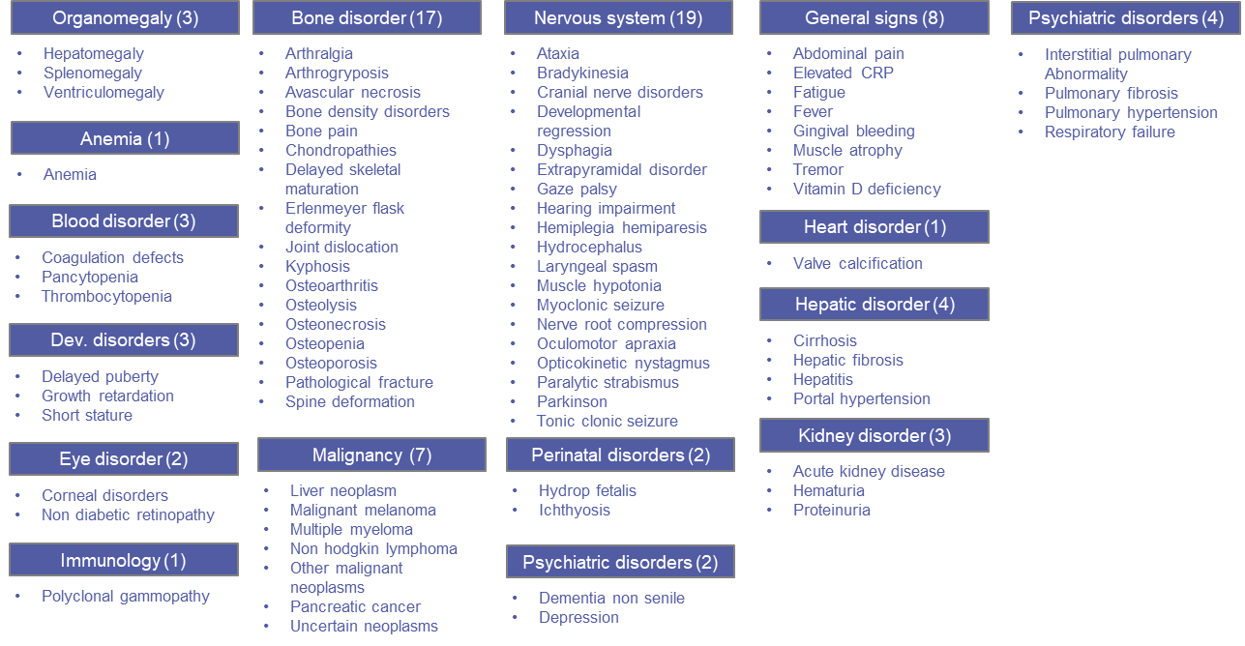

Figure S2. Defining clinical characteristics with symptoms, procedures, laboratory measurement and SDS terms.

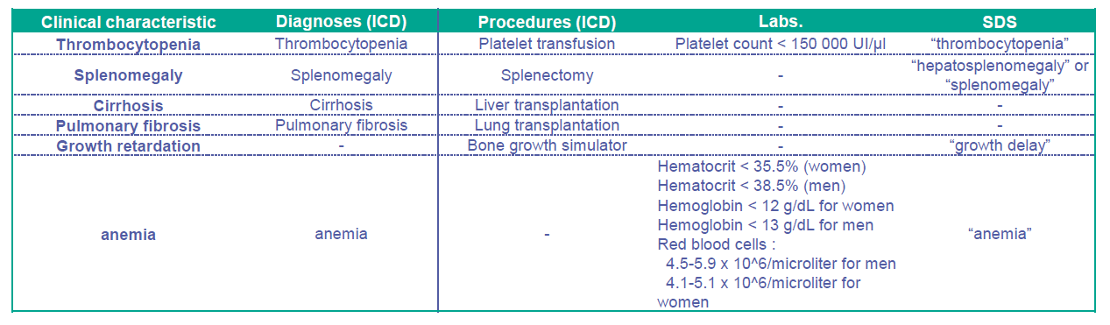

Figure S3. Patients identified using the clinical diagnostic algorithm as having suspected GD.
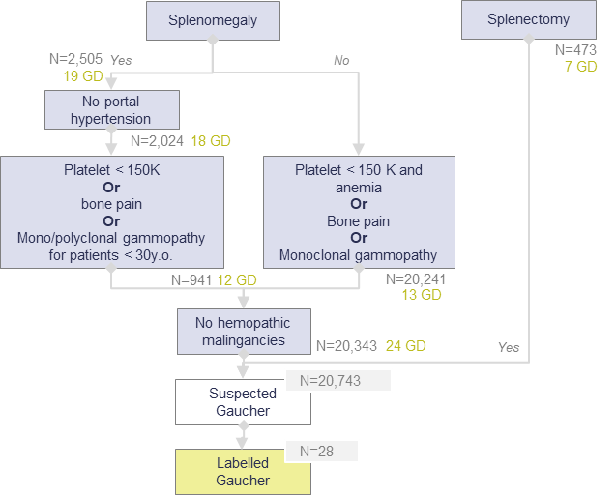

Figure S4. Methodology overview.
