Pymol

- NYX: c.611G>T, p.Gly204Val
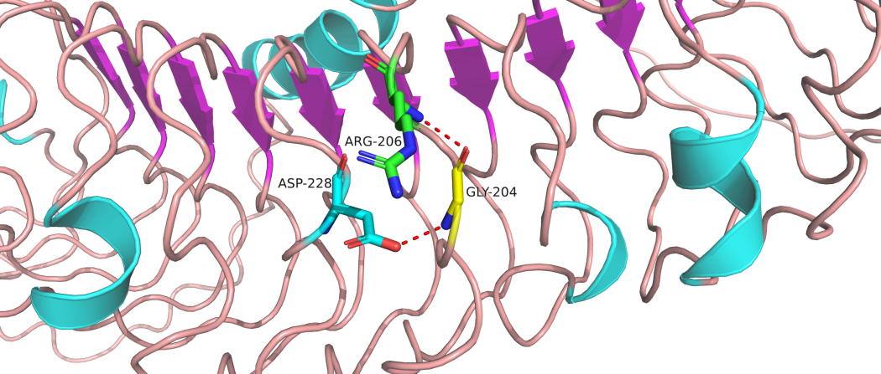
Wild:

Mutant:
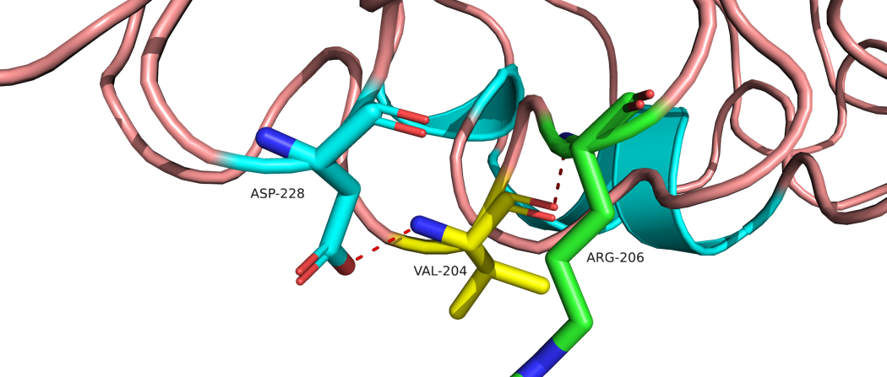

Figure 1. 3-D model construction showed a wild-type amino acid of Glycine was replaced by an amino acid of Valine at codon 204 in NYX.

- NYX: c.662T>G p.Val221Gly
Wild:
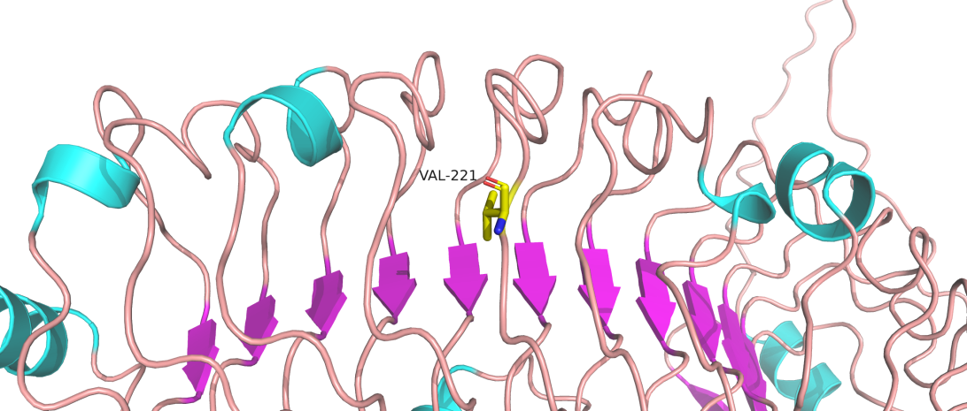
Mutant:

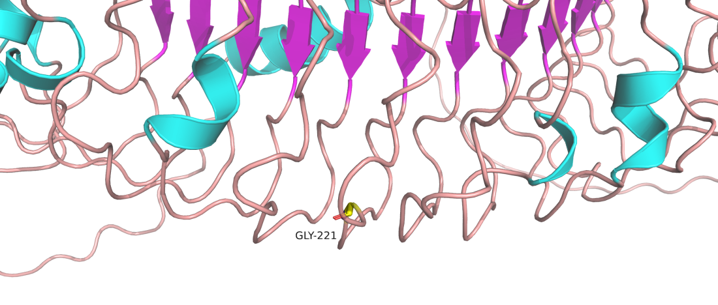
Figure 2. 3-D model construction showed a wild-type amino acid of Valine was replaced by an amino acid of Glycine at codon 221 in NYX.

3.NYX: c.719A>G p.Asn240Ser
Wild
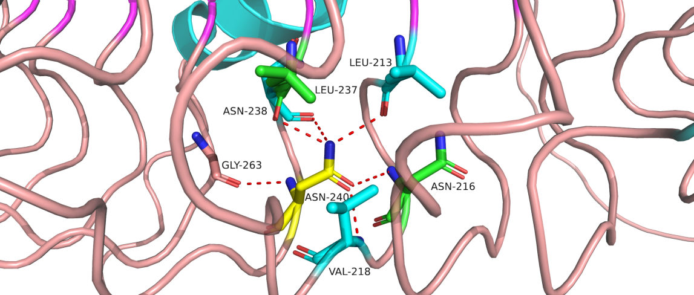
Mutant
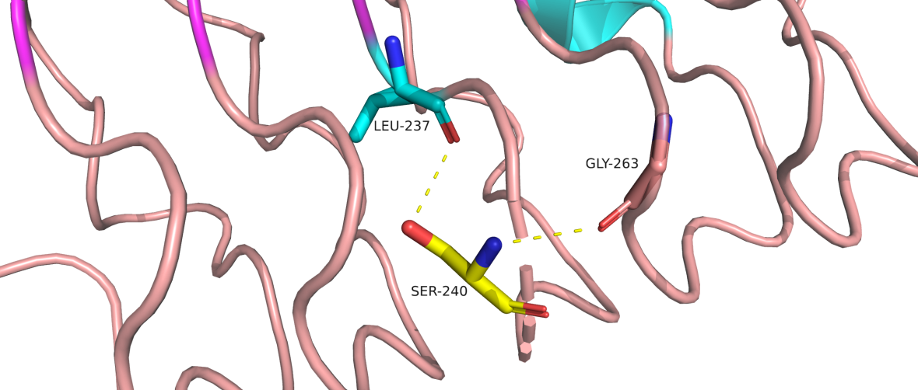

Figure 3. 3-D model construction showed a wild-type amino acid of Asn was replaced by an amino acid of Ser at codon 240 in NYX.

4.CACNA1F : c.1714T>C p.Phe572Leu
Wild
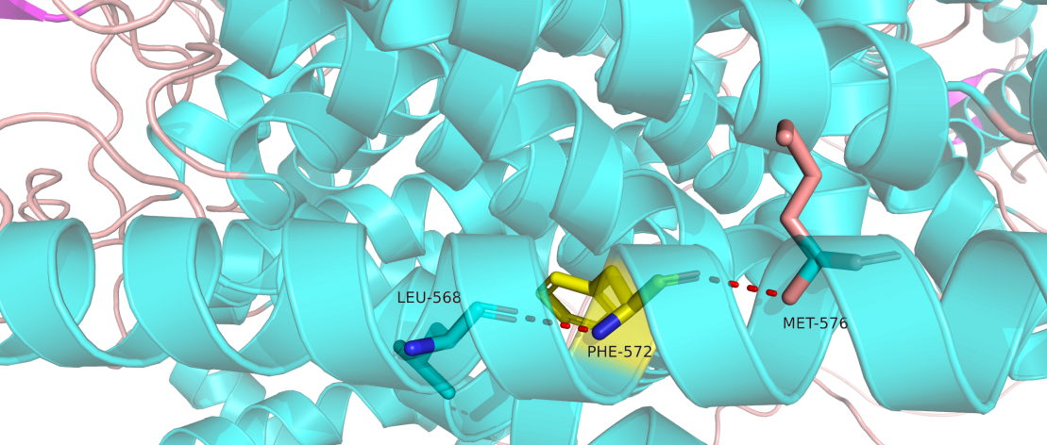

Mutant
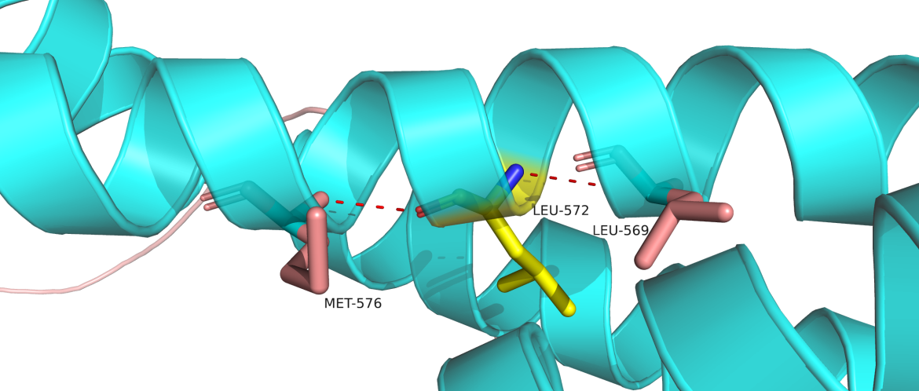

Figure 4. 3-D model construction showed a wild-type amino acid of Phe was replaced by an amino acid of Leu at codon 572 in CACNA1F.

- CACNA1F： c.2266A>T p.Ile756Phe
Wild

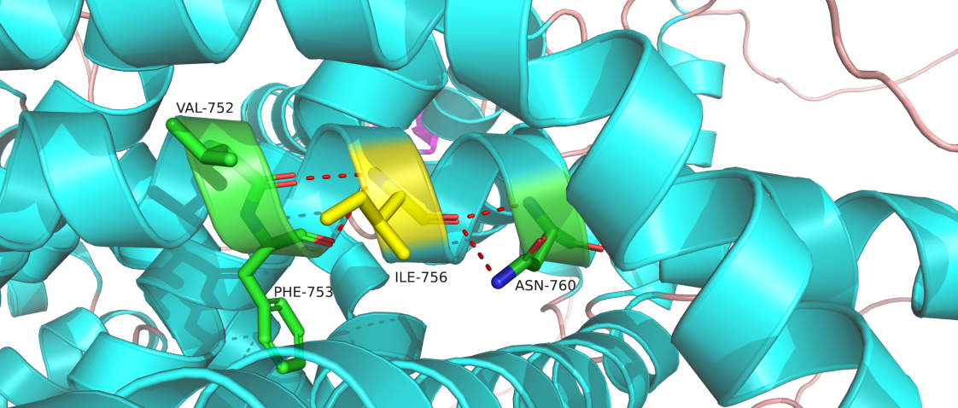
Mutant

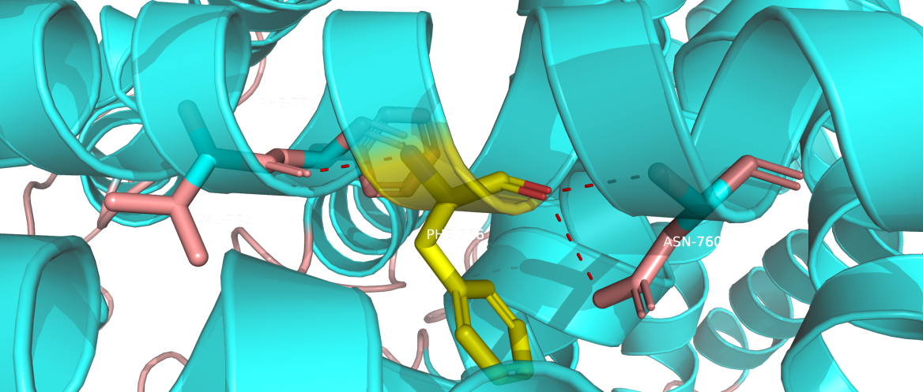

Figure 5. 3-D model construction showed a wild-type amino acid of Ile was replaced by an amino acid of Phe at codon 756 in CACNA1F.

- CACNA1F ： c.4097T>C p.Phe1366Ser
Wild

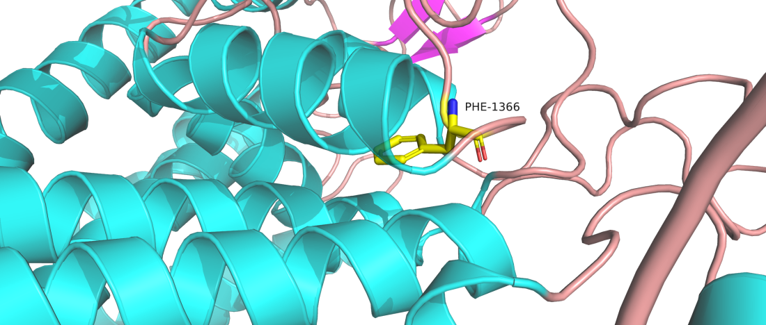

Mutant

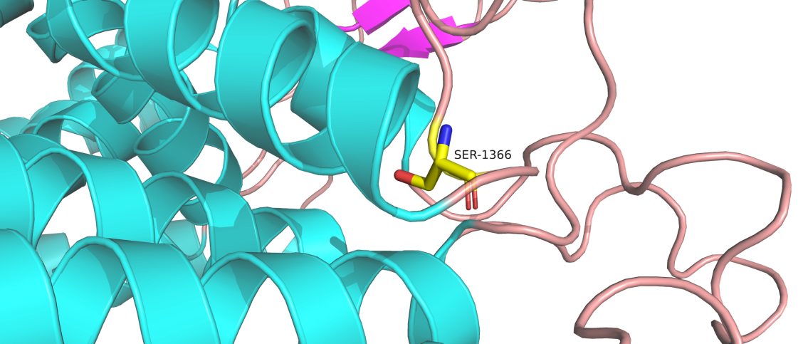

Figure 6. 3-D model construction showed a wild-type amino acid of Phe was replaced by an amino acid of Ser at codon 1366 in CACNA1F.

- CACNA1F： c.5429G>A p.Arg1810His
Wild

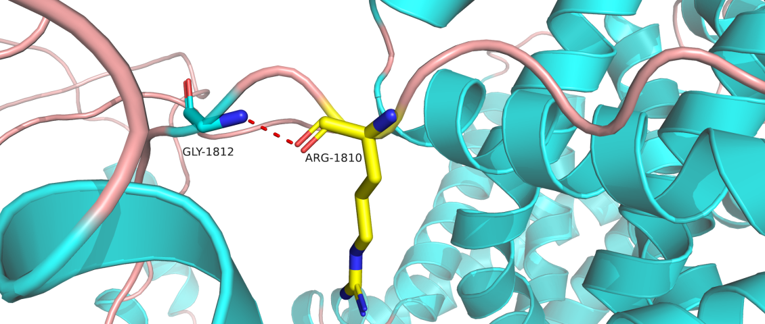

Mutant

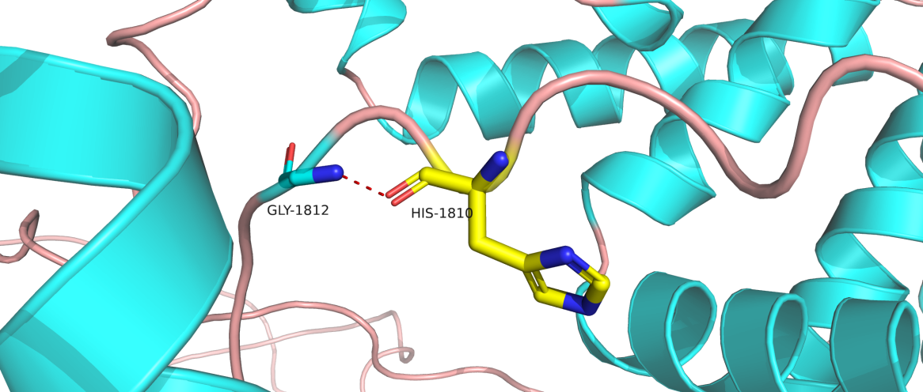

Figure 7. 3-D model construction showed a wild-type amino acid of Arg was replaced by an amino acid of His at codon 1810 in CACNA1F.

- TRPM1： c.2750G>A p.Arg917His
Wild

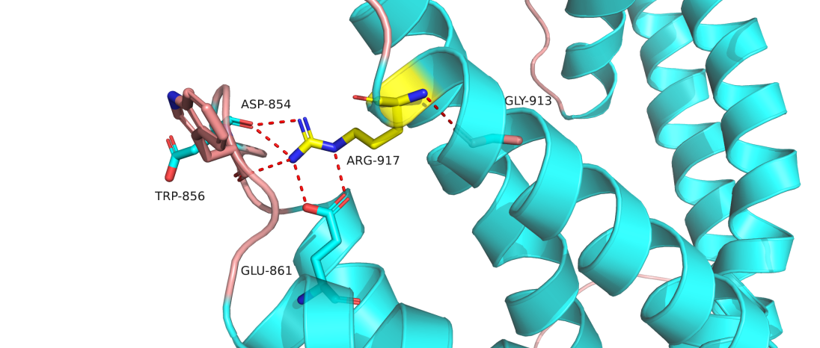
Mutant

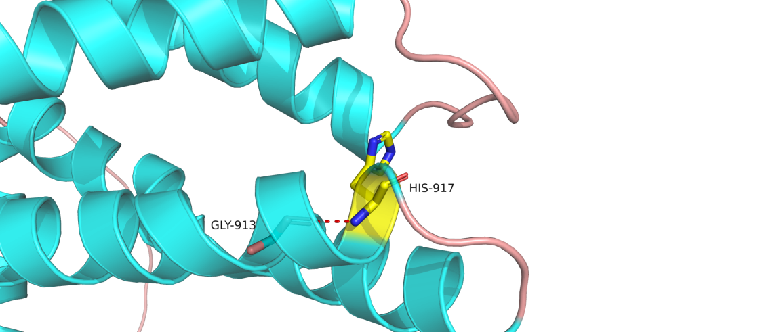

Figure 8. 3-D model construction showed a wild-type amino acid of Arg was replaced by an amino acid of His at codon 917 in TRPM1.

- TRPM1：c.416G>A p.Gly139Asp
Wild

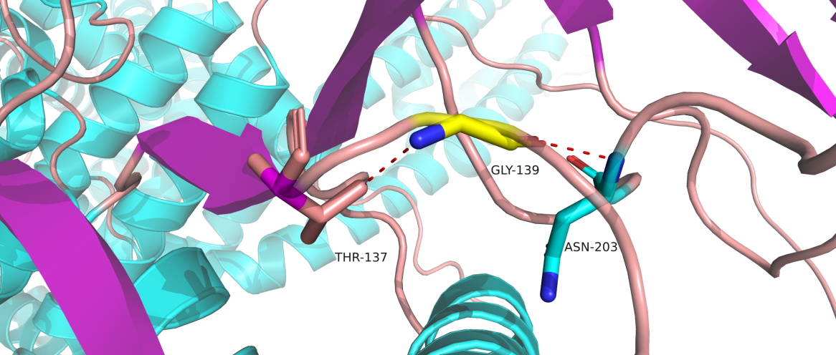
Mutant
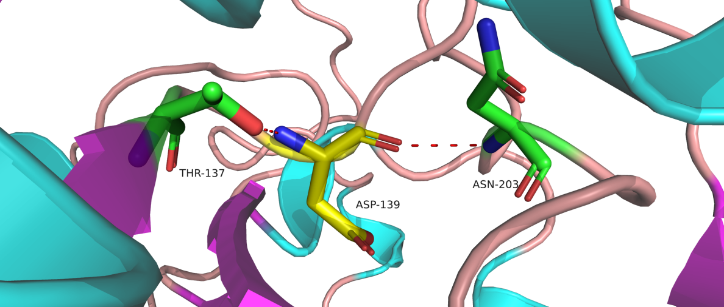

Figure 9. 3-D model construction showed a wild-type amino acid of Gly was replaced by an amino acid of Asp at codon 139 in TRPM1.

- TRPM1：c.2543T>A p.Val848Asp
Wild
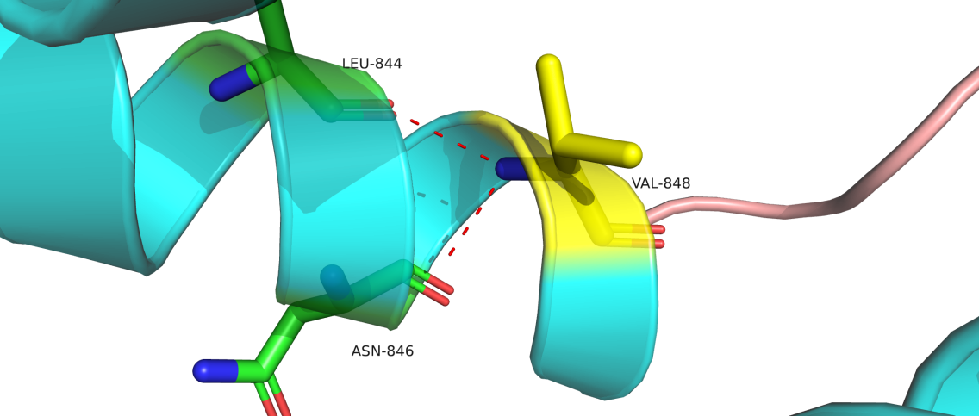

Mutant

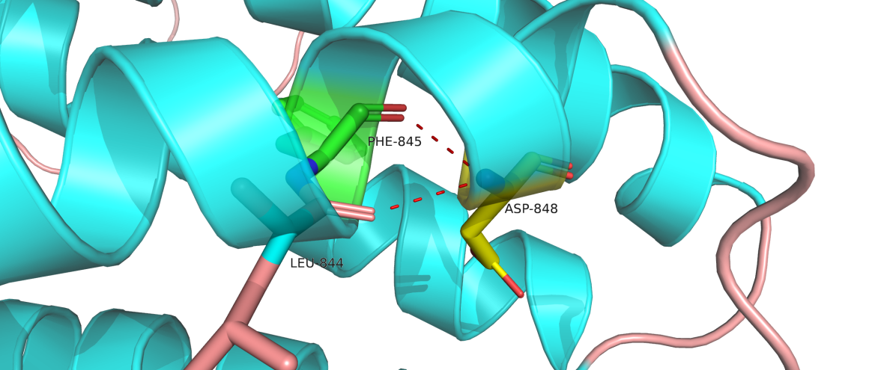

Figure 10. 3-D model construction showed a wild-type amino acid of Val was replaced by an amino acid of Asp at codon 848 in TRPM1.

- TRPM1： c.2737G>A p.Gly913Arg

Wild

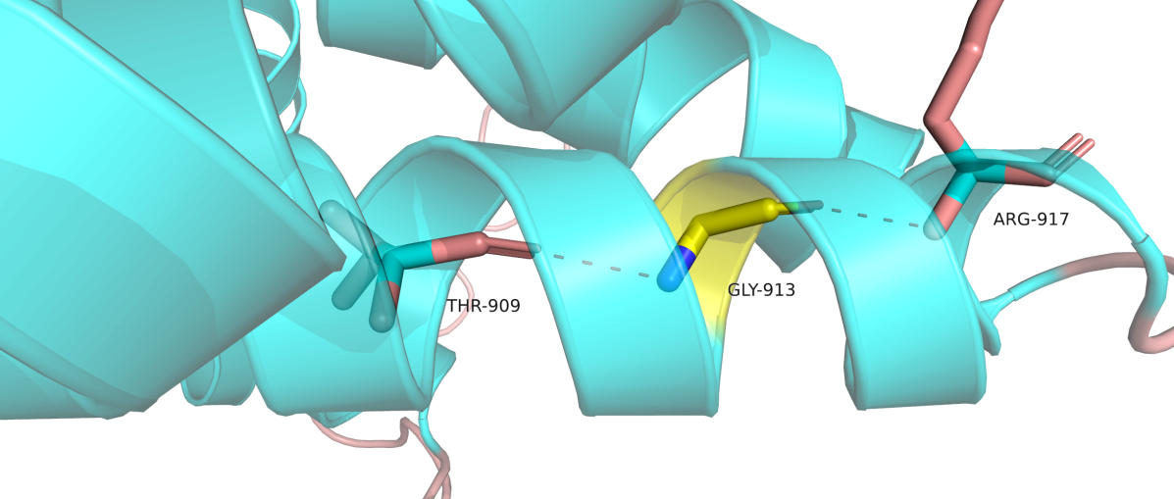
Mutant

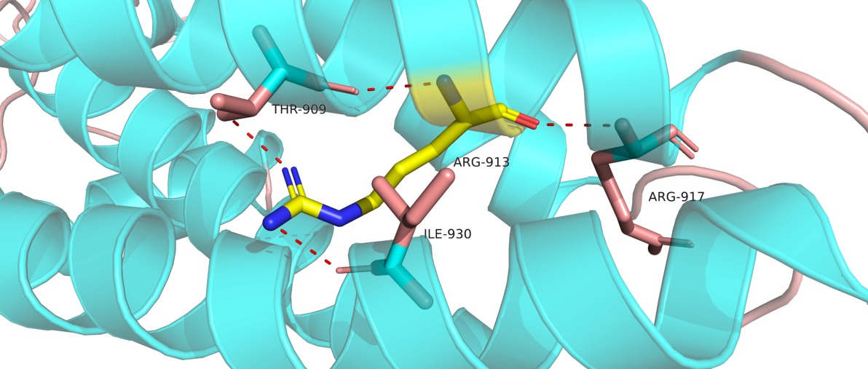

Figure 11. 3-D model construction showed a wild-type amino acid of Gly was replaced by an amino acid of Arg at codon 913 in TRPM1.

- TRPM1：c.2855T>C p.Leu952Arg
Wild
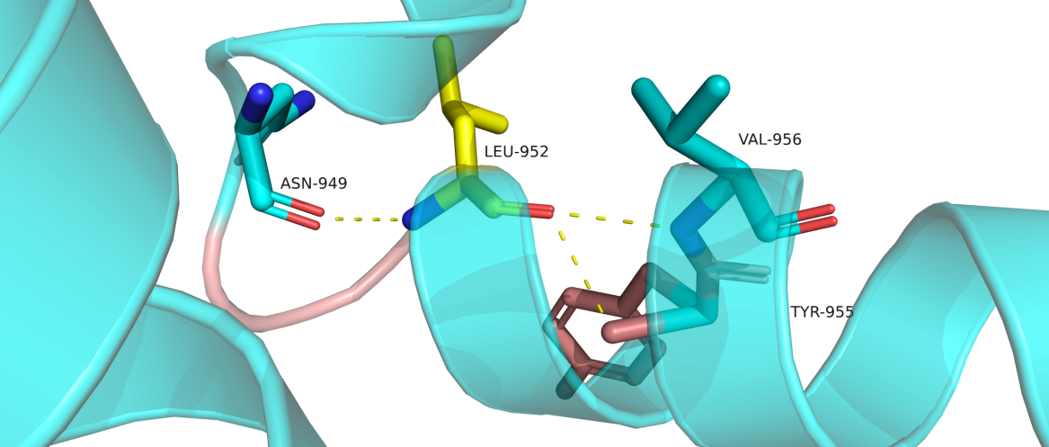

Mutant

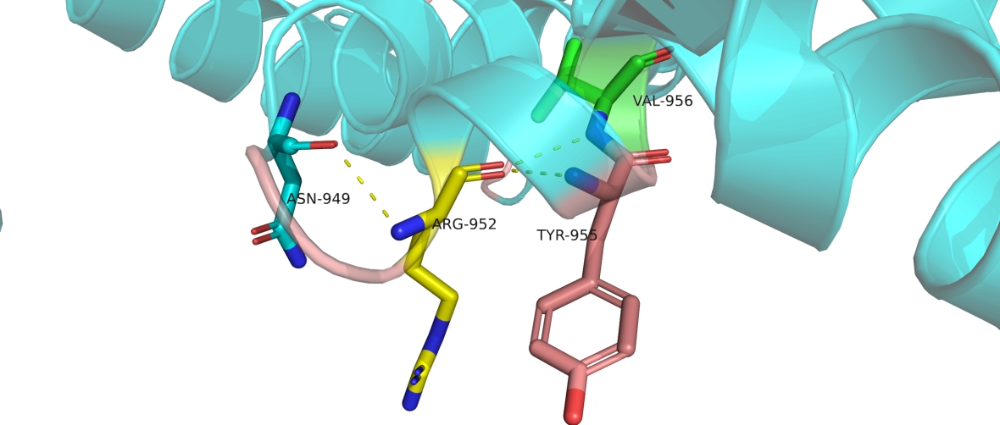

Figure 12. 3-D model construction showed a wild-type amino acid of Leu was replaced by an amino acid of Arg at codon 952 in TRPM1.

- TRPM1： c.2954A>G p.Gln985Arg
Wild

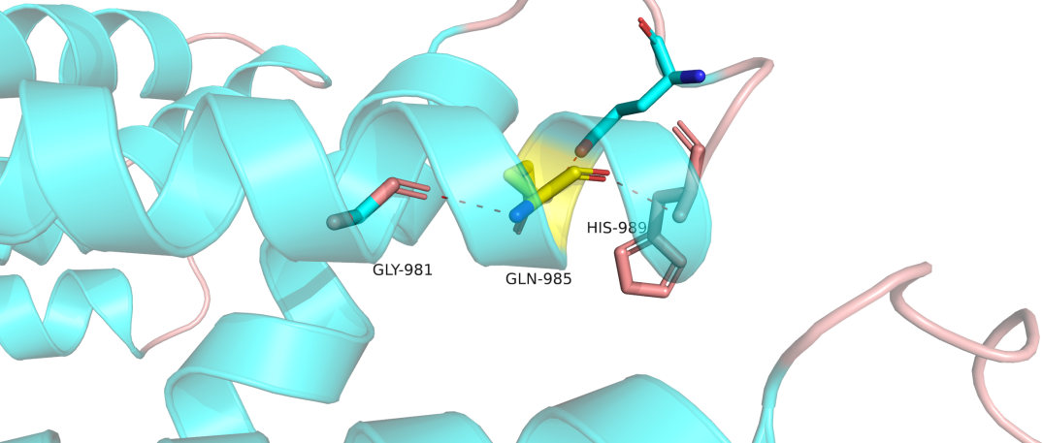
Mutant

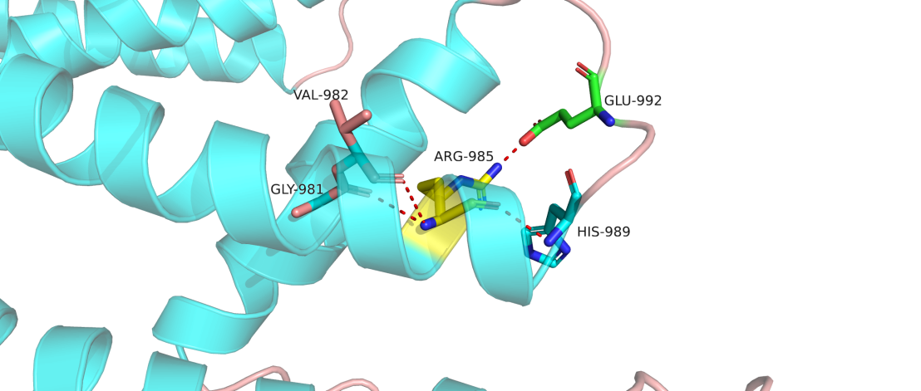

Figure 13. 3-D model construction showed a wild-type amino acid of Gln was replaced by an amino acid of Arg at codon 985 in TRPM1.

- TRPM1： c.3067G>A P.Ala1023Thr
Wild

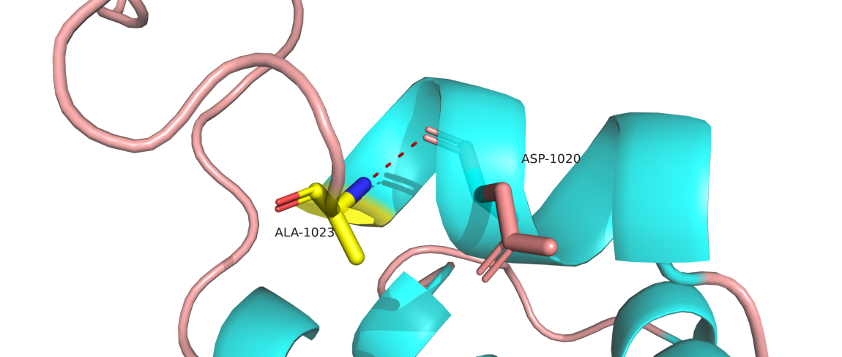
Mutant

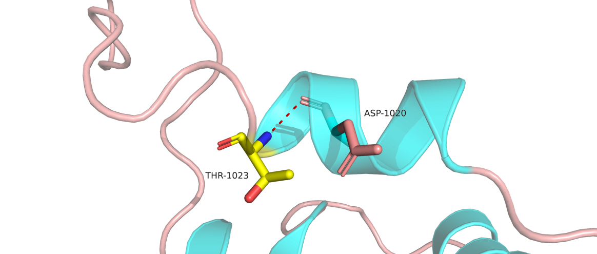

Figure 14. 3-D model construction showed a wild-type amino acid of Ala was replaced by an amino acid of Thr at codon 1023 in TRPM1.

- TRPM1：c.3133T>C p.Cys1045Arg
Wild
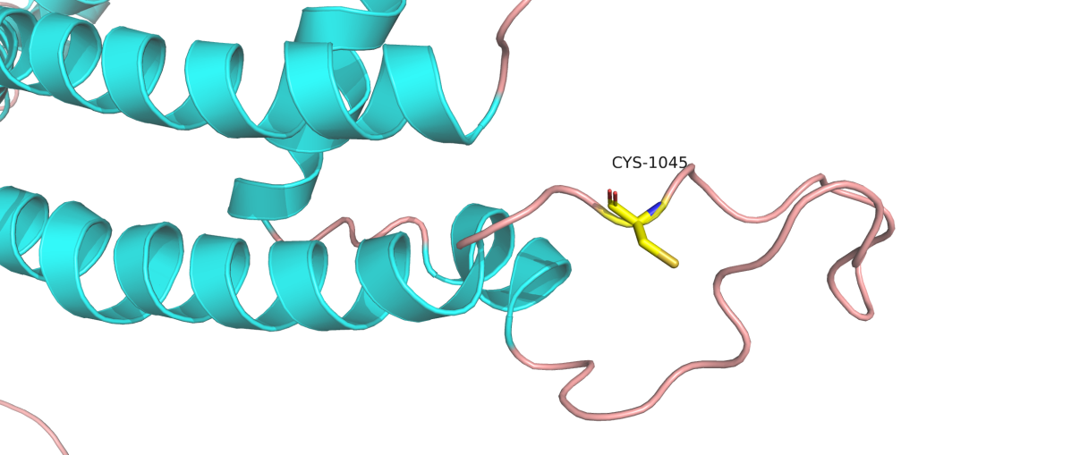
Mutant
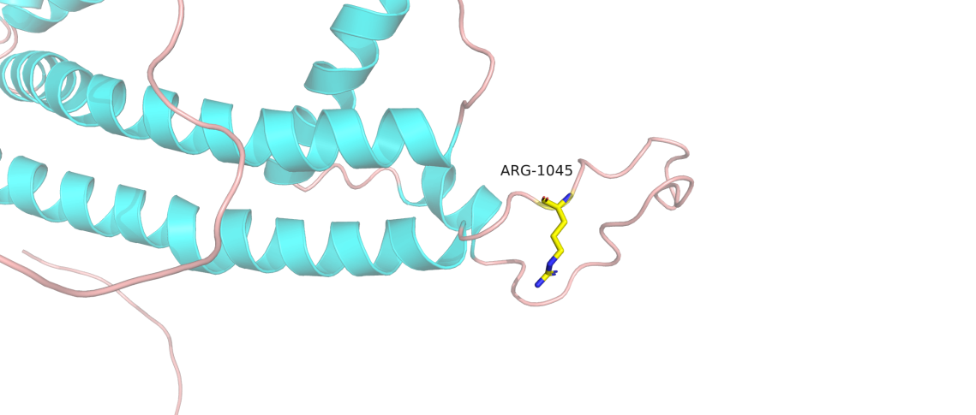
Figure 15. 3-D model construction showed a wild-type amino acid of Cys was replaced by an amino acid of Arg at codon 1045 in TRPM1.

