SUPPLEMENTARY MATERIALS
- Supplementary Figure 1. Study Period
- Supplementary Figure 2. Chronic HP Patient Selection Flowchart
- Supplementary Figure 3. Transient HP Patient Selection Flowchart
- Supplementary Table 1. Diagnosis and Procedure Codes for Selection Criteria

Supplementary Figure 1: Study Period
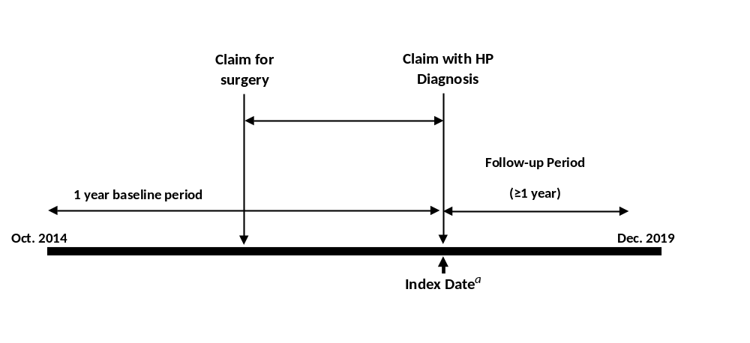
ªcHP Index Date: defined as the date of the first qualifying HP diagnosis claim; tHP Index Date: defined as the date of the last HP diagnosis claim.
cHP: Chronic Hypoparathyroidism; HP: Hypoparathyroidism; tHP: Transient Hypoparathyroidism

Supplementary Figure 2: Patient selection flowchart for Chronic HP cohort
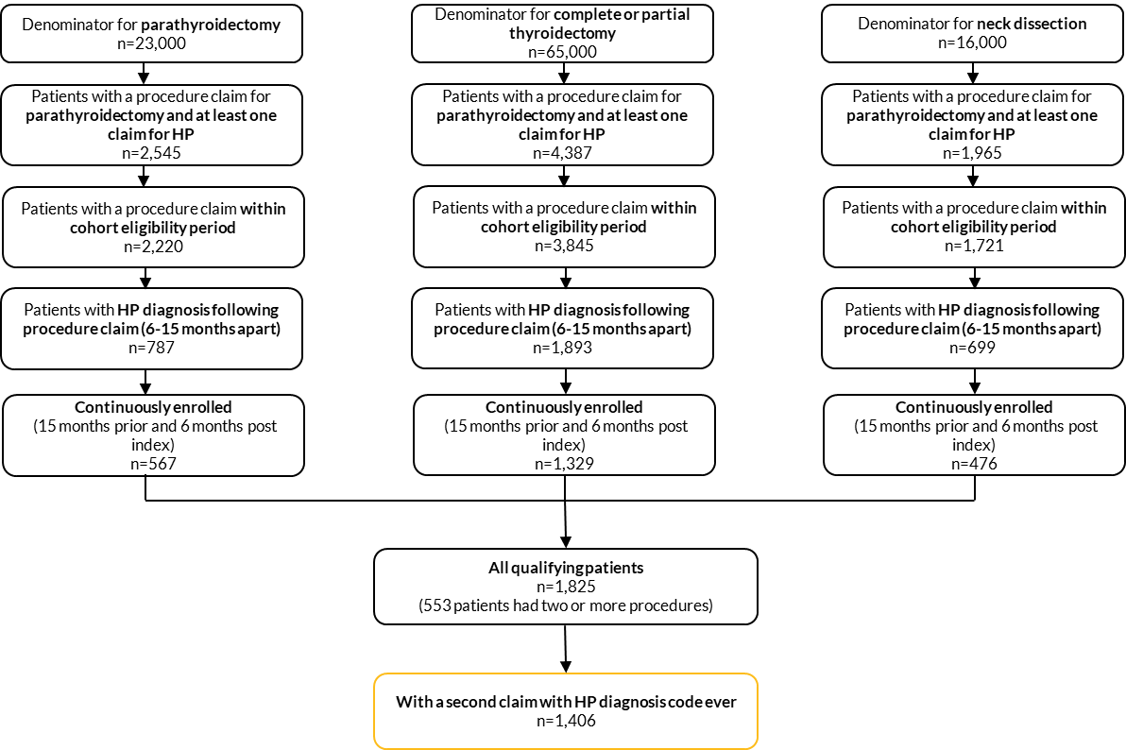
HP: Hypoparathyroidism

Supplementary Figure 3: Patient selection flowchart for Transient HP cohort
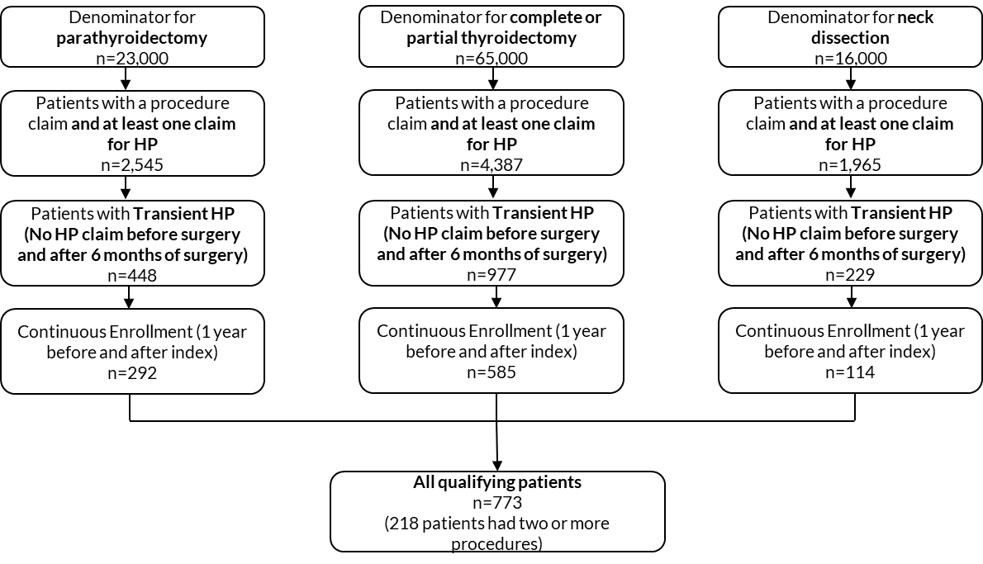
HP: Hypoparathyroidism

Supplementary Table 1: Diagnosis and Procedure Codes for Selection Criteria
Diagnosis/Procedure | ICD 9 | ICD 10 | CPT
Hypoparathyroidism | 252.1 | E20.0, E20.8, E20.9, E89.2 | Not applicable
Parathyroidectomy | 068, 0681, 0689 | 0GTR0ZZ, 0GTR4ZZ, 0G5R0ZZ, 0G5R3ZZ, 0G5R4ZZ, 0GBR0ZZ, 0GBR3ZZ, 0GBR4ZZ | 60500, 60502
Complete or partial Thyroidectomy | 064, 062, 063, 063, 0639, 065, 0650, 0651, 0652 | 0GTG0ZZ, 0GTG4ZZ, 0GTH0ZZ, 0GTH4ZZ, 0G5K0ZZ, 0G5K3ZZ, 0G5K4ZZ, 0GBG0ZZ, 0GBG3ZZ, 0GBG4ZZ, 0GBH0ZZ, 0GBH3ZZ, 0GBH4ZZ, 0GTK0ZZ, 0GTK4ZZ, 0GBJ0ZZ, 0GBJ3ZZ, 0GBJ4ZZ | 60220, 60225, 60240, 60252, 60254, 60270  60271, 60212, 60210
Neck Dissection | 4040, 4041, 4042 | 07T10ZZ, 07T14ZZ, 07T20ZZ, 07T24ZZ | 38724, 38720

