Additional files 1

the Fluorescent PCR-capillary Electrophoresis Results in Related Genes
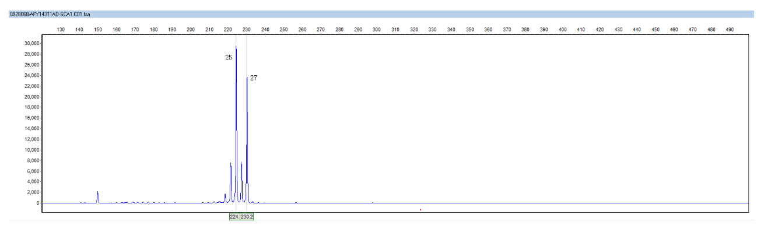
The number of repeats in the three-base repeat region (CAG) n of the two alleles of the ATXN1 gene in the subjects was 25/27.
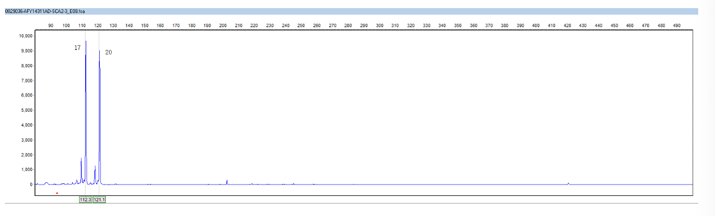
The number of repeats in the three-base repeat region (CAG) n of the two alleles of the ATXN2 gene in the subjects was 17/20.
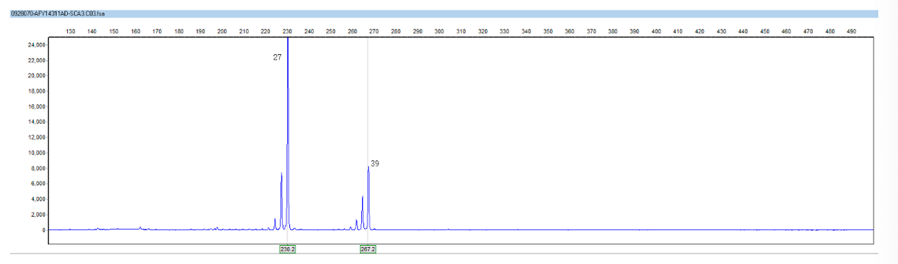
The number of repeats in the three-base repeat region (CAG) n of the two alleles of the ATXN3 gene in the subjects was 27/39.
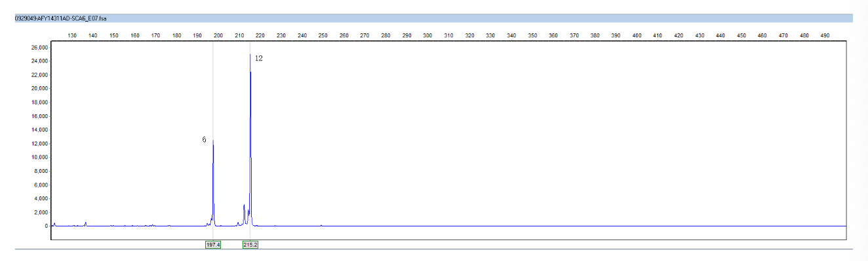
The number of repeats in the three-base repeat region (CAG) n of the two alleles of the CACNA1A gene in the subjects was 6/12.
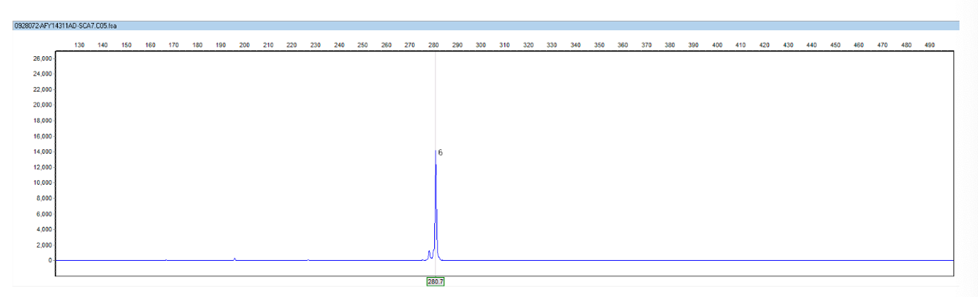
The number of repeats in the three-base repeat region (CAG) n of the two alleles of the ATXN7 gene in the subjects was 6/6.
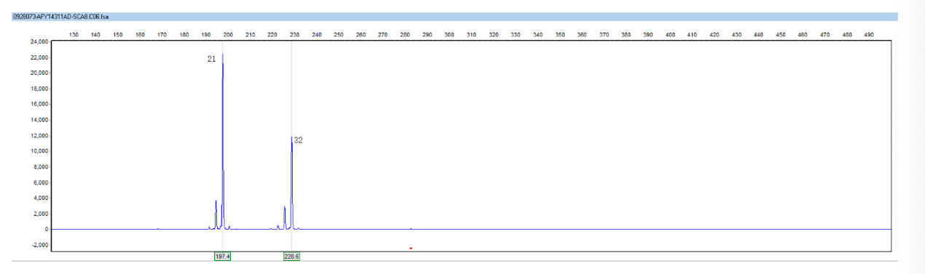
The number of repeats in the three-base repeat region (CAG/TAG) n of the two alleles of the ATXN8OS gene in the subjects was 21/32.
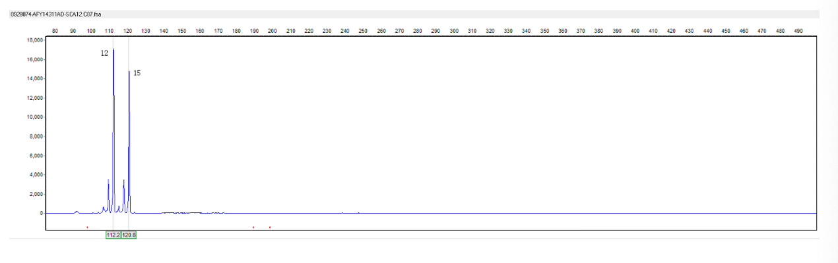
The number of repeats in the three-base repeat region (CAG) n of the two alleles of the PPP2R2B gene in the subjects was 12/15.
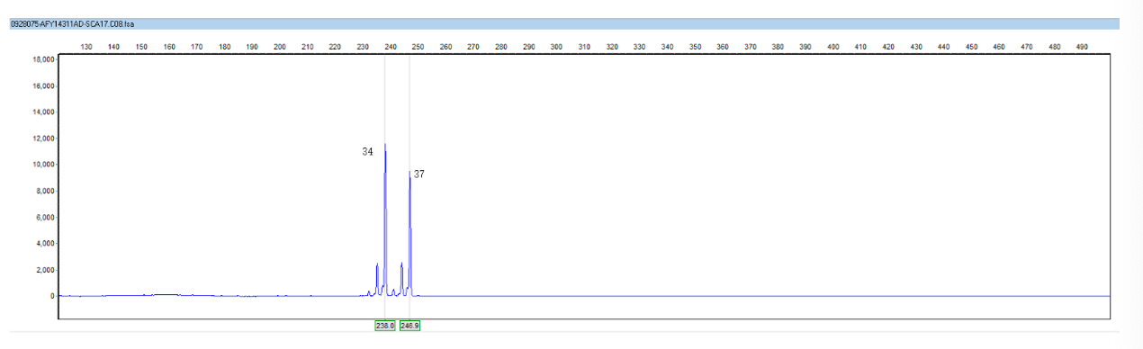
The number of repeats in the three-base repeat region (CAG/CAA) n of the two alleles of the TBP gene in the subjects was 34/37.
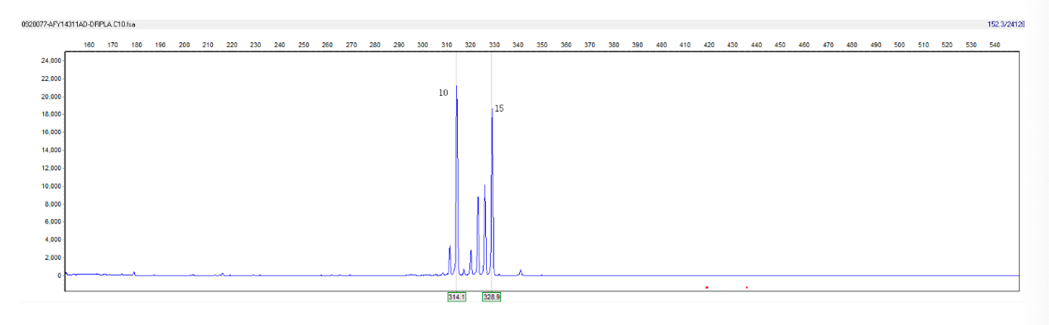
The number of repeats in the three-base repeat region (CAG) n of the two alleles of the ATN1 gene in the subjects was 10/15.
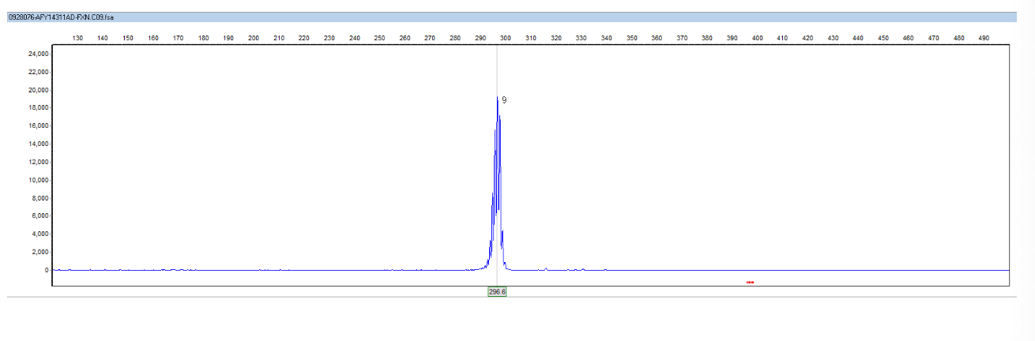
The number of repeats in the three-base repeat region (GAA)n of the two alleles of the FXN gene in the subjects was 9/9.

Summary of ataxia related 10 types of dynamic mutation detection
Disease | Gene | Repetition
SCA1 | ATXN1 | 25/27
SCA2 | ATXN2 | 17/20
SCA3 | ATXN3 | 27/39
SCA6 | CACNA1A | 6/12
SCA7 | ATXN7 | 6/6
SCA8 | ATXN8OS | 21/32
SCA12 | PPP2R2B | 12/15
SCA17 | TBP | 34/37
DRPLA | ATN1 | 10/15
FRDA | FXN | 9/9

