Additional file 1

Supplementary Tables and Figures

Table S1 Key concepts associated with ataxia and their onset in patients living with GD3
Concepts related to ataxia | Onset of symptom (age)
Concepts related to ataxia | Newborns/ infants  (0–1 year) | Toddlers  (1–3 years) | Pre-schoolers  3–5 years) | Children and adults  (≥6 years)
Trouble with walking | + | + | — | —
Extrapyramidal signs | + | + | — | —
Cerebellar symptoms (trouble with balance/wide base gait) | + | + | — | —
Abnormal fine motor skills | — | + | — | —
Retroflexion of the head/spinal alignment | — | + | — | —
Ataxia | + | + | + | —
Increased deep tendon reflexes | + | + | + | —
Swallowing difficulties (dysphagia, choking) | — | + | + | —
Limited gross motor skills | — | + | + | —
Muscle weakness/hypotonia/dystonia | — | + | + | —
Frequent falls | — | — | + | —
Feeding issues (chewing difficulties, poor suck) | — | — | + | —
Dysarthria (trouble with speech) | — | — | + | —
Lack of coordination | — | — | + | +
Note: The “+” sign indicates the symptom when it was first observed and, after onset, these symptoms persisted beyond 6 years of age in patients living with GD3.
GD3: Gaucher disease type 3

Table S2 Key concepts associated with cognitive impairment and their onset in patients living with GD3
Concepts related to cognitive impairment | Onset of symptom (age)
Concepts related to cognitive impairment | Newborns/  infants  (0–1 year) | Toddlers  (1–3 years) | Pre-schoolers  3–5 years) | Children and adults  (≥6 years)
Cognitive regression/impairment | — | + | + | —
Impulsive behavior (agitated/inconsolable) | — | — | + | —
Developmental delay/regression | — | — | + | —
Explosive speech | — | — | — | +
Diminished intelligence | — | — | — | +
Dementia/memory loss/trouble with memory | — | — | — | +
Trouble organizing thoughts | — | — | — | +
Difficulty solving problems/making decisions | — | — | — | +
Slow to process new information | — | — | — | +
Note: The “+” sign indicates the symptom when it was first observed and after onset these symptoms persisted beyond 6 years age in patients living with GD3.
GD3: Gaucher disease type 3

Table S3 Common GD3 systemic signs and symptoms in patients aged ≤5 years
Systemic signs and symptomsª | Highest prevalence (%) | Visual prevalence | Number of sources mentioning the concept
Splenomegaly | 100 | >50% | 5 (a, c–e)
Hepatomegaly | 97 | >50% | 4 (a, c–e)
Thrombocytopenia | 70 | >50% | 2 (a, c)
Anemia | 60 | >50% | 2 (a, c)
Growth retardation | 56 | >50% | 1 (a)
Vertebral body collapse/osteonecrosis | 20 | 20–49% | 1 (c)
Bone pain | 11 | <20% | 2 (a, e)
Bone crisis | 10 | <20% | 2 (a, c)
Enlarged abdomen | N/A | N/A | 6 (d, e)
Umbilical hernia | N/A | N/A | 1 (d)
Excessive sweat | N/A | N/A | 1 (d)
Poor appetite | N/A | N/A | 1 (e)
Vomiting | N/A | N/A | 1 (e)
Concurrent chest infections | N/A | N/A | 2 (c, d)
ªConcepts were aggregated from all sources, which cover articles, patient forums, and qualitative interviews. Prevalence: percentage of patients mentioning a symptom.
Sources: (a) Tylki-Szymańska et al., 2010; (b) Davies et al., 2007; (c) Kraoua et al., 2011; (d) Patient forum; (e) Qualitative interviews.
GD3: Gaucher disease type 3; N/A: not applicable

Table S4 Neuromuscular and neurocognitive signs and symptoms of GD3 in patients aged ≤5 years
Neurological sign or symptom | Highest prevalence of patients mentioning sign/symptom¹ | Age (in months) when signs or symptoms presented² | Number of sources mentioning sign or symptom
Inability to look extreme right or left (horizontal gaze palsy) | 100% | 5–48 | 7 (a–e)
Ataxia | 80% | 5–36 | 3 (b–d)
Head movement rather than eye movement | 63% | 24–48 | 4 (a, d, e)
Head thrusting | 55% | 24 | 1 (a)
Cerebellar symptoms (trouble with balance/wide-based gait) | 53% | 5–36 | 4 (a–d)
Retroflexion of the head/spinal alignment | 53% | 3–20 | 2 (a, b)
Inability to look extreme up or down | 45% | 24 | 1 (a)
Seizures (dystonic, myoclonic seizures) | 44% | 9–17 | 4 (a–d)
Slow object tracking | 43% | 24 | 1 (a)
Swallowing difficulties (dysphagia, choking) | 40% | 3–48 | 6 (a–e)
Dysarthria (trouble/delay with speech) | 33% | 48 | 4 (a, b, e)
Limited gross motor skills | 32% | 17 | 1 (d)
Muscle weakness/dystonia | 25% | 13–17 | 2 (a, c)
Increased deep tendon reflexes | 23% | — | 1 (a)
Extrapyramidal signs | 21% | 3–36 | 2 (a, b)
Trouble with walking | 15% | 13–18 | 3 (a, c, d)
Cognitive regression/impairment | 13% | 5–60 | 3 (b, c, e)
Feeding issues (chewing difficulties, poor suck) | 11% | 17 | 1 (a)
Abnormal finger tapping | 11% | 60 | 1 (a)
Frequent falls | 10% | 16–48 | 3 (c–e)
Developmental milestones delay/regression | 10% | 48 | 1 (c)
Abnormal fine motor skills | 10% | 13 | 1 (a)
Impulsive behavior (agitated/inconsolable) | NR | 24 | 3 (d, e)
Apnea-induced choking | NR | 17 | 5 (a, e)
Decreased blinking | NR | — | 1 (d)
¹Concepts were aggregated from all sources (i.e., articles, blogs/forums, and qualitative interviews). Shown for each sign or symptom is the highest prevalence mentioned from the different sources.
²Age ranges were from all sources that mentioned the sign or symptom.
Sources: (a) Tylki-Szymańska et al., 2010 (cohort size, 131 patients); (b) Davies et al., 2007 (cohort size, 55 patients); (c) Kraoua et al., 2011 (cohort size, 10 patients); (d) Patient forum(s) (cohort size, 1 patient each); (e) Qualitative interviews.
GD3: Gaucher disease type 3; NR: not reported (in any source)

Fig. S1 Conceptual model for onset of GD3 signs and symptoms associated with ataxia*
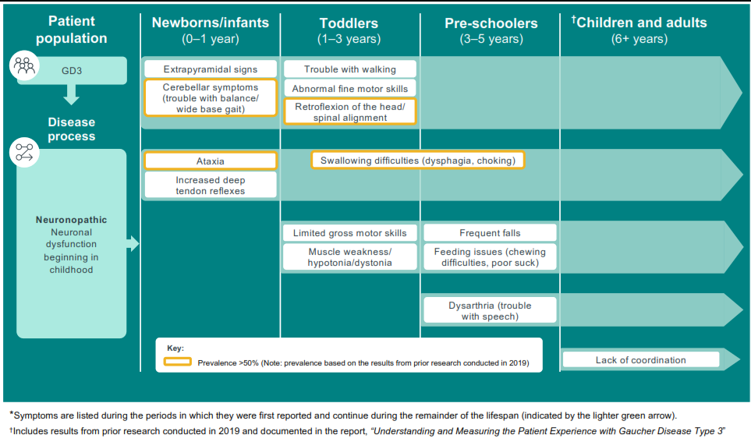
GD3: Gaucher disease type 3

Fig. S2 Conceptual model for onset of GD3 signs and symptoms associated with cognitive impairment*
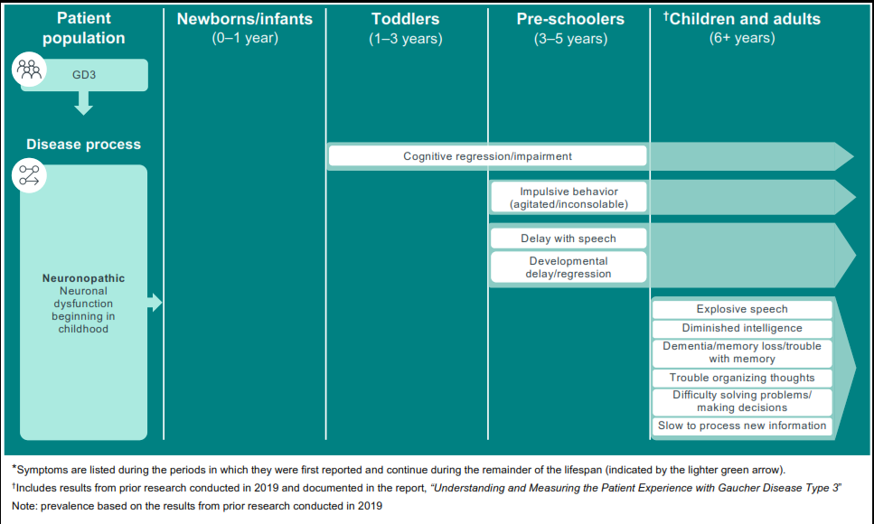
GD3: Gaucher disease type 3

