Additional file 1: Search strategy and study selection in publication databases.
Literature screening was done by two independent reviewers based on the below criteria, for import into the Rayyan software (Doha, Qatar [1]) [1].
Database | Search String and Filters | Results
PubMed | "Epidermolysis bullosa simplex" NOT "dystrohpic" NOT "junctional" NOT "carcinoma"  Filters applied: Abstract, Case Reports, Clinical Study, Clinical Trial, Clinical Trial, Phase I, Clinical Trial, Phase II, Clinical Trial, Phase III, Clinical Trial, Phase IV, Randomized Controlled Trial. Publication time: 2020 – 2024. | 27
PubMed | “Epidermolysis bullosa simplex” AND “treatment”  Filters applied: Case Reports, Clinical Study, Clinical Trial, Clinical Trial, Phase I, Clinical Trial, Phase II, Clinical Trial, Phase III, Clinical Trial, Phase IV, Randomized Controlled Trial. Publication time: 2020 – 2024. | 11
GoogleScholar | treatment "clinical trial" OR "clinical study" OR "case report" OR "case study" "epidermolysis bullosa simplex" -cancer -carcinoma -review | 54

Inclusion criteria:
- Skin-related outcomes.
- Publications: 2020 – 2024.
- Population: mixed populations when including EBS.
Exclusion criteria:
- Systematic review, scoping review, meta-analysis.
- Pre-clinical studies.
- Investigation of dressings.
- Population: Junctional EB, Dystrophic EB, patients with other diseases.
- Studies on incidence and prevalence.
- Qualitative studies.
- Conference abstract.

Screening:
Screening of titles, abstracts and full-text reports was performed by two independent reviewers (V.W., S.D.) using Rayyan (Doha, Qatar, [1]).

PRISM:
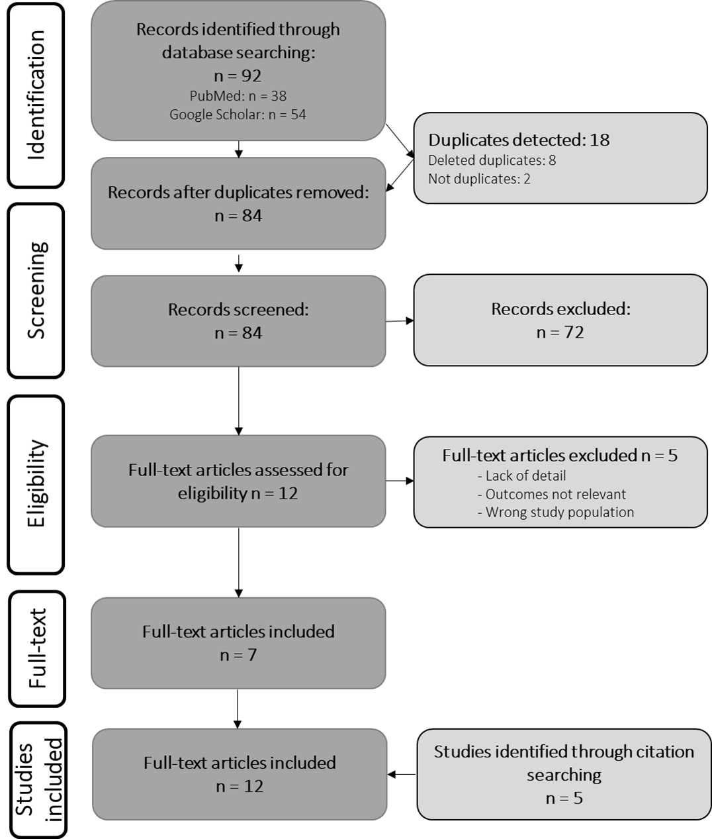

References:
1 Ouzzani M, Hammady H, Fedorowicz Z, Elmagarmid A. Rayyan-a web and mobile app for systematic reviews. Syst Rev 2016; 5: 210.

