Supplementary Table S1: Diagnosis and prognosis of FOP patients
Variables | Total Population  N=67 | Age <8  N=18 | Age 8-15  N=17 | Age≥16  N=32
First Onset Status
Site of First Acute Flare-up, n (%)
Neck | 35 (52.2%) | 12 (66.7%) | 10 (58.8%) | 13 (40.6%)
Back | 18 (26.9%) | 6 (33.3%) | 4 (23.5%) | 8 (25.0%)
Shoulders | 9 (13.4%) | 2 (11.1%) | 4 (23.5%) | 3 (9.4%)
Hips | 7 (10.4%) | 1 (5.6%) | 2 (11.8%) | 4 (12.5%)
Elbows | 3 (4.5%) | 0 (0.0%) | 1 (5.9%) | 2 (6.3%)
Orther Site | 5 (7.5%) | 1 (5.6%) | 0 (0.0%) | 4 (12.5%)
First Acute Flare-up Symptoms, n (%)
Swelling | 58 (86.6%) | 18 (100.0%) | 13 (76.5%) | 27 (84.4%)
Restricted mobility | 19 (28.4%) | 3 (16.7%) | 6 (35.3%) | 10 (31.3%)
Pain | 8 (11.9%) | 1 (5.6%) | 2 (11.8%) | 5 (15.6%)
Fever | 5 (7.5%) | 2 (11.1%) | 0 (0.0%) | 3 (9.4%)
Seeking Immediate Medical Care after first flare-up, n (%) | 57 (85.1%) | 17 (94.4%) | 14 (82.4%) | 26 (81.3%)
Interval to Medical Care After Qnset, days, mean (SD) | 61.5 (445.9) | 1.7 (7.1) | 18.8 (51.8) | 117.8 (644.6)
95% Confidence interval | [-47.2,170.2] | [-1.8,5.2] | [-7.8,45.5] | [-114.6,350.2]
Receiving Off-Site Medical Care, n (%) | 59 (88.1%) | 17 (94.4%) | 14 (82.4%) | 28 (87.5%)
Diagnosis status of FOP patients
First visit department
Pediatrics | 21 (31.3%) | 8 (44.4%) | 7 (41.2%) | 6 (18.8%)
Orthopedics | 19 (28.4%) | 2 (11.1%) | 4 (23.5%) | 13 (40.6%)
Surgey | 8 (11.9%) | 3 (16.7%) | 2 (11.8%) | 3 (9.4%)
Immunology | 6 (9.0%) | 1 (5.6%) | 2 (11.8%) | 3 (9.4%)
Endocrinology | 6 (9.0%) | 1 (5.6%) | 2 (11.8%) | 3 (9.4%)
Other | 8 (11.9%) | 3 (16.7%) | 2 (11.8%) | 3 (9.4%)
First diagnosis department
Endocrinology | 20 (29.9%) | 2 (11.1%) | 6 (35.3%) | 12 (37.5%)
Orthopedics | 13 (19.4%) | 2 (11.1%) | 3 (17.6%) | 8 (25.0%)
Immunology | 12 (17.9%) | 5 (27.8%) | 3 (17.6%) | 4 (12.5%)
Pediatrics | 8 (11.9%) | 3 (16.7%) | 2 (11.8%) | 3 (9.4%)
Rare disease center | 6 (9.0%) | 3 (16.7%) | 1 (5.9%) | 2 (6.3%)
Other | 8 (11.9%) | 3 (16.7%) | 2 (11.8%) | 3 (9.4%)
Patients Diagnosed at Initial Visit Hospital, n (%) | 16 (23.9%) | 2 (11.1%) | 5 (29.4%) | 9 (28.1%)

Supplementary Table S1: Diagnosis and prognosis of FOP patients (continued)
Variables | Total Population  N=67 | Age <8  N=18 | Age 8-15  N=17 | Age≥16  N=32
Location of Heterotopic Ossification, n (%) | 65 (97.0%) | 18 (100.0%) | 16 (94.1%) | 31(96.9%)
Back | 54 (80.6%) | 15 (83.3%) | 15 (88.2%) | 24 (75.0%)
Neck | 51 (76.1%) | 15 (83.3%) | 12 (70.6%) | 24 (75.0%)
Shoulder | 46 (68.7%) | 11 (61.1%) | 15 (88.2%) | 20 (62.5%)
Elbow | 36 (53.7%) | 5 (27.8%) | 9 (52.9%) | 22 (68.8%)
Jaw | 29 (43.3%) | 3 (16.7%) | 9 (52.9%) | 17 (53.1%)
Chest | 28 (41.8%) | 8 (44.4%) | 9 (52.9%) | 11 (34.4%)
Knee | 25 (37.3%) | 3 (16.7%) | 6 (35.3%) | 16 (50.0%)
Hip | 24 (35.8%) | 3 (16.7%) | 8 (47.1%) | 13 (40.6%)
Abdomen | 22 (32.8%) | 8 (44.4%) | 3 (17.6%) | 11 (34.4%)
Wrist | 18 (26.9%) | 3 (16.7%) | 6 (35.3%) | 9 (28.1%)
Ankle | 14 (20.9%) | 1 (5.6%) | 4 (23.5%) | 9 (28.1%)
Other² | 15 (22.4%) | 5 (27.8%) | 1 (5.9%) | 9 (28.1%)
Complications, n (%) | 62 (92.5%) | 14 (77.8%) | 17 (100%) | 31 (96.6%)
Spinal Deformities | 54 (80.6%) | 11 (61.1%) | 15 (88.2%) | 28 (87.5%)
Temporomandibular Joint Stiffness | 31 (46.3%) | 3 (16.7%) | 9 (52.9%) | 19 (59.4%)
Hearing Impairment | 27 (40.3%) | 2 (11.1%) | 8 (47.1%) | 17 (53.1%)
Thoracic Insufficiency Syndrome | 11 (16.4%) | 1 (5.6%) | 4 (23.5%) | 6 (18.8%)
Pressure Ulcer | 8 (11.9%) | 0 (0.0%) | 1 (5.9%) | 7 (21.9%)
Pneumonia | 7 (10.4%) | 3 (16.7%) | 1 (5.9%) | 3 (9.4%)
Other³ | 3 (4.5%) | 2 (11.1%) | 0 (0.0%) | 1 (3.1%)
Disability Level
Disability Certificate Level, n (%)
Level 1 | 11 (16.4%) | 0 (0.0%) | 1 (5.9%) | 10 (31.3%)
Level 2 | 23 (34.3%) | 2 (11.1%) | 6 (35.3%) | 15 (46.9%)
Level 3 | 7 (10.4%) | 1 (5.6%) | 3 (17.6%) | 3 (9.4%)
Level 4 | 2 (3.0%) | 1 (5.6%) | 1 (5.9%) | 0 (0.0%)
Using Assistive Devices Patients, n (%) | 30 (44.8%) | 6 (33.3%) | 7 (41.2%) | 17 (53.1%)
Walker (such as crutches, etc.) | 12 (17.9%) | 0 (0.0%) | 1 (5.9%) | 11 (34.4%)
Wheelchair | 10 (14.9%) | 2 (11.1%) | 4 (23.5%) | 4 (12.5%)
Hearing Aid | 4 (6.0%) | 0 (0.0%) | 1 (5.9%) | 3 (9.4%)
Breathing Trainer | 1 (1.5%) | 1 (5.6%) | 0 (0.0%) | 0 (0.0%)
Oxygen Concentrator | 1 (1.5%) | 0 (0.0%) | 1 (5.9%) | 2 (6.3%)
Home or Vehicle Modifications | 2 (3.0%) | 0 (0.0%) | 0 (0.0%) | 2 (6.3%)
Orther² | 6 (9.0%) | 3 (16.7%) | 2 (11.8%) | 1 (3.1%)

Supplementary Table S2: Healthcare resource utilization and costs of FOP patients
Variables | Total Population  N=67 | Age <8  N=18 | Age 8-15  N=17 | Age≥16  N=32
Healthcare resource utilization over the last year
Patients without hospitalization and outpatient visits, n (%) | 41 (61.2%) | 9 (50.0%) | 9 (52.9%) | 23 (71.9%)
Hospitalized Patients, n (%) | 10 (14.9%) | 4 (22.2%) | 3 (17.6%) | 3 (9.4%)
Number of hospitalizations among hospitalized patients, mean (SD) | 1.8 (1.6) | 2.3 (2.5) | 2.0 (1.0) | 1.0 (0.0)
95% Confidence interval | (0.6,3.0) | (-1.7,6.2) | (-0.48,4.5) | (1,1)
Median (range) | 1.0 (1,6) | 1.0 (1,6) | 2.0 (1,3) | 1.0 (1,1)
Patients with Outpatient Visits, n (%) | 23 (34.3%) | 8 (44.4%) | 7 (41.2%) | 8 (25.0%)
Number of Outpatient Visits, mean (SD) | 2.6 (1.9) | 3.1 (2.2) | 2.7 (2.1) | 2.0 (1.4)
95% Confidence interval | (1.8,3.4) | (1.3,4.9) | (0.8,4.6) | (0.8,3.2)
Median (range) | 2.0 (1,7) | 3.0 (1,6) | 2.0 (1,7) | 1.5 (1,5)
Total Annual Costs, $,mean (SD) | 10820(10894) | 14141(15071) | 8559(8970) | 10154(8771)
95% Confidence interval | (8163,13478) | (6646,21636) | (3947,13171) | (6992,13316)
Median (range) | 12621 (0,50756) | 12840 (56,50756) | 3811 (0,25689) | 12621 (0,27492)
Direct Medical Costs, $,mean (SD) | 355 (791) | 376 (595) | 723 (1308) | 147 (370)
95% Confidence interval | (162,548) | (80,672) | (51,1396) | (14,281)
Median (range) | 300 (0,3967) | 42 (0,2090) | 0 (0,3967) | 0 (0,1624)
Hospitalisation, mean (SD) | 223 (704) | 200 (421) | 557 (1266) | 57 (200)
95% Confidence interval | (51,394) | (-9,410) | (-93,1208) | (-15,130)
Median (range) | 0 (0,3967) | 0 (0,1412) | 0 (0,3967) | 0 (0,993)
Outpatient, mean (SD) | 132 (315) | 176 (273) | 166 (390) | 90 (297)
95% Confidence interval | (55,209) | (40,312) | (-34,366) | (-17,197)

Supplementary Table S2: Healthcare resource utilization and costs of FOP patients (continued)
Variables | Total Population  N=67 | Age <8  N=18 | Age 8-15  N=17 | Age≥16  N=32
Median (range) | 0 (0,1624) | 0 (0,862) | 0 (0,1483) | 0 (0,1624)
Direct Non-Medical Costs, $,mean (SD) | 2332 (7374) | 6356 (13512) | 1030 (1324) | 760 (1366)
95% Confidence interval | (533,4131) | (-364,13075) | (349,1711) | (268,1252)
Median (range) | 282 (0,42373) | 685 (0,42373) | 446 (0,4668) | 174 (0,5791)
Transports, mean (SD) | 197 (308) | 370 (400) | 180 (290) | 109 (213)
95% Confidence interval | (122,272) | (170,569) | (31,329) | (32,186)
Median (range) | 25 (0,1412) | 353 (0,1412) | 25 (0,1130) | 0 (0,706)
Accommodation, mean (SD) | 218 (474) | 445 (773) | 182 (345) | 110 (217)
95% Confidence interval | (103,334) | (60,830) | (5,359) | (32,188)
Median (range) | 14 (0,2825) | 177 (0,2825) | 14 (0,1412) | 0 (0,706)
Nursing, mean (SD) | 1442 (6611) | 5148 (12221) | 133 (548) | 53 (300)
95% Confidence interval | (-171,3054) | (-930,11225) | (-149,415) | (-55,161)
Median (range) | 0 (0,40678) | 0 (0,40678) | 0 (0,2260) | 0 (0,1695)
Nutrition, mean (SD) | 306 (953) | 367 (1323) | 322 (725) | 263 (836)
95% Confidence interval | (73,538) | (-291,1025) | (-50,695) | (-39,564)
Median (range) | 0 (0,5650) | 0 (0,5650) | 0 (0,2373) | 0 (0,4520)
Assistive Device, mean (SD) | 168 (429) | 27(68) | 212(495) | 225(497)
95% Confidence interval | (64,273) | (-7,60) | (-42,467) | (46,404)
Median (range) | 0 (0,2119) | 0 (0,282) | 0 (0,1603) | 0 (0,2119)
Indiect Costs, $,mean (SD) | 8134(7978) | 7409(6406) | 6806(8367) | 9247(8622)
95% Confidence interval | (6188,10080) | (4224,10595) | (2504,11107) | (6138,12355)

Supplementary Table S2: Healthcare resource utilization and costs of FOP patients (continued)
Variables | Total Population  N=67 | Age <8  N=18 | Age 8-15  N=17 | Age≥16  N=32
Median (range) | 12621 (0, 26645) | 12621 (0,14023) | 1402 (0,25242) | 12621 (0, 26645)
Patients’ indirect costs, mean (SD) | 2451(5028) | 0 (0) | 0 (0) | 5132(6294)
95% Confidence interval | (1225,3677) | (0,0) | (0,0) | (2862,7401)
Median (range) | 0 (0,12621) | 0 (0,0) | 0 (0,0) | 0 (0,12621)
Unemployment costs, mean (SD) | 2449(5029) | 0 (0) | 0 (0) | 5127(6298)
95% Confidence interval | (1222,3675) | (0,0) | (0,0) | (2857,7398)
Median (range) | 0 (0,12621) | (0,0) | (0,0) | 0 (0,12621)
Absenteeism costs, mean (SD) | 2(17) | 0 (0) | 0 (0) | 4(25)
95% Confidence interval | (-2,6) | (0,0) | (0,0) | (-5,13)
Median (range) | 0 (0,140) | 0 (0,0) | 0 (0,0) | 0 (0,140)
Caregivers’ costs, mean (SD) | 5683(6814) | 7409(6406) | 6806(8367) | 4115(5937)
95% Confidence interval | (4021,7345) | (4224,10595) | (2504,11107) | (1974,6256)
Median (range) | 982 (0,25242) | 12621 (0,14023) | 1402 (0,25242) | 0 (0,14023)
Unemployment Costs, mean (SD) | 5275(6646) | 7012(6453) | 5939(7879) | 3944(5944)
95% Confidence interval | (3654,6896) | (3803,10221) | (1888,9990) | (1801,6087)
Median (range) | 0 (0,25242) | 12621 (0,12621) | 0 (0,25242) | 0 (0,12621)
Absenteeism Costs, mean (SD) | 408(792) | 397(540) | 866(1266) | 171(418)
95% Confidence interval | (215,601) | (129,666) | (215,1517) | (20,322)
Median (range) | 0 (0,4207) | 0 (0,1402) | 0 (0,4207) | 0 (0,1402)

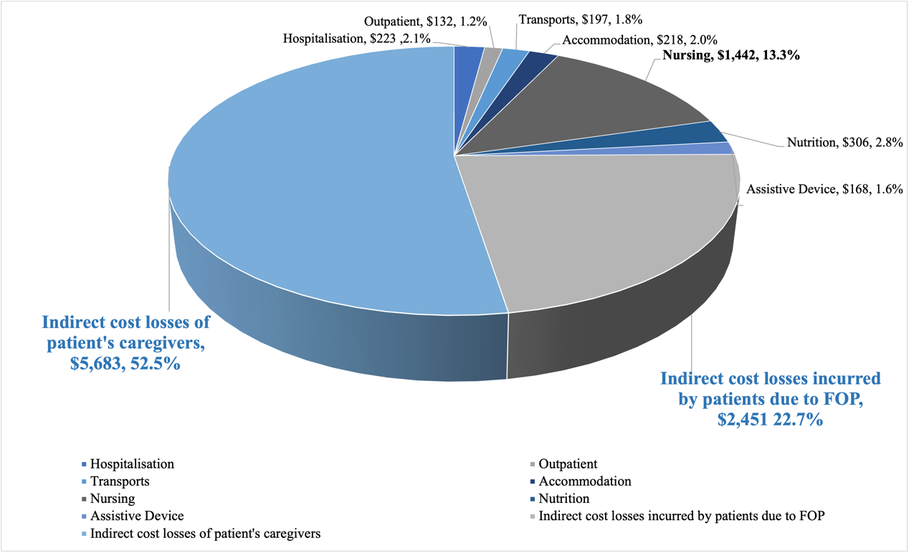

Supplementary Figure S1: Annual cost structure of the FOP total population
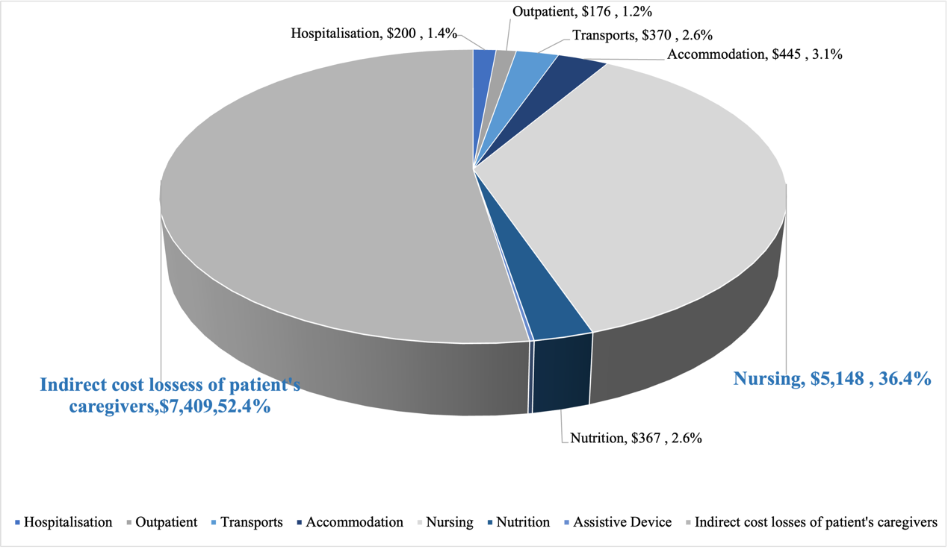

Supplementary Figure S2: Annual cost structure of the < 8-year-old FOP population
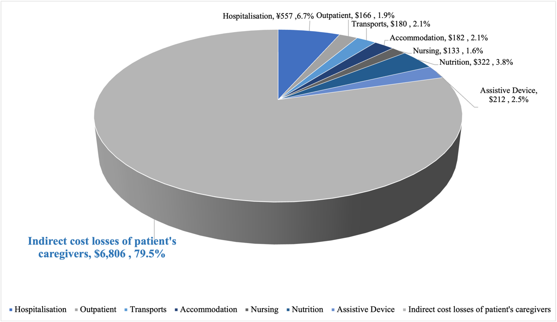

Supplementary Figure S3: Annual cost structure of the 8–15-year-old FOP population
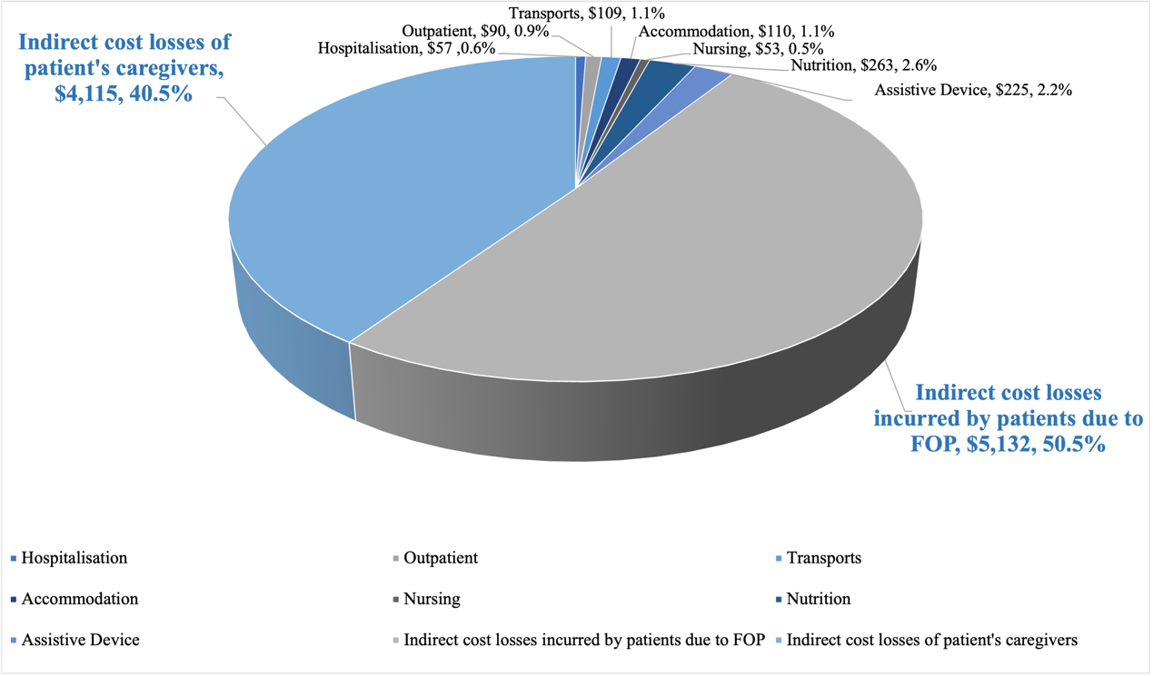

Supplementary Figure S4: Annual cost structure of the ≥ 16-year-old FOP population

