Supplementary Information

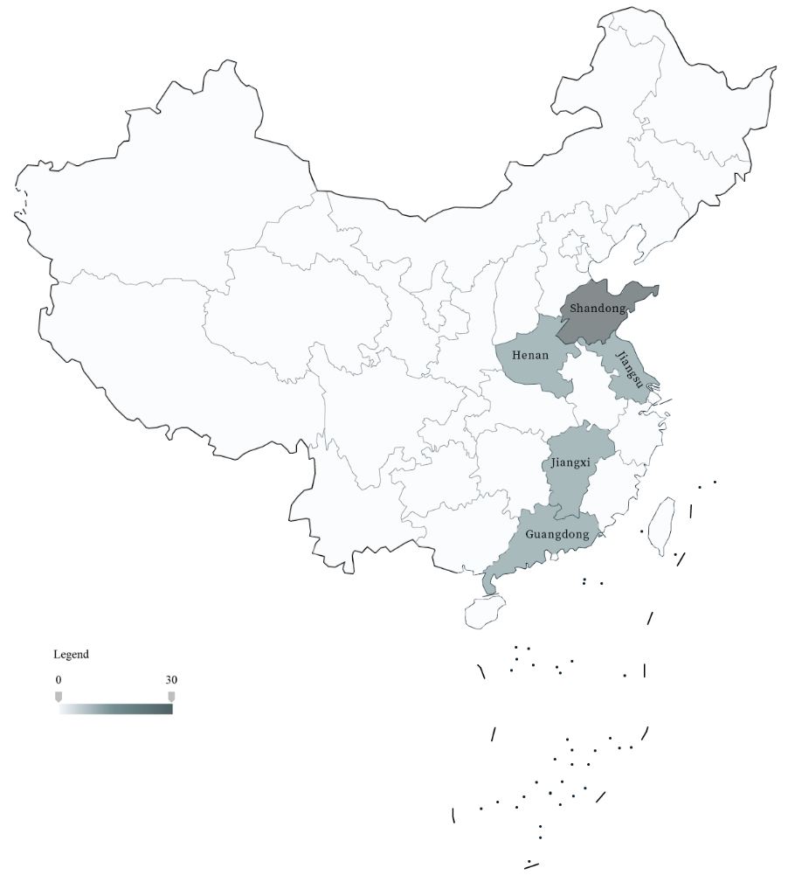
Figure S1 Map of the distribution of surveyed patientsꭝ
ꭝThe map was sourced from the China Standard Map Service website (http://bzdt.ch.mnr.gov.cn/index.html)

Table S1 Instruments used by different age groups
 | EQ-5D |  | SF-6D ¹
 | ED-5D-5L ² | ED-5D-Y ³ | SF-6D ¹
Domains | 5  (mobility, self-care, usual activities, pain/discomfort and anxiety/depression) | 5  (walking about, looking after myself, doing usual activities, having pain/discomfort, and feeling worried/ sad/ unhappy) | 6  (physical functioning, role limitation, social functioning, bodily pain, mental health and vitality)
Levels | 5  (no problems, slight problems, moderate problems, severe problems and extreme problems) | 3  (no problems, some problems, and a lot of problems) | 5/6  (none of the time, a little of the time, some of the time, most of the time, all of the time)
Valuation technique | TTO | TTO | TTO
Possible health states | 3125 | 243 | 18750
Value set | Chinese value set ⁴ | Chinese value set ⁵ | Chinese value set ⁶
Boundaries | -0.391 to 1 | -0.088 to 0.924 | -0.277 to 1
Target patient group | Adult group | Children group | Adult group
TTO: time trade-off

Table S2 Cost components
Outcome | Measured element | Description and definition
Medicines costs | Prothrombin complex concentrates | Costs associated with medications for haemophilia prophylaxis or on-demand treatment.
 | Plasma-derived factor VIII
 | Recombinant FVIIa
 | Recombinant FVIII
 | Non-factor products
Direct medical costs | Medicines | Ibid
 | Consultant visits | Costs associated with consultations at medical institutions resulting from haemophilia and its related complications.
 | Hospitalisations | Hospitalization costs resulting from haemophilia and its associated complications.
 | Tests and examinations | The costs associated with diagnostic tests for haemophilia and its complications, including blood tests, joint ultrasound examinations and other tests.
Out-of-pocket direct medical cost✝ | Individuals pay directly from their own finances for direct medical costs, without reimbursement from insurance or other third-party payers.
Non-medical costs | Assistive devices and home alterations | For the purchase of assistive devices or the costs associated with home modifications, such as walking aids and home adjustments.
 | Professional care | Costs associated with professional care resulting from haemophilia and its complications.
 | Travelling and accommodation expenses | Travel and accommodation costs incurred for consultant visits, medication purchases, and hospitalizations.
Indirect costs | Work productivity impact | Costs associated with absenteeism and early retirement resulting from haemophilia and its complications.
 | Caregiver burden | Costs associated with caregiver absenteeism and early retirements resulting from the care of haemophilia patients.
Note: All data are derived from real-world patient/caregiver reports, and to ensure the authenticity of the information, patients provide invoices, receipts, or payment documentation with their personal information anonymized.
✝Direct medical costs, including medication expenses, constitute the primary cost category, and are the main source of patients' out-of-pocket expenses. Based on previous studies, we use the term 'out-of-pocket direct medical cost⁷.

Table S3 Comparison of major clinical and humanistic outcomes in inhibitor and non-inhibitor patients
 |  | Children (N=22) |  |  | Adults (N=38)
Main outcome |  | Inhibitors  (N= 12) | Without inhibitors(N=10) |  | Inhibitors  (N=13) | Without inhibitors (N=25)
ABR, mean (SD) |  | 21.21 (12.69) | 7.47 (5.00) |  | 32.17(47.57) | 38.58(38.25)
ABR, Median (Range) |  | 20.20 (4.04-46.46) | 7.58 (1.01- 15.15) |  | 10.10(3.03-151.52) | 23.23 (3.03-121.21)
Number of bleeds per year, N (%)
<5 |  | 1 (8.33) | 3 (30.00) |  | 2 (15.38) | 1(4.00)
5-20 |  | 6 (50.00) | 7 (70.00) |  | 6 (46.15) | 10 (40.00)
21-50 |  | 5 (41.67) | 0 (0.00) |  | 3 (23.08) | 7 (28.00)
>51 |  | 0 (0.00) | 0 (0.00) |  | 2 (15.38) | 7 (28.00)
History of joint surgery, N (%) |  | 0 (0.00) | 1 (10.00) |  | 3 (23.08) | 12 (48.00)
Bleeding-related outpatient visit, mean (SD) |  | 19.25 (18.33) | 26.00 (50.79) |  | 9.77 (13.80) | 15.04 (22.22)
Bleed-related hospitalisations, mean (SD) |  | 2.75(4.25) | 0.4 (1.26) |  | 1.38 (1.12) | 1.16 (2.72)
Bleed-related hospital days per patient, mean (SD) |  | 16.00 (23.82) | 1.2 (3.79) |  | 8.69 (7.52) | 11.52 (19.63)
EQ-5D utility value, mean (SD) |  | 0.66 (0.29) | 0.87 (0.08) |  | 0.41 (0.35) | 0.56 (0.33)
SF-6D utility value, mean (SD) |  | - | - |  | 0.23 (0.27) | 0.45 (0.26)
"-" indicates not applicable

N=70
30 from Shandong, 10 each from Jiangsu, Henan, Guangdong and Jiangxi
N=61
Questionnaire too long (N=4);
Concerns about child's privacy being revealed (N=3);
No clear memory of details of spending (N=2)
Missing data in the questionnaires (N=1)
N=60
Figure S2 Flow diagram on enrolment procedures for haemophilia A patients

Figure S3 Target joints most affected by patient reports

Reference
1. Wu J, Xie S, He X, et al. The Simplified Chinese version of SF-6Dv2: translation, cross-cultural adaptation and preliminary psychometric testing.Qual Life Res. 2020;29(5):1385-91.
2. Devlin NJ, Brooks R. EQ-5D and the EuroQol Group: Past, Present and Future.Appl Health Econ Health Policy. 2017;15(2):127-37.
3. Golicki D, Młyńczak K. Measurement Properties of the EQ-5D-Y: A Systematic Review.Value Health. June 2022;S1098-3015(22)02001-0.
4. Yang Z, Busschbach J, Liu G, et al. EQ-5D-5L norms for the urban Chinese population in China.Health Qual Life Outcomes. 2018;16(1):210.
5. Yang Z, Jiang J, Wang P, et al. Estimating an EQ-5D-Y-3L Value Set for China.Pharmacoeconomics. 2022;40(Suppl 2):147-55.
6. Wu J, Xie S, He X, et al. Valuation of SF-6Dv2 Health States in China Using Time Trade-off and Discrete-Choice Experiment with a Duration Dimension.Pharmacoeconomics. 2021;39(5):521-35.
7. Li Z, Wu J, Zhao Y, et al. Influence of medical insurance schemes and charity assistance projects on regular prophylaxis treatment of the boys with severe haemophilia A in China.Haemophilia. 2018;24(1):126-33.

