Additional File 1. Estimated mean values at age 18 years in children who initiated imiglucerase treatment at age 2 years. Values for organ volume and BMI are extrapolated. Shaded areas represent long-term therapeutic goal thresholds for treated patients.^{1,2} MN: multiples of normal.
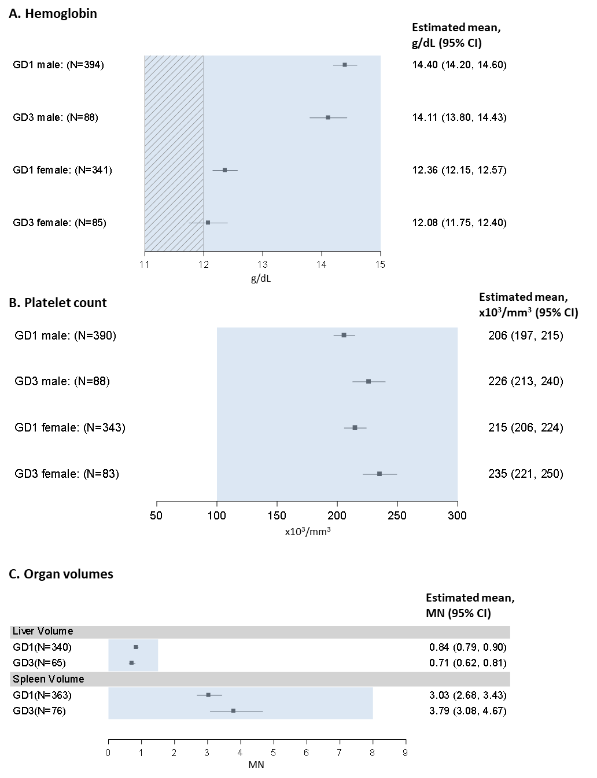
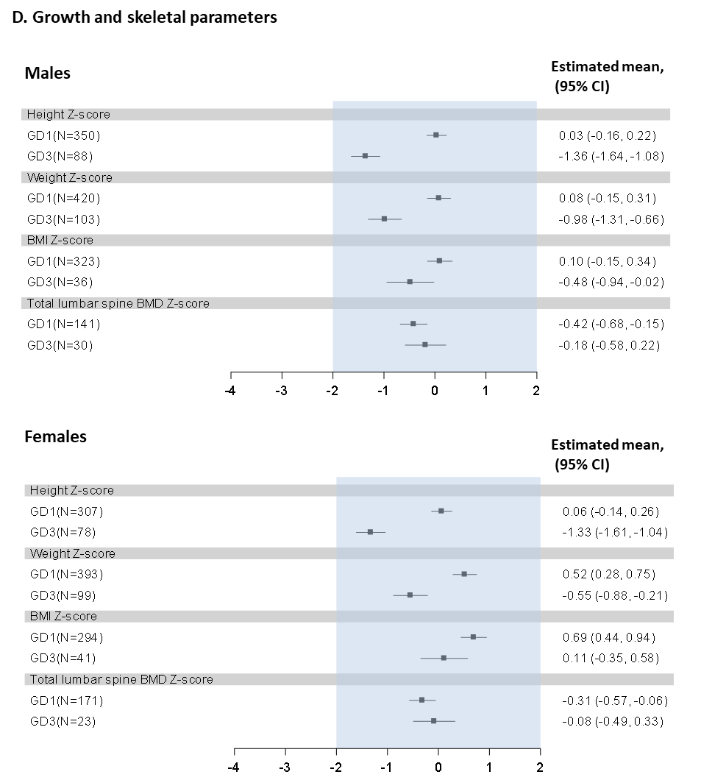

References:

- Biegstraaten M, Cox TM, Belmatoug N, et al. Management goals for type 1 Gaucher disease: An expert consensus document from the European working group on Gaucher disease. Blood Cells Mol Dis. Feb 2018;68:203-208. doi:10.1016/j.bcmd.2016.10.008
- Pastores GM, Weinreb NJ, Aerts H, et al. Therapeutic goals in the treatment of Gaucher disease. Semin Hematol. 2004;41(4 suppl 5):4-14. doi:S0037196304001325

