Table S1 Clinical Characteristics of 21 VEXAS Patients
 | Duration | Sex | Previous diagnosis | Previous main treatment | Initial symptoms | Age at onset | Age | Fever | Rash | Chondritis | Lung involvement | Ophthalmitis | Arthritis | Cardiac involvement | PNS involvement | CNS involvement | Kidney involvement | Venous thrombosis
Case1 | 6 | M | Suspected lymphoma | Antibiotics | Rash | 58 | 59 | 1 | 1 | 0 | 1 | 0 | 0 | 0 | 1 | 0 | 1 | 0
Case2 | 18 | M | Thrombophilia | Anticoagulation, antibiotics | Rash | 55 | 56 | 1 | 1 | 1 | 1 | 1 | 0 | 0 | 1 | 0 | 0 | 1
Case3 | 16 | M | UA | GC, MTX | Arthritis | 55 | 57 | 1 | 1 | 1 | 1 | 1 | 1 | 0 | 0 | 1 | 0 | 0
Case4 | 60 | M | RP | GC, MTX, cyclosporine | Rash | 60. | 66 | 1 | 1 | 1 | 1 | 1 | 1 | 0 | 0 | 0 | 0 | 1
Case5 | 25 | M | RP | Antibiotics, GC, CsA, Tac | Fever | 27 | 30 | 1 | 1 | 1 | 1 | 1 | 1 | 0 | 0 | 0 | 0 | 0
Case6 | 2 | M | None | Antibiotics,GC | Fever，rash | 49 | 49 | 1 | 1 | 0 | 0 | 0 | 0 | 0 | 0 | 0 | 0 | 0
Case7 | 24 | M | None | NA | Leukopenia | 43 | 44 | 0 | 0 | 0 | 1 | 0 | 0 | 0 | 0 | 0 | 0 | 0
Case8 | 8 | M | EN | GC, Thal | Rash | 62 | 63 | 1 | 1 | 1 | 1 | 1 | 1 | 0 | 0 | 0 | 0 | 0
Case9 | 36 | M | CCUS,EN | GC,TWHF, CTX | Rash | 55 | 58 | 1 | 1 | 0 | 1 | 1 | 1 | 0 | 0 | 0 | 0 | 0
Case10 | 7 | M | Suspected lymphoma | Antibiotics, GC | Fatigue | 61 | 62 | 1 | 1 | 0 | 1 | 0 | 1 | 0 | 0 | 0 | 1 | 0
Case11 | 5 | M | RP | GC | Fever | 60 | 62 | 1 | 1 | 1 | 1 | 0 | 1 | 0 | 0 | 0 | 1 | 0
Case12 | 24 | M | Vasculitis,HLH | GC, IS | Fever | 57 | 59 | 1 | 1 | 1 | 0 | 0 | 1 | 0 | 0 | 0 | 0 | 1
Case13 | 12 | M | HLH | GC, MTX | Rash | 49 | 50 | 1 | 1 | 1 | 0 | 0 | 0 | 0 | 0 | 0 | 0 | 0
Case14 | 12 | M | None | None | Fever | 71 | 71 | 1 | 1 | 1 | 1 | 1 | 0 | 0 | 0 | 0 | 0 | 0
Case15 | 23 | M | HLH / TTP | GC | Rash | 64 | 68 | 1 | 1 | 1 | 1 | 0 | 0 | 0 | 1 | 1 | 1 | 0
Case16 | 48 | M | None | None | Rash | 68 | 72 | 1 | 1 | 0 | 1 | 0 | 0 | 0 | 0 | 0 | 0 | 1
Case17 | 2 | M | Vasculitis,panniculitis | NA | Rash | 58 | 59 | 0 | 1 | 1 | 1 | 0 | 0 | 0 | 0 | 0 | 0 | 0
Case18 | 120 | M | RP | GC, LEF, MMF | Rash | 59 | 69 | 0 | 1 | 1 | 0 | 1 | 1 | 0 | 0 | 0 | 0 | 1
Case19 | 24 | M | Urticarial vasculitis | GC, TWHF, HCQ | Rash | 69 | 71 | 0 | 1 | 1 | 0 | 0 | 0 | 1 | 0 | 0 | 0 | 0
Case20 | 72 | M | Vasculitis | GC, CTX, MMF | Rash | 56 | 61 | 1 | 1 | 0 | 1 | 0 | 0 | 0 | 0 | 0 | 1 | 0
Case21 | 48 | M | Panniculitis | GC,MTX, JAK | Fever | 57 | 61 | 1 | 1 | 0 | 0 | 0 | 0 | 0 | 0 | 0 | 0 | 0
Abbreviations: UA, Undifferentiated Arthritis; RP, Relapsing Polychondritis; EN, Erythema Nodosum; CCUS, Clonal Cytopenia of Undetermined Significance; HLH, Hemophagocytic Lymphohistiocytosis; TTP, Thrombotic Thrombocytopenic Purpura; GC, Glucocorticoids; MTX, Methotrexate; CsA, Cyclosporine A; Tac, Tacrolimus; Thal, Thalidomide; TWHF, Tripterygium wilfordii Hook F; CTX, Cyclophosphamide; IS, Immunosuppressants; LEF, Leflunomide; MMF, Mycophenolate Mofetil; HCQ, Hydroxychloroquine; JAK, Janus Kinase inhibitor; PNS, Peripheral Nervous System; CNS, Central Nervous System.

Table S2 Laboratory Parameters of 21 VEXAS Patients
 | Macrocytic Anemia | Neutropenia | Thrombocytopenia | ESR max(mm/h) | CRP max  (mg/L) | ANA  positive | APS positive | ANCA positive | M protein | MGUS | Pathological hematopoiesis | MDS | Vacuoles
Case1 | 1 | 1 | 1 | 140 | 126 | 0 | 1 | 0 | 0 | 0 | 1 | 0 | 1
Case2 | 1 | 1 | 0 | 91 | 48 | 0 | 0 | 0 | 1 | 1 | 1 | 0 | 1
Case3 | 1 | 1 | 1 | 110 | 68 | 0 | 0 | 0 | 0 | 0 | 0 | 0 | 1
Case4 | 1 | 0 | 0 | 99 | 96 | 0 | 0 | 0 | 0 | 0 | 0 | 0 | 1
Case5 | 1 | 1 | 0 | 105 | 105 | 0 | 0 | 0 | 0 | 0 | 1 | 1 | 1
Case6 | 1 | 1 | 0 | 99 | 96 | 0 | 0 | 0 | 0 | 0 | 1 | 0 | 1
Case7 | 1 | 1 | 0 | 40 | 92 | 0 | 0 | 0 | 0 | 0 | 0 | 0 | 0
Case8 | 1 | 0 | 0 | 101 | 77.6 | 0 | 0 | 1 | 1 | 1 | 0 | 0 | 1
Case9 | 1 | 0 | 0 | 102 | 157.24 | 0 | 1 | 0 | 0 | 0 | 1 | 0 | 1
Case10 | 1 | 1 | 0 | 107 | 75.91 | 1 | 1 | 1 | 0 | 0 | 0 | 0 | 1
Case11 | 1 | 0 | 0 | 188 | 88 | 1 | 0 | 0 | 0 | 0 | 0 | 0 | 1
Case12 | 1 | 1 | 1 | 140 | 190 | 0 | 0 | 0 | 0 | 0 | 0 | 0 | NA
Case13 | 1 | 0 | 1 | 88 | 91 | 0 | 0 | 0 | 0 | 0 | 0 | 0 | NA
Case14 | 0 | 1 | 0 | 98 | 125.13 | 1 | 0 | 0 | 0 | 0 | 0 | 0 | 0
Case15 | 1 | 0 | 0 | 140 | 133 | 1 | NA | 0 | 0 | 0 | 0 | 0 | NA
Case16 | 0 | 1 | 1 | 60 | 159.7 | 1 | NA | 0 | NA | NA | 1 | 0 | 1
Case17 | 1 | 0 | 1 | 100 | 100 | 0 | NA | NA | 0 | 0 | 1 | 1 | 1
Case18 | 1 | 0 | 0 | 100 | 201 | 0 | 0 | 0 | NA | NA | 1 | 0 | 1
Case19 | 0 | 0 | 0 | 80 | 44 | 1 | 1 | 1 | 0 | 0 | 0 | 0 | NA
Case20 | 1 | 1 | 0 | 213 | 140 | 1 | NA | 0 | 0 | 0 | 0 | 0 | 1
Case21 | 1 | 0 | 0 | 130 | 204 | 1 | 0 | 0 | 0 | 0 | 0 | 0 | 1
Abbreviations: ESR, Erythrocyte Sedimentation Rate; CRP, C-Reactive Protein; ANA, Antinuclear Antibody; APS, Antiphospholipid Syndrome; ANCA, Antineutrophil Cytoplasmic Antibody; M protein, Monoclonal Protein; MGUS, Monoclonal Gammopathy of Undetermined Significance; MDS, Myelodysplastic Syndrome.

Table S3 Genetic Testing Results in 21 VEXAS Patients
 | Detection method | UBA1 mutation type | VAF | Additional genetic mutations
 |  |  |  | Gene 1 | Gene 2 | Gene 3 |  | Gene 4 |  | Gene 5 |  | Gene 6
Case1 | MM-NGS | p.M41V | 96.2 | EZH2(50.8)
Case2 | MM-NGS | p.M41L | 56.6 | None
Case3 | MM-NGS | p.M41L | 81.9 | None
Case4 | WES | p.M41T | NA | Unknown
Case5 | MM-NGS | p.M41V | 84.5 | None
Case6 | MM-NGS | p.M41V | 69.6 | TET2 (3.1)
Case7 | WES | p.M41V | NA | Unknown
Case8 | WES | p.M41T | NA | Unknown
Case9 | WES | p.M41T | NA | DNMT3A
Case10 | UBA1 M41-PCR-Sanger | p.M41L | NA | Not performed
Case11 | MM-NGS | p.M41L | 54.9 | DNMT3A(29.5)
Case12 | WES | p.M41V | NA | TET2 | NBAS |  | NLRP4 |  | BRCA |  | IKZF1 |  | PTGIS
Case13 | WES of the UBA1 gene | p.M41V | 88.8 | Not performed
Case13 | WES of the UBA1 gene | C.1181G>C | 3.8
Case14 | UBA1 M41-PCR-Sanger | p.M41T | >20% | Not performed
Case15 | WES | p.M41T | NA | TET2 | BACH2
Case16 | WES | p.M41L | NA | DNMT3A | SPEN |  | FAT1 |  | TNRC18
Case17 | WES | p.M41T | NA | None
Case18 | MM-NGS | p.M41L | 33.4 | SF3BI(25.9)
Case19 | MM-NGS | p.M41L | 44 | None
Case20 | MM-NGS | p.M41T | 51.4 | None
Case21 | MM-NGS | p.T318M | 99.85 | IDH2(44.87) | SRSF2(25.2) |  | JAK2(7.7)
None：No mutations other than in UBA1 were detected.
Unknown：The original sequencing report is unavailable; therefore, variants in genes other than UBA1 could not be assessed.
Not performed：Testing for variants in genes other than UBA1 was not conducted.
Abbreviations: MM-NGS:myeloid malignancy-targeted NGS panel;WES:Whole Exome Sequencing

Table S4 Treatment Modalities, Efficacy, and Infectious Complications in 21 VEXAS Patients
 | Glucocorticoid | Immunosuppression | IL-6 inhibition | Jak inhibition | Azacitidine | Follow-up time(months） | Response | Survival Status | Infection
Case1 | 70 | CSA |  |  |  | 3.00 | NR | Unknow | PCP
Case2 | 50 | FK506 |  | Tofacitinib |  | 15.00 | PR | Alive
Case3 | 12.5 | MTX | Tocilizumab |  |  | Lost to follow up | - | Alive | LP
Case4 | 45 | MTX,FK506 |  |  |  | 1.00 | NR | Alive
Case5 | 60 |  | Tocilizumab | Ruxolitinib | Azacitidine | 21.00 | NR | Alive | PCP/ANP
Case6 | 10 | CSA |  |  | Azacitidine | 18.00 | CR | Alive
Case7 | 50 | FK506 |  |  |  | 28.00 | NR | Alive | PI (Unidentified Pathogen)
Case8 | 30 | MTX |  |  |  | 6.00 | PR | Dead | LP
Case9 | 20 | CSA | Tocilizumab |  |  | 10.00 | CR | Alive | LP,PCP
Case10 | 50 | FK506 |  |  |  | 1.00 | NR | Alive
Case11 | 60 | CTX,MMF |  |  |  | 10.00 | PR | Alive | PCP
Case12 | 17.5 |  |  |  |  | 16.00 | PR | Alive
Case13 | 20 |  | Tocilizumab | Ruxolitinib | Azacitidine | 23.00 | PR | Alive | PI (Unidentified Pathogen)
Case14 | 30 |  | Tocilizumab | Tofacitinib |  | 1.00 | PR | Alive
Case15 | 22.5 |  |  |  |  | 6.00 | NR | Alive | LP
Case16 | 20 |  |  |  |  | Lost to follow up | - | Alive
Case17 | 60 | FK506 |  |  |  | 10.00 | NR | Alive
Case18 | 10 | MMF,MTX |  | Tofacitinib |  | 5.00 | NR | Alive
Case19 | 20 | TWHF | Tocilizumab |  |  | 1.00 | PR | Alive
Case20 | 0 | MMF |  |  |  | 4.00 | CR | Alive
Case21* | 20 |  |  | Baricitinib |  | 0.00 | - | Alive | PI (Unidentified Pathogen)
*Case 21 has not been evaluated for treatment response due to recent diagnosis.
Abbreviations: CSA, Cyclosporine A; FK506, Tacrolimus; MTX, Methotrexate; CTX, Cyclophosphamide; MMF, Mycophenolate Mofetil; TWHF, Tripterygium wilfordii Hook F; LP,Legionella pneumonia; PCP,Pneumocystis pneumonia; PI,Pulmonary infection; ANP,Aspergillus niger pneumonia.

Table S5 Genetic mutations, initial symptoms, and suspected diagnoses in the non-VEXAS group
 | Gene mutations(VAF) | Detection method | Initial symptoms | Suspected diagnosis
Case1 | SRSF2(43.4)，IDH2 (42.5) | MM-NGS | Fever | CMML
Case2 | SRSF2(16.6) | MM-NGS | Fever | AID→MDS
Case3 | None | MM-NGS | Low back pain | MDS
Case4 | U2AF(42.7), SETBP1(24.7), TP53(3.0) | MM-NGS | Fever | MDS
Case5 | None | MM-NGS | Fever | MGUS
Case6 | NLRC4 | WES | Fever | CCUS→MDS+Pyoderma gangrenosum
Case7 | None | MM-NGS | Pancytopenia | CCUS→MDS
Case8 | SRSF2(55.5),RUNX1 (45.9),TET2 (44.6),KIT (13.8),TP53(9.7) | MM-NGS | Fever | FUO
Case9 | FAT1 | WES | Fatigue | MDS
Case10 | None | WES | Rash | AID
Case11 | TET2 (24.0) | MM-NGS | Fever | Lymphoma
Case12 | ETV6(37.2) | MM-NGS | Fever | AID
Case12 | MEFV | WES | Fever | AID
Case13 | MEFV | WES | Fever | RP
Case14 | TET2 (47.1),IDH1 (42),ZRSR2 (36.2) | MM-NGS | Arthralgia | CCUS+IM
Case15 | None | MM-NGS | Fever | CTD
Case16 | Unknow | WES | Fever | AID
Case17 | MEFV | WES | Myalgia | AID
Case18 | CTPS1 | WES | Rash | VEXAS
Case19 | None | WGS | Fever | AID
Case20 | None | WGS | Fever | AID
Case21 | MEFV | WGS | Fever | AID
Case21 | IDH2(43.7) | MM-NGS | Fever | AID
Case22 | IRSR2 (77.1),IDH2 (42.7), ASXL1(38.6) | MM-NGS | Fever | Sweet syndrome
Case23 | Unknow | WES | Fever | AOSD
Case24 | Unknow | WES | Fever
Case25 | IDH2 (45.9),SRSF2 (42.8) | MM-NGS | Fever | FUO
Case26 | None | MM-NGS | Fever | AA
Case27 | None | MM-NGS | Fever and Rash | FUO
Case28 | None | MM-NGS | Fever | FUO
Case29 | FANCA (46.6) | MM-NGS | Fever | FUO
Case30 | DNMT3A(33.1),SF3B1(32.8),IDH2(12.0),MPL(9.6) | MM-NGS | Fever | MDS
Case31 | IDH1 (33.2) | MM-NGS | Fever | FUO
Case32 | None | MM-NGS | Fever | FUO
Case33 | CBL(76.7),ASXL(47.7),SETBP1(47.1) | MM-NGS | Rash | VEXAS
Case34 | KMT2D(43.1) | MM-NGS | Rash | MDS
Case35 | None | MM-NGS | Fever | HLH
Case36 | Unknow | WES | Fever | AID
None, no mutation detected; Unknown, original report unavailable.
Abbreviations: MM-NGS, myeloid-malignancy targeted next-generation sequencing; WES, Whole Exome Sequencing; WGS, Whole Genome Sequencing; CMML, Chronic Myelomonocytic Leukemia; AID, Autoinflammatory Disease; MDS, Myelodysplastic Syndrome; MGUS, Monoclonal Gammopathy of Undetermined Significance; CCUS, Clonal Cytopenia of Undetermined Significance; FUO, Fever of Unknown Origin; RP, Relapsing Polychondritis; IM, Inflammatory Myopathy; CTD, Connective Tissue Disease; AOSD, Adult-Onset Still’s Disease; AA, Aplastic Anemia; HLH, Hemophagocytic Lymphohistiocytosis.

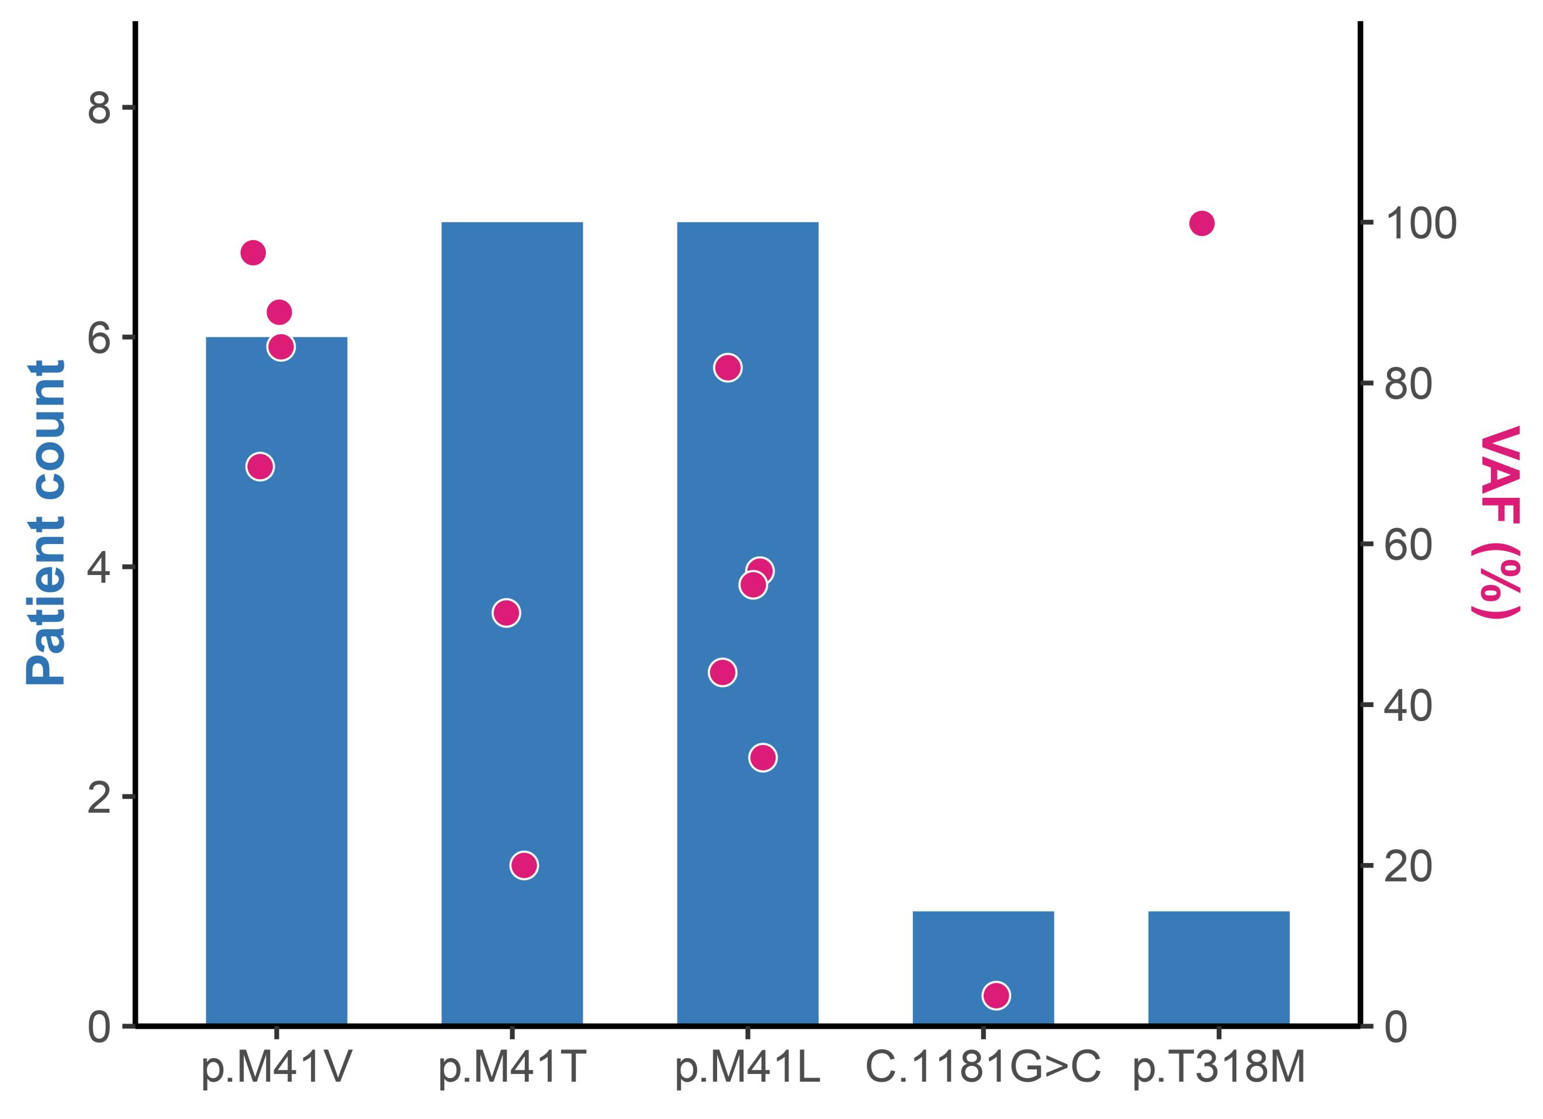

Figure S1. Patient distribution and variant allele frequencies (VAFs) of UBA1 variants. Bars indicate the number of patients carrying each variant type, and red dots represent the VAF (%) of individual patients on the secondary y-axis (0–100%).

