Risk of Bias of the included studies.

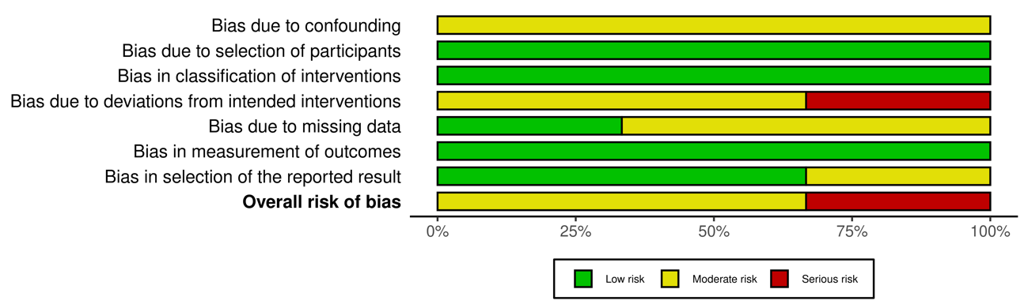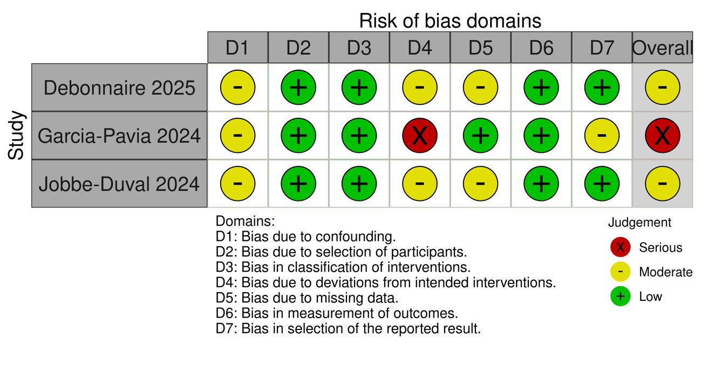

Search strategy Pubmed:
("tafamidis") AND ("octogenarians" OR "wild type"OR "elderly" OR "nonagenarians")

Search strategy Embase:
('tafamidis') AND ('octogenarians' OR 'wild type' OR 'elderly' OR 'nonagenarians')

