Supplement 1. Clinical questionnaire used for data collection
Patient Number：
Demographic Information
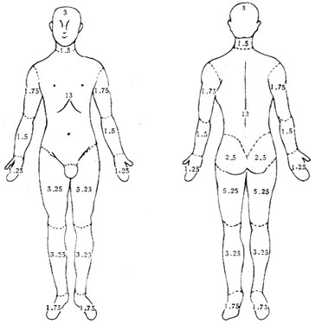
- Patient origin: ① 1= Outpatient clinics ② 2= The Neurofibromatosis Care Center
- Gender: ① 1= Male ② 2= Female
- Age: (years)
- Ethnicity: ① 1= Han ② 2= Non-Han minorities
- Place of birth:
- Occupation:
- E-mail:
- Age of onset: (years)
- Disease course: (years)
- Family history: ① 1= Yes ② 2= No
- Treatment: ① 1= Yes and specific treatment options: ② 2= No
Café-au-lait macules characteristics
- Café-au-lait macules: ① 1= Yes ② 2= No
- Age of appearance of café-au-lait macules:
- Areas of café-au-lait macules involved in the onset of the disease: ① Head, face and neck ② Trunk ③ Upper Extremities ④ Lower Extremities ⑤ The whole body
- Age at which café-au-lait macules increase significantly: (years)
- Maximum diameter of the current café-au-lait macules: (cm)
- Approximate number of café-au-lait macules at present:
- Areas of café-au-lait macule currently involved: ① Head, face and neck ② Trunk ③ Upper Extremities ④ Lower Extremities ⑤ The whole body
Neurofibromas characteristics
- Neurofibromas: ① 1= Yes ② 2= No
- Age of appearance of neurofibromas:
- Areas of neurofibromas involved in the onset of the disease: ① Head, face and neck ② Trunk ③ Upper Extremities ④ Lower Extremities ⑤ The whole body
- Age at which neurofibromas increase significantly: (years)
- Approximate number of neurofibromas at present:
- Areas of neurofibromas currently involved: ① Head, face and neck ② Trunk ③ Upper Extremities ④ Lower Extremities ⑤ The whole body
- Plexiform neurofibromas: ① 1= Yes ② 2= No
- Abnormal sensation of neurofibromas: ① 1= Yes ② 2= No
Other manifestations
- Axillary and/or inguinal freckles: ① 1= Yes ② 2= No
- Bony abnormalities: ① 1= Yes: ② 2= No
- Lisch nodules: ① 1= Yes ② 2= No ③ 3= not checked
- Learning disabilities: ① 1= Yes ② 2= No
- Nevus anemicus: ① 1= Yes ② 2= No
- Juvenile xanthogranulomas: ① 1= Yes ② 2= No
- Halo-like phenomenon on dermal melanocytosis: ① 1= Yes ② 2= No
- Optic pathway glioma, epilepsy, meningioma, schwannoma, and other spinal cord tumors: ① 1= Yes ② 2= No ③ 3= not checked
Others
Photographs:
Genetic testing: ① 1= Yes and results: ② 2= No
Any additional information:

