Supplementary Information

Unveiling the depth of the knowledge gap in the Universe of Rare Diseases: the PLUTO mission
Diego Ardigò^{1†}, Francesco Bianchi^{1†}, Maria Cristina Bosio¹, Alessia Simonini¹, Marzieh Farahani¹, Katiuscia Dallaglio¹, Michela Gabaldo², Ana Rath³, Julie Bruyère-Zrelli³, Virginie Hivert⁴, Anneliene H. Jonker⁵, Maurizio Scarpa⁶
†These authors contributed equally to this work
¹Chiesi Farmaceutici S.p.A, Parma, Italy
²Aptuit (Verona) srl, an Evotec company, Verona, Italy
³Inserm, US14-Orphanet, Paris, France
⁴EURORDIS-Rare Diseases Europe, Paris, France
⁵Health Technology and Services Research Department, Technical Medical Centre, University of Twente, Enschede, Netherlands
⁶Regional Coordinator Centre for Rare Diseases, University Hospital of Udine, Udine, Italy and European Reference Network for Inherited Metabolic Diseases, MetabERN.

Outliers
As detailed in the Methods section, we defined four key proxy metrics representing the level of scientific and medical knowledge (number of publications) as well as past and current drug development efforts in each rare disease (number of clinical trials [CTs], number of European Union [EU] orphan drug designations [ODDs], and number of EU marketing authorisations [MAs]).
For each disease, the first recorded instance of these four metrics typically followed a consistent chronological sequence: publications appeared first, followed by CTs, then ODDs, and finally MAs. Although the publication-CT-ODD-MA sequence was the most frequently observed, 542 rare diseases (9.3% of the total) deviated from this trajectory and were defined as “outliers”. Through the analysis of these outliers, we identified three main categories explaining their deviation from our metrics order (Supplementary Table 1).
The 48% of outliers in the ‘ODD before CT' category and the 37% in the ‘MA before ODD' category reflect a significant deviation that could be attributed to the sourcing of our ODD and MA information from Orphadata, which primarily focuses on the EU. This regional emphasis resulted in a comprehensive capture of EU-related data but often left data from the US incomplete. As a result, the lack of complete data for the US within Orphadata at the time of analysis introduced discrepancies into our dataset, particularly impacting the timeline or sequence of events for drug development processes reported outside the EU.

Supplementary Table 1. Outlier categories
Type of outlier | Definition | Number of outliers  (N=542)
ODD before CT | Date of first orphan drug designation happened before date of first clinical trials | 262 (48.3%)
MA before ODD | Date of first marketing authorisations happened before date of first orphan drug designation | 201 (37.1%)
CT before PubMed | Date of first clinical trial happened before date of first publication identified by our algorithm in PubMed | 79 (14.6%)
CT, clinical trial; ODD, orphan drug designation; MA, market authorisation

Planet M0
Planet “Milestone 0” (M0) encompasses 207 rare diseases that lack information across all metrics (i.e. no published papers, no registered trials, no orphan drug designations, and no approved products). Initially, these diseases accounted for more entries, but after a manual check by Orphanet analysts, 241 disorders were eliminated. These eliminated disorders represented obsolete entities that are still recorded in the database but have changed in terms of name or classification level. The remaining 207 disorders were kept in the database by Orphanet analysts because they were identified as relevant records for various reasons. Our analysis identified 65 of these diseases as historical records, 35 as information entities currently under development and the remaining 107 as records that need a more precise categorisation. We can define these disorders with no data available as a “proto-planet,” where the rare diseases that constitute it need to be validated, integrated, cleaned and re-classified to be included in another planet.

Timeline of rare disease discovery evolution
Supplementary Figure 1A highlights the correlation between the number of new rare diseases documented each year over the last 180 years with key historical events and significant medical discoveries. The starting date of 1840 corresponds to the first publication detected on rare diseases among those included in our dataset.¹ The frequency of documentation for rare diseases did not exhibit a consistent linear pattern of growth over time. Instead, multiple spikes were observed, which correlated with significant historical and scientific breakthroughs. For example, during the twentieth century, the two world wars halted any kind of discovery in the field, depriving researchers of time and resources. On the other hand, the conclusion of World War II, the consequent start of the economic boom and the onset of new important scientific discoveries (e.g. the description of the structure of deoxyribonucleic acid [DNA]) advanced research activities which in turn resulted in the identification of new diseases. Similarly, improvements in innovative medical diagnostic tools and techniques, as well as the rise of new therapeutic options, had a significant impact on the identification of new rare diseases. Indeed, medical developments such as cytogenetics and amniocentesis as a prenatal diagnostic tool for foetal diseases directly contributed to an increase in the number of known rare genetic diseases.² Later, the number of new rare diseases per year continued to grow in parallel with groundbreaking scientific discoveries such as the characterisation of restriction enzymes and DNA recombination techniques. However, the golden age of rare disease discovery was the 1970’s. The most remarkable “spike” occurred in 1974, when approximately 900 new rare diseases were described. Interestingly, this pivotal moment coincided with the Asilomar Conference on Recombinant DNA,³ which increased worldwide awareness of recent advances in molecular biology and their technological possibilities. From 1977 onward, no spikes of similar magnitude can be observed. The level of discoveries returned to around 50 diseases per year, steadily increasing until 2001. Since then, despite approximately 250 new gene variants being discovered each year,⁴ there has been a downward trend in the number of newly identified rare diseases. The reasons behind this require further investigation; however, one possibility is that most of the common genetic variants associated with rare diseases have already been identified, making the discovery of additional genes increasingly challenging.
As shown in Supplementary Figure 1B, when the number of disorders is plotted against the year of their first publication as a cumulative percentage, the data show a steady increase in the number of new disease descriptions since 2000, followed by a downward trend. This post-2000 decline likely reflects a reduction in the rate of rare disease discovery, suggesting that a plateau has been reached, potentially because most common variants have already been identified.

Supplementary Figure 1. Timeline of rare disease discoveries and key historical events
A) The timeline of rare disease discoveries is plotted as the number of disorders against the year of their first publication. Major historical events are indicated along the timeline, while significant scientific and medical discoveries are highlighted at peaks

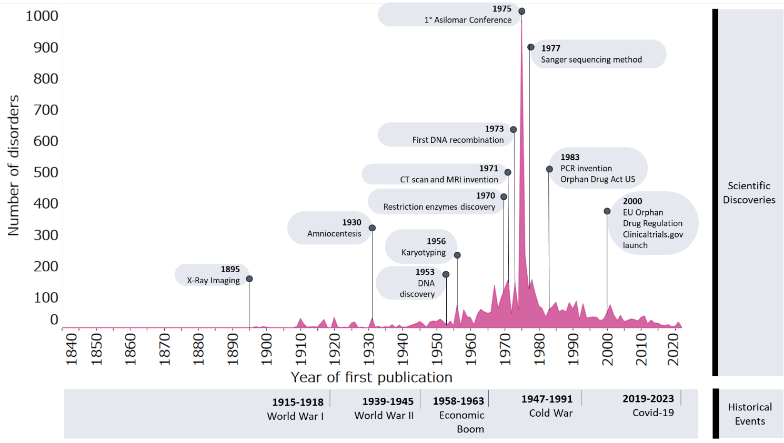

B) The number of rare disorders against the year of their first publication is represented as the cumulative percentage of new rare diseases versus year of first publication

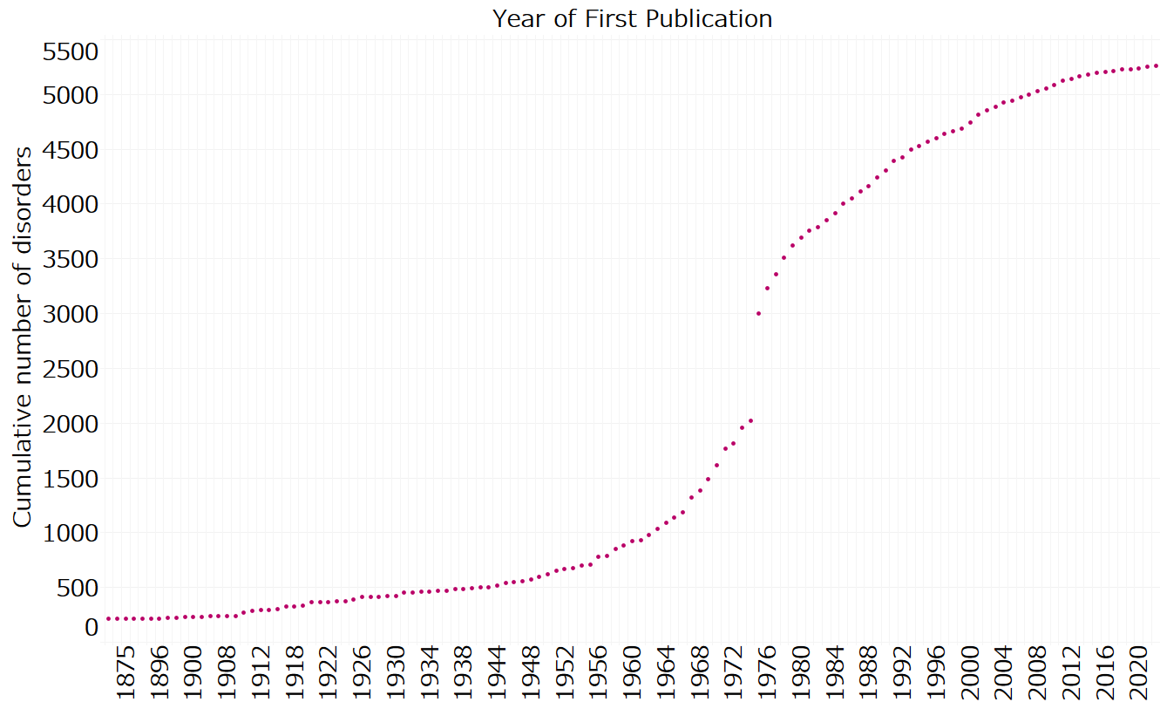
CT, computed tomography; EU, European Union; MRI, magnetic resonance imaging;
PCR, polymerase chain reaction.

Supplementary Table 2. List of variables identified and selected for the analysis
Variable | Year of first data available | Sources | Description
Number of publications | 1840¹ | Medline (PubMed) | - Linguamatics search of title and abstract using ontologies listed in the Methods section  - No filters regarding the type of document or language were applied
Number of clinical trials | 1999 | ClinicalTrials.gov  Trialtrove | - Linguamatics search of all the text in each record using ontologies listed in the Methods section  - No filters regarding the type of trial were applied  - To increase the power of the system, Trialtrove was added as a source for data augmentation (this private data source includes information and trial records from different databases) and as a control for ClinicalTrials.gov
Number of ODDs – EU only | 2000 | Orphadata | - Linguamatics search for ORPHAcode in Orphadata API and collection of the number of ODDs (called ‘Substances’ in Orphanet) present for each specific rare disease  - Note: the number reported is related to Europe only because the Orphanet dataset does not sufficiently cover the USA and RoW
Number of approved drugs – EU only | 2001 | Orphadata  Drugbank | - Linguamatics search for ORPHAcode in Orphadata API and collection of the number of approved drugs (called ‘Products’ in Orphanet) present for each specific rare disease  - To increase the power of the system, Drugbank was added as a source for data augmentation (this private data source includes information and records from different countries, in particular the USA) and as a control for Orphadata
API, application programming interface; EU, European Union; ODD, orphan drug designation; RoW, rest of world

Supplementary Table 3. List of other variables identified and selected for the analysis
Term | Key milestones and metrics
Milestone onset years | Initial years of significant development related to earliest publications, clinical trials, orphan drug designations and marketing authorisations
Regulatory and research interval metrics | Intervals between publications, clinical trials, marketing authorisations and orphan drug designations
PubMed milestone documentation intervals | Intervals from first PubMed document to first clinical trial, orphan drug designation and marketing authorisation
Clinical trial regulatory progression intervals | Time from first clinical trial to first orphan drug designation and marketing authorisation
Regulatory approval intervals | Time from first orphan drug designation to first marketing authorisation

Supplementary Table 4. Filters applied to data sources in the integration phase
Topic⁵ | Filter⁵ | Rationale⁵
Nomenclature and clusters | Exclusion of non-rare diseases | A group of disorders that do not meet the European definition of a rare disease (less than five affected individuals per 10,000 in Europe) in light of current epidemiological knowledge and have therefore been removed from the Orphanet nomenclature http://www.orphadata.org/cgi-bin/img/PDF/WhatIsORDO.pdf
Nomenclature and clusters | Orphadata (http://www.orphadata.org/cgi-bin/index.php) is the primary source for the classification of rare diseases. The classification used thus follows the rules of Orphanet to select and classify rare diseases | The Orphanet nomenclature is at the crossroads of scientific data repositories and of clinical terminology standards and is suitable to use as a standard terminology
Nomenclature and clusters | Exclusion of deprecated and obsolete records in Orphanet data | These are entities that have been excluded from the Orphanet nomenclature, including obsolete entities, deprecated entities and entities that have been inactivated because they are not rare in Europe. http://www.orphadata.org/cgi-bin/img/PDF/WhatIsORDO.pdf
Nomenclature and clusters | Exclusion of rare neoplastic disorders | Rare neoplastic disorders were excluded for the following reasons: internal analytical capacity, possible generation of a large dataset that would be difficult to handle and analyse, possible outlier generation
Nomenclature and clusters | Exclusion of group of disorders and subtype of disorders as source of disease names | The Orphanet rare disease nomenclature comprises a heterogeneous typology of entities of decreasing extension, including groups of disorders, disorders and subtypes of disorders. A disorder in the database can be a disease, a malformation syndrome, a clinical syndrome, a morphological or a biological anomaly or a particular clinical situation (during a disorder). They are organised into groups and further divided into clinical, etiological or histopathological subtypes. We decided to only include disorders to reduce noise and avoid duplicates in the analysis
Drugs | For MAs and ODDs, we only covered data from Europe | The Orphanet dataset on ODDs and MAs did not fully cover the USA at the time of the analysis in 2022. Orphanet also excludes medicinal products with a regulatory status outside Europe or the USA. https://www.orpha.net/orphacom/cahiers/docs/GB/medicinal_products_in_Orphanet_R2_R_D_Drugs_EP_06.pdf
Drugs | Drugbank (https://go.drugbank.com/) was used as an augmented dataset to maximise and foster the identification of MAs for specific rare diseases | To increase the power of the system, Drugbank (a private data source that includes information and records from different countries, particularly the USA) was added as a source of data augmentation and as a control for Orphadata (Drugbank API was used under a private Chiesi license)
Drugs | Only centralised registrations were included | Orphanet excludes medicinal products approved in Europe through procedures other than the centralised procedure
Genes | OMIM database was used in this study only to retrieve information on the human genes associated with rare diseases | OMIM was only used as link between different sources (e.g. OMIM numbers)
Time | The timescale was different for each data source selected for the analysis | This timescale is linked to the creation and start of each specific database
Publications | MEDLINE (PubMed) research was conducted only on titles, abstracts and MeSH terms | Our NLP tool, Linguamatics, searched title, abstract and MeSH terms using ontologies listed in the Methods section (Linguamatics was used under a Chiesi license)
Clinical trials | The search of ClinicalTrials.gov records was performed on both interventional trials and observational trials | We included all clinical trial types to avoid missing information
Clinical trials | ClinicalTrials.gov research was performed on specific descriptive fields (such as title, description, conditions, study arms, MeSH headings) | Linguamatics searched title, brief/descriptions, conditions/disease, eligibility criteria, additional criteria, intervention/treatment, outcome measures, MeSH terms of records using ontologies listed in the Methods section
Clinical trials | Trialtrove (https://pharmaintelligence.informa.com/products-and-services/clinical-planning/trialtrove) was used as an augmented dataset to maximise and foster the identification of clinical trials for specific rare diseases | To increase the power of the system, Trialtrove (a private data source that includes information and trial records from different databases) was added as an additional source for data augmentation and as a control for ClinicalTrials.gov (Trialtrove API was used under a private Chiesi license)

API, application programming interface; ODD, orphan drug designation; MA, market authorisation; MeSH, Medical Subject Headings; NLP, natural language processing; OMIM, Online Mendelian Inheritance in Man

Supplementary Figure 2. Data cleaning, preprocessing and feature extraction flow chart
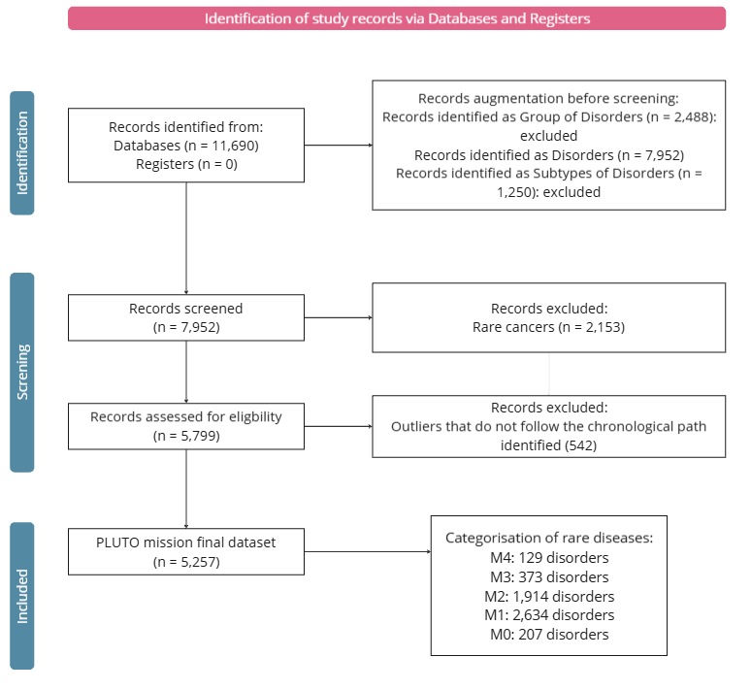
Structure of the workflow used to prepare the dataset for our rare disorders analysis. Initially, a comprehensive dataset comprising 11,690 entries was extracted, representing all entities across Orphanet. This dataset was categorised into three groups: Groups of Disorders (2,488 entries), Disorders (7,952 entries), and Subtypes of Disorders (1,250 entries). After excluding the 2,153 entries classified as oncologic or non-rare conditions, we integrated data for the remaining entries across the four metrics and related timepoints from all data sources.
M, milestone.

References
1. Gerhard, W. W. On the history of tuberculous meningitis. Med Exam (Phila) 3, 293–295 (1840).
2. Lindee, M. S. Genetic disease in the 1960s: a structural revolution. Am J Med Genet 115, 75–82 (2002).
3. Berg, P., Baltimore, D., Brenner, S., Roblin, R. O. & Singer, M. F. Summary statement of the Asilomar Conference on Recombinant DNA Molecules. Proc Natl Acad Sci U S A 72, 1981–1984 (1975).
4. Boycott, K. M. et al. International cooperation to enable the diagnosis of all rare genetic diseases. Am J Hum Genet 100, 695–705 (2017).
5. Rath, A. et al. Representation of rare diseases in health information systems: the Orphanet approach to serve a wide range of end users. Hum Mutat 33, 803–808 (2012).

