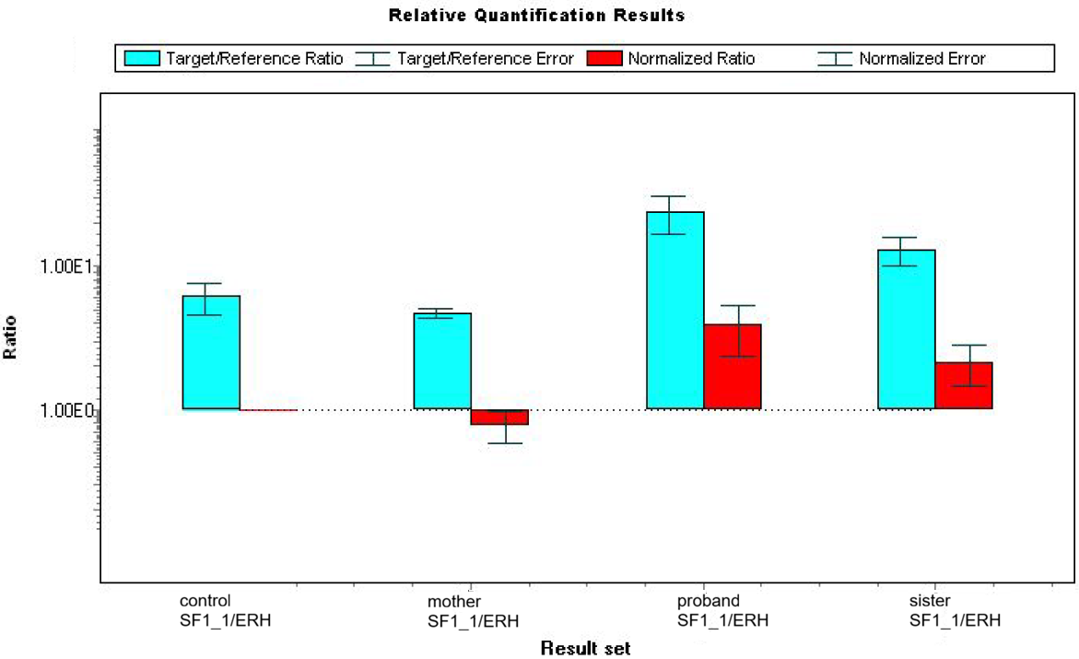
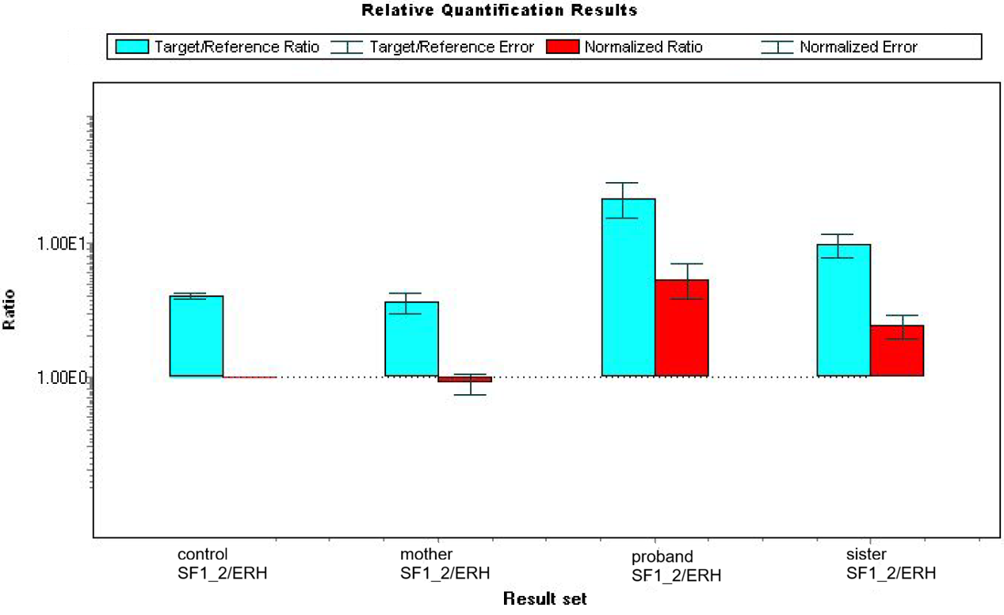
Supplementary Figure 1 The results of the SF1 gene expression analysis. Relative gene expression was calculated as a Ratio using the LightCycler 480 software (v1.5), based on ΔΔCt method, in a control and affected individuals (proband, mother, sister). Target SF1 gene expression was normalized to a reference ERH gene in control (calibrator) sample (set to 1). The target/reference ratios were calculated for all samples (turquoise columns) and normalization was performed for affected individuals relative to control (red columns). The y-axis is shown on a logarithmic scale. The graphs were automatically generated by the software. The upper figure summarizes the results of RT-qPCR for the region targeting the exon 2/3 borderline. The bottom figure summarizes the results of RT-qPCR for the region targeting the exon 3/4 borderline. SF1_1 – target region for exon 2/3 borderline, SF1_2 – target region for exon 3/4 borderline, ERH – reference gene region (exon 3).

