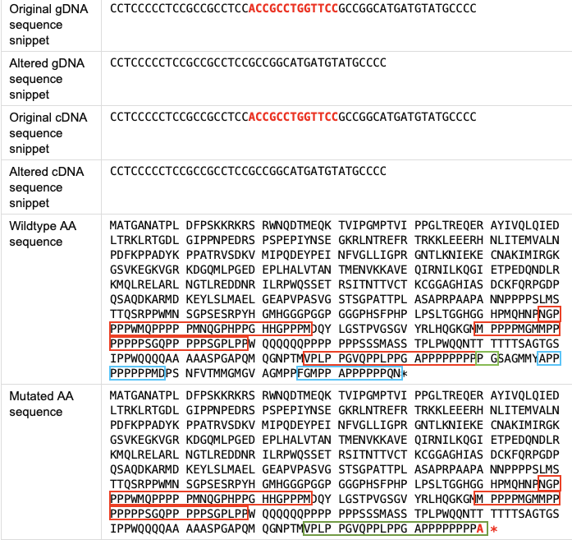
The proline-rich domains and their alterations in the SF1 protein. The figure shows the partial output of the MutationTaster 2025 prediction tool. The molecular consequences of c.1764_1776del are shown on genomic, cDNA and protein levels. The protein level is represented by amino acid (AA) sequences. The proline-rich domains present in both wildtype and mutated AA sequences are marked by red frames. The absent proline-rich domains are marked by blue frames (on the wildtype AA sequence). The altered proline-rich domain is marked by green frames: the start of the truncation (on the wildtype AA sequence) and the whole truncated domain (on the mutated AA sequence). The positions of proline-rich domains in the human SF1 protein were obtained from the UniProt database (www.uniprot.org).

