Supplementary Methods
The diagnosis of cardiac transthyretin amyloidosis (ATTR-CM) needed to be made based on ​​​invasive ​​and/or​​ non-invasive criteria. The invasive diagnostic criteria were defined as (a) endomyocardial biopsy confirming transthyretin amyloid deposits by Congo red staining and amyloid typing (immunohistochemistry or mass spectrometry) irrespective of the degree of left ventricular (LV) wall thickness, and/or (b) extracardiac biopsy confirming transthyretin amyloid by the same staining/typing methods, accompanied by characteristic features of cardiac amyloidosis either on echocardiography (in the absence of an alternative cause for increased LV wall thickness), or on cardiac magnetic resonance (CMR). The non-invasive diagnostic criteria demanded typical echocardiographic/CMR findings consistent with cardiac amyloidosis, grade 2 or 3 myocardial uptake of radiotracer on ^{99m}Tc-pyrophosphate (PYP), ^{99m}Tc-3, 3-diphosphono-1,2-propanodicarboxylic acid or ^{99m}Tc-hydroxymethylene diphosphonate scintigraphy with single-photon emission computed tomography, and exclusion of clonal dyscrasia, which was confirmed by a serum free light-chain assay within normal limits (adjusted for estimated glomerular filtration rate) and negative serum and urine protein electrophoresis with immunofixation. The diagnosis of transthyretin amyloidosis with polyneuropathy (ATTR-PN) required a positive genetic test alongside clinical suspicion of ATTR-PN that was sufficient to rule out alternative causes. If another plausible cause (e.g., a different type of amyloidosis) for the polyneuropathy existed, a confirmatory biopsy should have been performed to confirm the diagnosis of ATTR amyloidosis.

Table S1. Study objectives and outcome measures.
Objectives | Outcome measures
Primary objectives
- To comprehensively describe patient characteristics, treatment patterns, disease outcomes in patients diagnosed with ATTR amyloidosis in routine clinical care for the defined domains/variables | - Patient characteristics including:  - Demographics  - Family history of ATTR amyloidosis  - Post-diagnosis ATTR-related clinical characteristics
 | - Post-diagnosis treatments
 | - Post-diagnosis clinical outcomes
- To characterize and quantify the clinical burden in patients diagnosed with ATTR amyloidosis in routine clinical care for the defined domains/variables. | - Post-diagnosis HCRU
Secondary objectives
- To describe clinical characteristics and burden in patients with ATTR amyloidosis before diagnosis | - Pre-diagnosis ATTR-related clinical characteristics
 | - Pre-diagnosis HCRU
Abbreviations: ATTR, transthyretin amyloidosis; HCRU, healthcare resource utilisation.

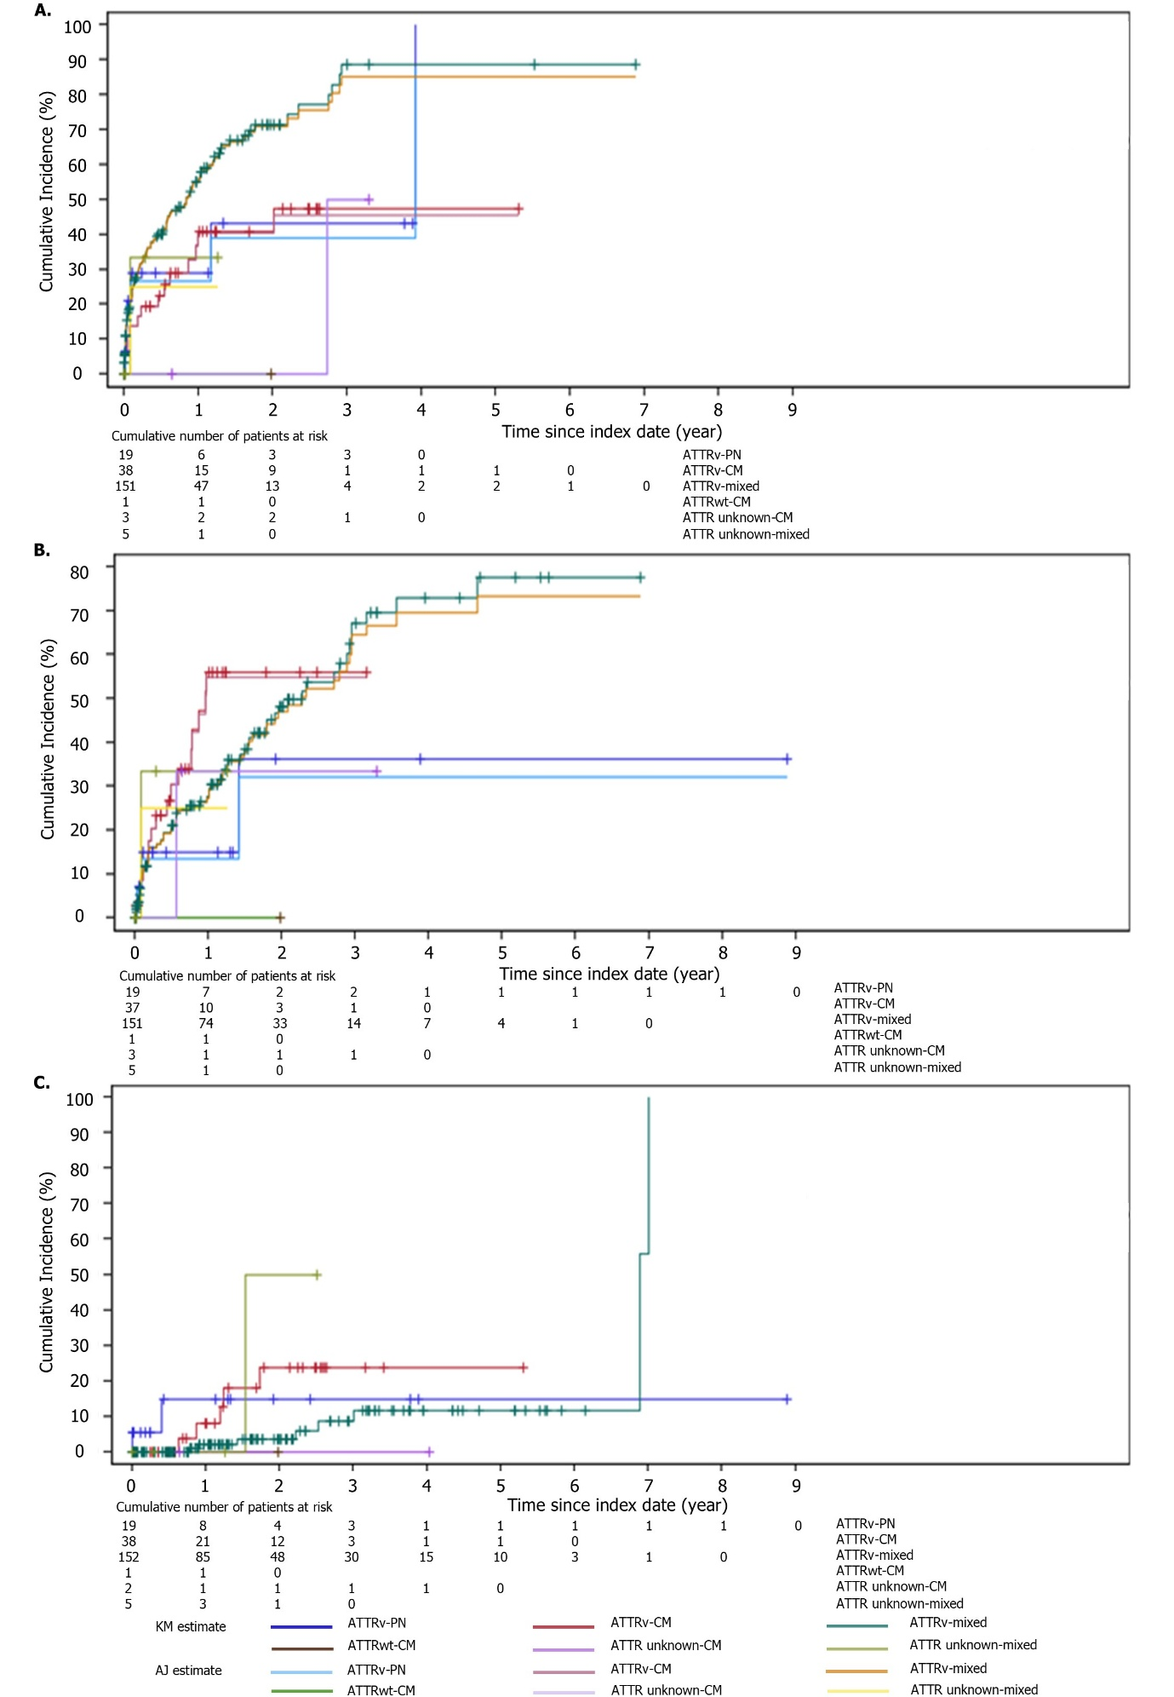

Fig. S1 Time to (A) new amyloidosis manifestation, (B) all-cause hospitalisation, and (C) all-cause mortality in patients with ATTR amyloidosis (post-diagnosis) by genotype and phenotype. AJ, Aalen-Joansen method; ATTR, transthyretin amyloidosis; ATTRv, hereditary transthyretin amyloidosis; ATTRwt, wild-type transthyretin amyloidosis; CM, cardiomyopathy; KM, Kaplan-Meier; PN, polyneuropathy.

