Journal: Orphanet Journal of Rare Diseases

Title: Economic and diagnostic impact of adopting WES and WGS as first-tier tests in the paediatric rare disease diagnosis: evidence from Italy and Spain

María Palomares-Bralo^{1,2*}, Antonio Novelli^{3*}, Dario Cocciadiferro³, Lorena Travaglini³, Fe Amalia García-Santiago^{1,2}, Fernando Santos-Simarro^{1,4#}, Marta Pacio-Míguez^{1,5#}, Carmen Rodríguez-Jiménez¹, María Ángeles Gómez-Cano¹, Karen E. Heath^{1,2}, Anna Baggi⁶, Valeria Scagliotti^{6§}, Martina Tedesco⁶, Victoria Lucia Rabsiun Aramburu⁶, Maria Antonietta Magno⁶, Giuseppe Inebria⁶, Lidia Pezzani⁷, Erica Rosina⁷, Laura Pezzoli⁷, Jean Marie Franzini⁶ and Maria Iascone¹.
1. Institute of Medical & Molecular Genetics (INGEMM) Hospital Universitario La Paz, IdiPAZ, Madrid, Spain. 2. CIBER for Rare Diseases (CIBERER), Institute of Health Carlos III (ISCIII), Madrid, Spain. 3. Translational Cytogenomics Research Unit, Bambino Gesù Children's Hospital, IRCCS, Rome, Italy. 4. Unit of Molecular Diagnostics and Clinical Genetics (UDMGC), Hospital Universitari Son Espases, Palma, Spain. 5. Service of Genetics, Hospital Universitario Ramón y Cajal, Madrid, Spain. 6. Life Sciences Division, Business Integration Partners S.p.A, Milan, Italy. 7. ASST Papa Giovanni XXIII, Bergamo, Italy.
* These authors contributed equally to this work and share first authorship
§ Corresponding author. Email: valeria.scagliotti@bip-group.com
# Current affiliation

Supplementary Materials

Supplementary Table 1
Table S1 List of genetic conditions included in the Extended Newborn Screening (ENS) programmes implemented in Lombardy and Lazio (Italy) and in the Madrid region (Spain) as of 2022. Abbreviations: CACT, carnitine-acylcarnitine translocase; CPT I/II, carnitine palmitoyltransferase I/II; HPA, hyperphenylalaninemia; LCAD, long-chain Acyl-CoA dehydrogenase; M/SCHAD, medium/short chain 3-hydroxyacyl-CoA dehydrogenase; MCAD, medium-chain Acyl-CoA dehydrogenase; MTHFR, methylenetetrahydrofolate reductase; VLCAD, very long-chain Acyl-CoA dehydrogenase
Category | Condition | Italy [1]  (Lombardy, Lazio) | Spain [2]  (Madrid)
Aminoacidopathies | Phenylketonuria (PKU) / HPA | Yes | Yes
Aminoacidopathies | Biopterin defect in cofactor biosynthesis (BIOPT-BS) | Yes | No
Aminoacidopathies | Biopterin defect in cofactor regeneration (BIOPT-REG) | Yes | No
Aminoacidopathies | Maple syrup urine disease (MSUD) | Yes | Yes
Aminoacidopathies | Tyrosinemia type I | Yes | Yes
Aminoacidopathies | Tyrosinemia type II | Yes | No
Aminoacidopathies | Homocystinuria (CBS) | Yes | Yes
Aminoacidopathies | Severe MTHFR deficiency | Yes | No
Organic acidaemias | Glutaric acidaemia type I (GA I) | Yes | Yes
Organic acidaemias | Isovaleric acidaemia (IVA) | Yes | Yes
Organic acidaemias | Propionic acidaemia (PA) | Yes | Yes
Organic acidaemias | Methylmalonic acidaemia (MMA-Mut) | Yes | Yes
Organic acidaemias | Methylmalonic acidaemia (Cbl-A/B) | Yes | Yes
Organic acidaemias | Methylmalonic acidaemia (Cbl-C/D) | Yes | Yes
Organic acidaemias | 3-hydroxy-3-methylglutaric aciduria (HMGA) | Yes | Yes
Organic acidaemias | Beta-ketothiolase deficiency (BKD) | Yes | Yes
Organic acidaemias | 2-methylbutyryl-CoA dehydrogenase deficiency (2MBG) | Yes | No
Organic acidaemias | Malonic aciduria | Yes | No
Organic acidaemias | Multiple carboxylase deficiency (MCD) | Yes | No
Urea cycle disorders | Citrullinemia type I (CIT I) | Yes | Yes
Urea cycle disorders | Citrullinemia type II (CIT II) | Yes | No
Urea cycle disorders | Argininosuccinic acidaemia (ASA) | Yes | Yes
Urea cycle disorders | Argininaemia (ARG) | Yes | No
Fatty acid oxidation disorders | MCAD deficiency | Yes | Yes
Fatty acid oxidation disorders | VLCAD deficiency | Yes | Yes
Fatty acid oxidation disorders | LCHAD deficiency | Yes | Yes
Fatty acid oxidation disorders | Carnitine uptake defect (CUD) | Yes | Yes
Fatty acid oxidation disorders | CPT I deficiency | Yes | No
Fatty acid oxidation disorders | CPT II deficiency | Yes | No
Fatty acid oxidation disorders | CACT deficiency | Yes | No
Fatty acid oxidation disorders | Trifunctional protein deficiency (TPD) | Yes | No
Fatty acid oxidation disorders | M/SCHAD deficiency | Yes | No
Fatty acid oxidation disorders | Glutaric aciduria type II (MADD) | Yes | No
Endocrine disorders | Congenital hypothyroidism | Yes | Yes
Endocrine disorders | Congenital adrenal hyperplaesia | Yes (Lombardy) | Yes
Other disorders | Galactosemia | Yes | No
Other disorders | Biotinidase deficiency | Yes | Yes
Other disorders | Cystic fibrosis | Yes | Yes
Other disorders | Sickle cell disease | No | Yes
References
1. SIMMESN: Rapporto tecnico sui Programmi di Screening Neonatale in Italia - Anno 2022. (2023)
2. Castiñeras, D.E., Couce, M.-L., Marín, J.L., González-Lamuño, D., Rocha, H.: Newborn screening for metabolic disorders in Spain and worldwide. Anales de Pediatría (English Edition). 91, 128e.1-128e.14 (2019). https://doi.org/10.1016/j.anpede.2019.05.005

Figure S1
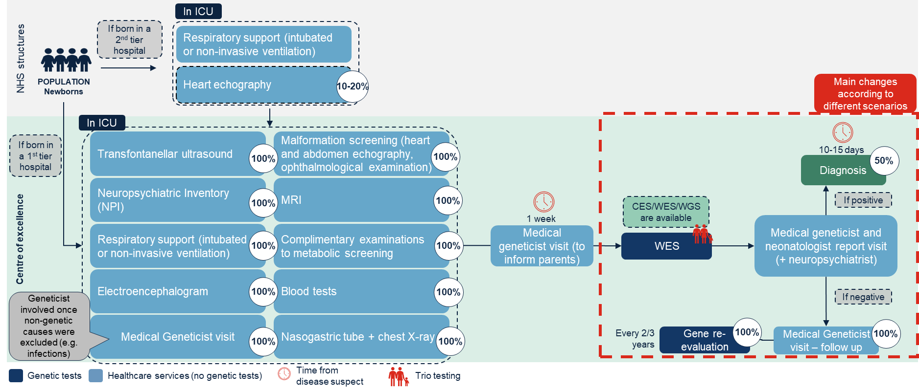
Fig. S1 Example of a diagnostic pathway for the inpatient group under one of the scenarios (S4). In light blue are reported the healthcare services, while in dark blue are represented the genetic tests. The white dots represent the proportion of patients receiving each listed activity. Abbreviations: CES, Clinical-Exome Sequencing; ICU, Intensive Care Unit; MRI, Magnetic Resonance Imaging; WES, Whole-Exome Sequencing; WGS, Whole-Genome Sequencing

Figure S2
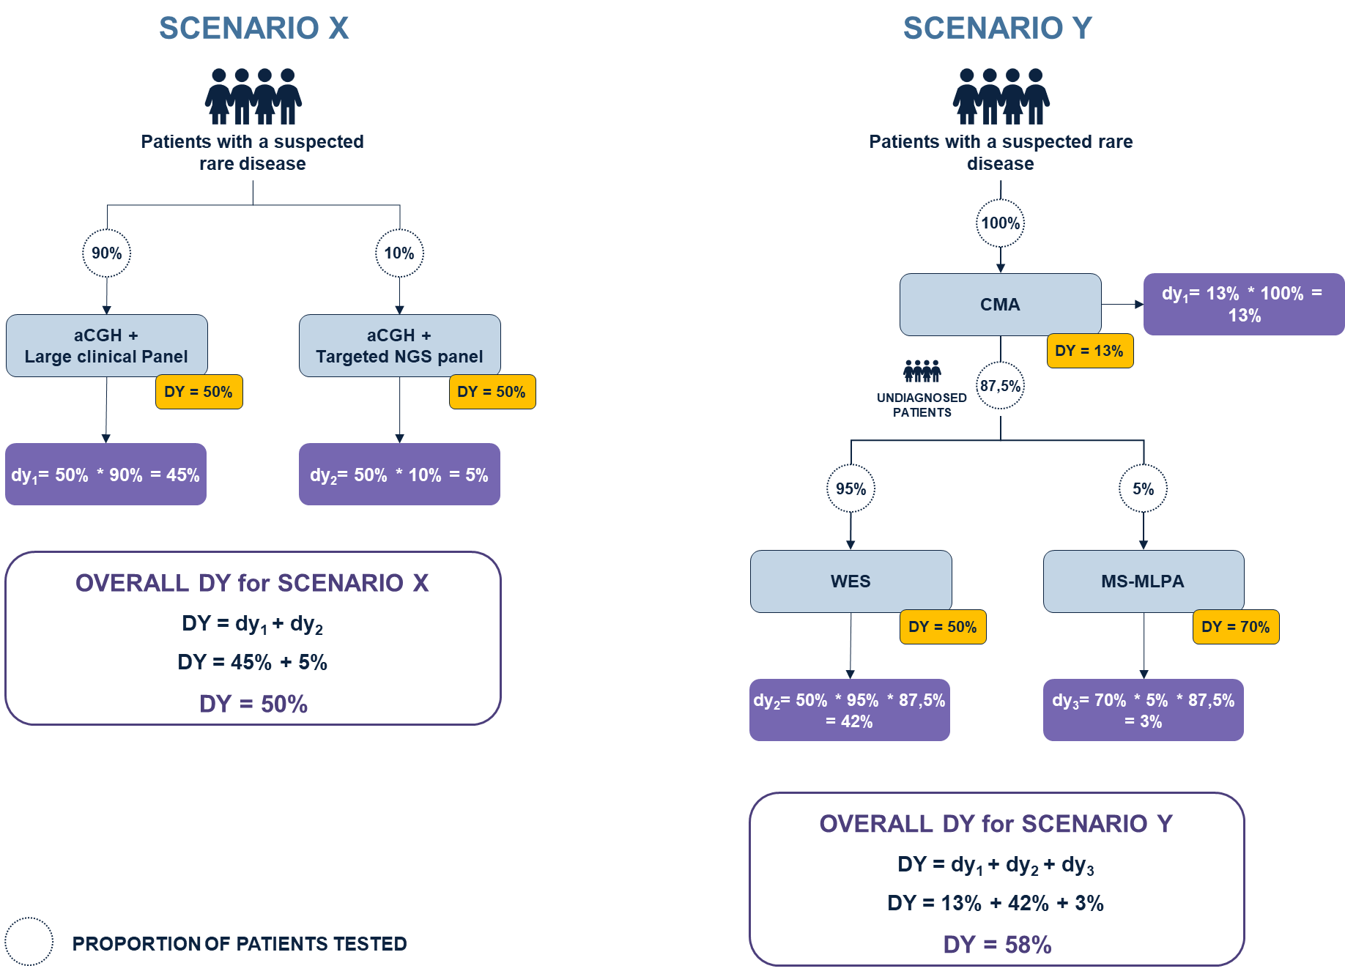
Fig. S2 Examples of how to calculate the overall diagnostic yield (DY) for different scenarios. The white dots represent the proportion of patients tested with a specific technique or combination of techniques, for which the DY is reported (yellow boxes). Weighted technique(s)-specific DYs (dy_{n}) are reported in the violet boxes. Abbreviations: aCGH, array Comparative Genomic Hybridisation; CMA, Chromosomal Microarray Analysis; MS-MLPA, methylation-specific Multiplex Ligation-dependent Probe Amplification; WES, Whole-Exome Sequencing

Supplementary Table 2
Table S2 Individual components of total diagnostic pathway costs for the inpatient group across scenarios (S) and centres (C). For each component, both the absolute estimated cost and its percentage contribution to the total are reported. Healthcare services refer to medical activities not included within the Neonatal Intensive Care Unit (NICU) tariff

 |  | INPATIENT
 |  | Cost components of total diagnostic pathway costs
Centre | Scenario |  | NICU  (%) | Healthcare services (%) |  | Genetic testing (%) | Total  (%)
C1 | S1 |  | 297,000 € (98.7%) | 1,063 €  (0.3%) |  | 2,999 €  (1.0%) | 301,062 €  (100%)
C1 | S2 |  | - | - |  | - | -
C1 | S3 |  | - | - |  | - | -
C1 | S4 |  | 32,175 € (88.9%) | 799 €  (2.2%) |  | 3,220 €  (8.9%) | 36,193 €  (100%)
C1 | S5 |  | - | - |  | - | -
C1 | S6 |  | 19,800 € (79.3%) | 799 €  (2.2%) |  | 4,370 €  (17.5%) | 24,968 €  (100%)
C2 | S1 |  | 45,000 € (93.9%) | - |  | 2,910 €  (6.1%) | 47,901 € (100%)
C2 | S2 |  | - | - |  | - | -
C2 | S3 |  | - | - |  | - | -
C2 | S4 |  | - | - |  | - | -
C2 | S5 |  | 30,000 € (92.1%) | - |  | 2,590 €  (7.9%) | 32,590 € (100%)
C2 | S6 |  | 22,500 € (85.7%) | - |  | 3,745 €  (14.3%) | 26,245 € (100%)
C3 | S1 |  | - | - |  | - | -
C3 | S2 |  | 157,500 € (98.7%) | - |  | 2,022 €  (1.3%) | 159,522 € (100%)
C3 | S3 |  | - | - |  | - | -
C3 | S4 |  | - | - |  | - | -
C3 | S5 |  | 49,500 € (95.1%) | - |  | 2,565 €  (4.9%) | 52,065 € (100%)
C3 | S6 |  | 22,500 € (76.0%) | - |  | 7,104 €  (24.0%) | 29,604 € (100%)

Supplementary Table 3
Table S3 Cost of individual genetic tests performed by the centres (C) grouped by scenario (S) for inpatient diagnosis. Costs are weighted by the proportion of inpatients tested with each technique. (*) For C3, NGS panels used under S2 corresponded to large clinical panels (>1000 genes). Abbreviations: CMA, chromosomal microarray analysis; FISH, fluorescence in situ hybridisation, MLPA, Multiplex Ligation-dependent Probe Amplification; NGS, NWES, Whole-Exome Sequencing; WGS, Whole-Genome Sequencing

INPATIENT
Genetic testing cost components
Centre | Scenario | CMA  (%) | Mitochondrial analysis (%) | MLPA  (%) | Karyotype (%) | FISH  (%) | NGS panel  (%) | WES Trio  (%) | WGS Trio  (%) | Total  (%)
C1 | S1 | 991 € (33.1%) | 203 € (6.8%) | 769 € (25.6%) | - | - | 1.036 € (34.5%) | - | - | 2,999 (100%)
C1 | S2 | - | - | - | - | - | - | - | - | -
C1 | S3 | - | - | - | - | - | - | - | - | -
C1 | S4 | - | - | - | - | - | - | 3,220 € (100%) | - | 3,220 € (100%)
C1 | S5 | - | - | - | - | - | - | - | - | -
C1 | S6 | - | - | - | - | - | - | - | 4,370 € (100%) | 4,370 € (100%)
C2 | S1 | 850 € (29.3%) | - | 300 € (10.3%) | 330 € (11.4%) | - | 1,421 € (49.0%) | - | - | 2,901 (100%)
C2 | S2 | - | - | - | - | - | - | - | - | -
C2 | S3 | - | - | - | - | - | - | - | - | -
C2 | S4 | - | - | - | - | - | - | - | - | -
C2 | S5 | 527 € (20.4%) | - | - | 89 € (3.4%) | 5 € (0.2%) | - | 1,969 € (76.0%) | - | 2,590 € (100%)
C2 | S6 | - | - | - | - | - | - | - | 3,745 € (100%) | 3,745 € (100%)
C3 | S1 | - | - | - | - | - | - | - | - | -
C3 | S2 | 700 € (34.6%) | - | - | - | - | 1,322 € (65.4%)* | - | - | 2,022 € (100%)
C3 | S3 | - | - | - | - | - | - | - | - | -
C3 | S4 | - | - | - | - | - | - | - | - | -
C3 | S5 | 700 € (27.3%) | - | - | - | - | - | 1,865 € (72.7%) | - | 2,565 € (100%)
C3 | S6 | - | - | - | - | - | - | - | 7,104 € (100%) | 7,104 € (100%)

Supplementary table 4
Table S4 Individual components of total diagnostic pathway costs for the outpatient group across scenarios (S) and centres (C). For each component, both the absolute estimated cost and its percentage contribution to the total are reported

OUTPATIENT
Cost component of total diagnostic pathway costs
Centre |  | Scenario | Healthcare services (%) |  | Genetic testing (%) | Total  (%)
C1 |  | S1 | 801 € (15.3%) |  | 4,439 € (84.7%) | 5,240 € (100%)
 |  | S2 | 819 € (10.2%) |  | 7,181 € (89.8%) | 8,000 € (100%)
 |  | S3 | - |  | - | -
 |  | S4 | 757 € (20.2%) |  | 2,987 € (79.8%) | 3,744 € (100%)
 |  | S5 | - |  | - | -
 |  | S6 | 756 € (14.7%) |  | 4,370 € (85.3%) | 5,126 € (100%)
C2 |  | S1 | 470 € (20%) |  | 1,880 € (80%) | 2,350 € (100%)
 |  | S2 | 528 € (17%) |  | 2,620 € (83%) | 3,148 € (100%)
 |  | S3 | - |  | - | -
 |  | S4 | - |  | - | -
 |  | S5 | 506 € (21%) |  | 1,854 € (79%) | 2,360 € (100%)
 |  | S6 | 493 € (12%) |  | 3,610 € (88%) | 4,103 € (100%)
C3 |  | S1 | - |  | - | -
 |  | S2 | 1,990 € (47.8%) |  | 2,176 € (52.2%) | 4,165 € (100%)
 |  | S3 | - |  | - | -
 |  | S4 | - |  | - | -
 |  | S5 | 1,919 € (42.8%) |  | 2,566 € (57.2%) | 4,485 € (100%)
 |  | S6 | 1,991 € (21.3%) |  | 7,104 € (78.7%) | 9,023 € (100%)

Supplementary Table 5
Table S5 Cost of individual genetic tests performed by the centres (C) grouped by scenario (S) for outpatient diagnosis. Costs are weighted by the proportion of outpatients tested with each technique. (*) For C3, NGS panels used under S2 corresponded to large clinical panels (>1000 genes). Abbreviations: CES, Clinical-Exome Sequencing; CMA, chromosomal microarray analysis; MLPA, Multiplex Ligation-dependent Probe Amplification; NGS, NWES, Whole-Exome Sequencing; WGS, Whole-Genome Sequencing
OUTPATIENT
Genetic testing cost components
Centre | Scenario | CMA  (%) | Fragile X  (%) | MLPA  (%) | Karyotype (%) | NGS panel  (%) | CES Trio  (%) | WES Trio  (%) | WGS Trio  (%) | Total  (%)
C1 | S1 | 991 € (22.3%) | 171 € (3.9%) | - | 13 € (0.3%) | 3,264 € (73.5%) | - | - | - | 4,439 (100%)
C1 | S2 | 991 € (13.8%) | 171 € (2.4%) | - | 13 € (0.2%) | 3,627 € (50.5%) | - | 2,379 € (33.1%) | - | 7,181 € (100%)
C1 | S3 | - | - | - | - | - | - | - | - | -
C1 | S4 | - | 13 € (0.4%) | - | - | - | - | 2,974 € (100%) | - | 2,987 € 100%)
C1 | S5 | - | - | - | - | - | - | - | - | -
C1 | S6 | - | - | - | - | - | - | - | 4,370 € (100%) | 4,370 € (100%)
C2 | S1 | 786 € (41.8%) | 120 € (6.4%) | - | 305 € (16.2%) | 668 € (35.6%) | - | - | - | 1,880 (100%)
C2 | S2 | 278 € (10.6%) | 120 € (4.6%) | - | 307 € (11.7%) | - | 1,915 € (73.1%) | - | - | 2,620 (100%)
C2 | S3 | - | - | - | - | - | - | - | - | -
C2 | S4 | - | - | - | - | - | - | - | - | -
C2 | S5 | 23 € (1.2%) | 10 € (0.5%) | - | - | - | - | 1,821 € (98.3%) | - | 1,854 € (100%)
C2 | S6 | - | - | - | - | - | - | - | 3,610 € (100%) | 3,610 € (100%)
C3 | S1 | - | - | - | - | - |  | - | - | -
 | S2 | 665 € (30.6%) | 302 € (13.9%) | 14 € (0.6%) | - | 1,195 € (54.9%)* |  | - | - | 2,176 € (100%)
 | S3 | - | - | - | - |  | - | - | - | -
 | S4 | - | - | - | - |  | - | - | - | -
 | S5 | 700 € (27.3%) | 302 € (11.8%) | 14 € (0.5%) | - |  | - | 1,550 € (60.4%) | - | 2,566 € (100%)
 | S6 | - | - | - | - |  | - | - | 7,104 € (100%) | 7,104 € (100%)

