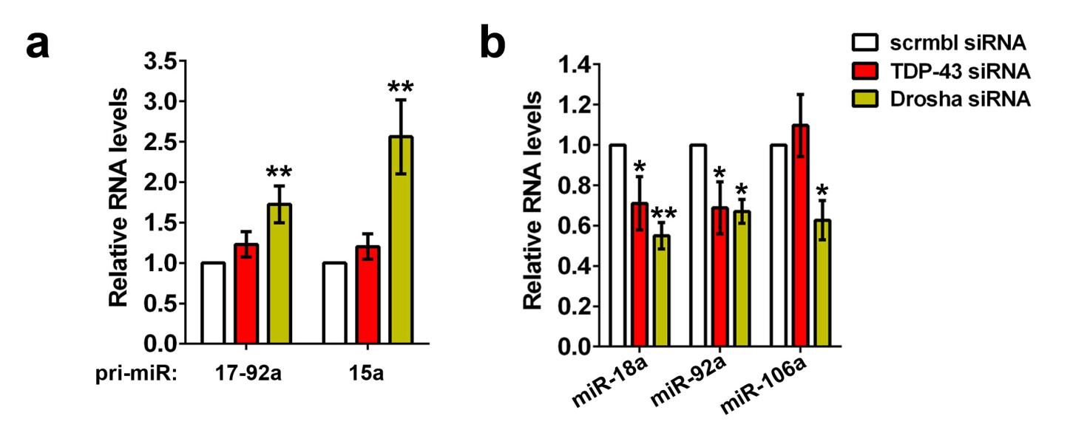
Additional file 2: Figure S2. Drosha or TDP-43 downregulation affects miRNA processing.
a Drosha knockdown leads to accumulation of miRNA precursors, pri-miR-17-92a and pri-miR-15a (n=4-6). **p<0.01 (one-way ANOVA with Holm-Sidak correction for multiple comparisons). Note the absence of significant accumulation of these pri-miRNAs in TDP-43 depleted cells, in accord with modulatory rather than essential function of this protein in miRNA processing in the nucleus.
b Drosha or TDP-43 knockdown leads to downregulation of mature miRNAs processed from pri-miR-17-92a (n=3). *p<0.05; **p<0.01 (one-way ANOVA with Holm-Sidak correction for multiple comparisons). Note that levels of all three mature miRNAs are significantly decreased in Drosha depleted cells, and TDP-43 knockdown also negatively affects two of the three miRNAs measured.

