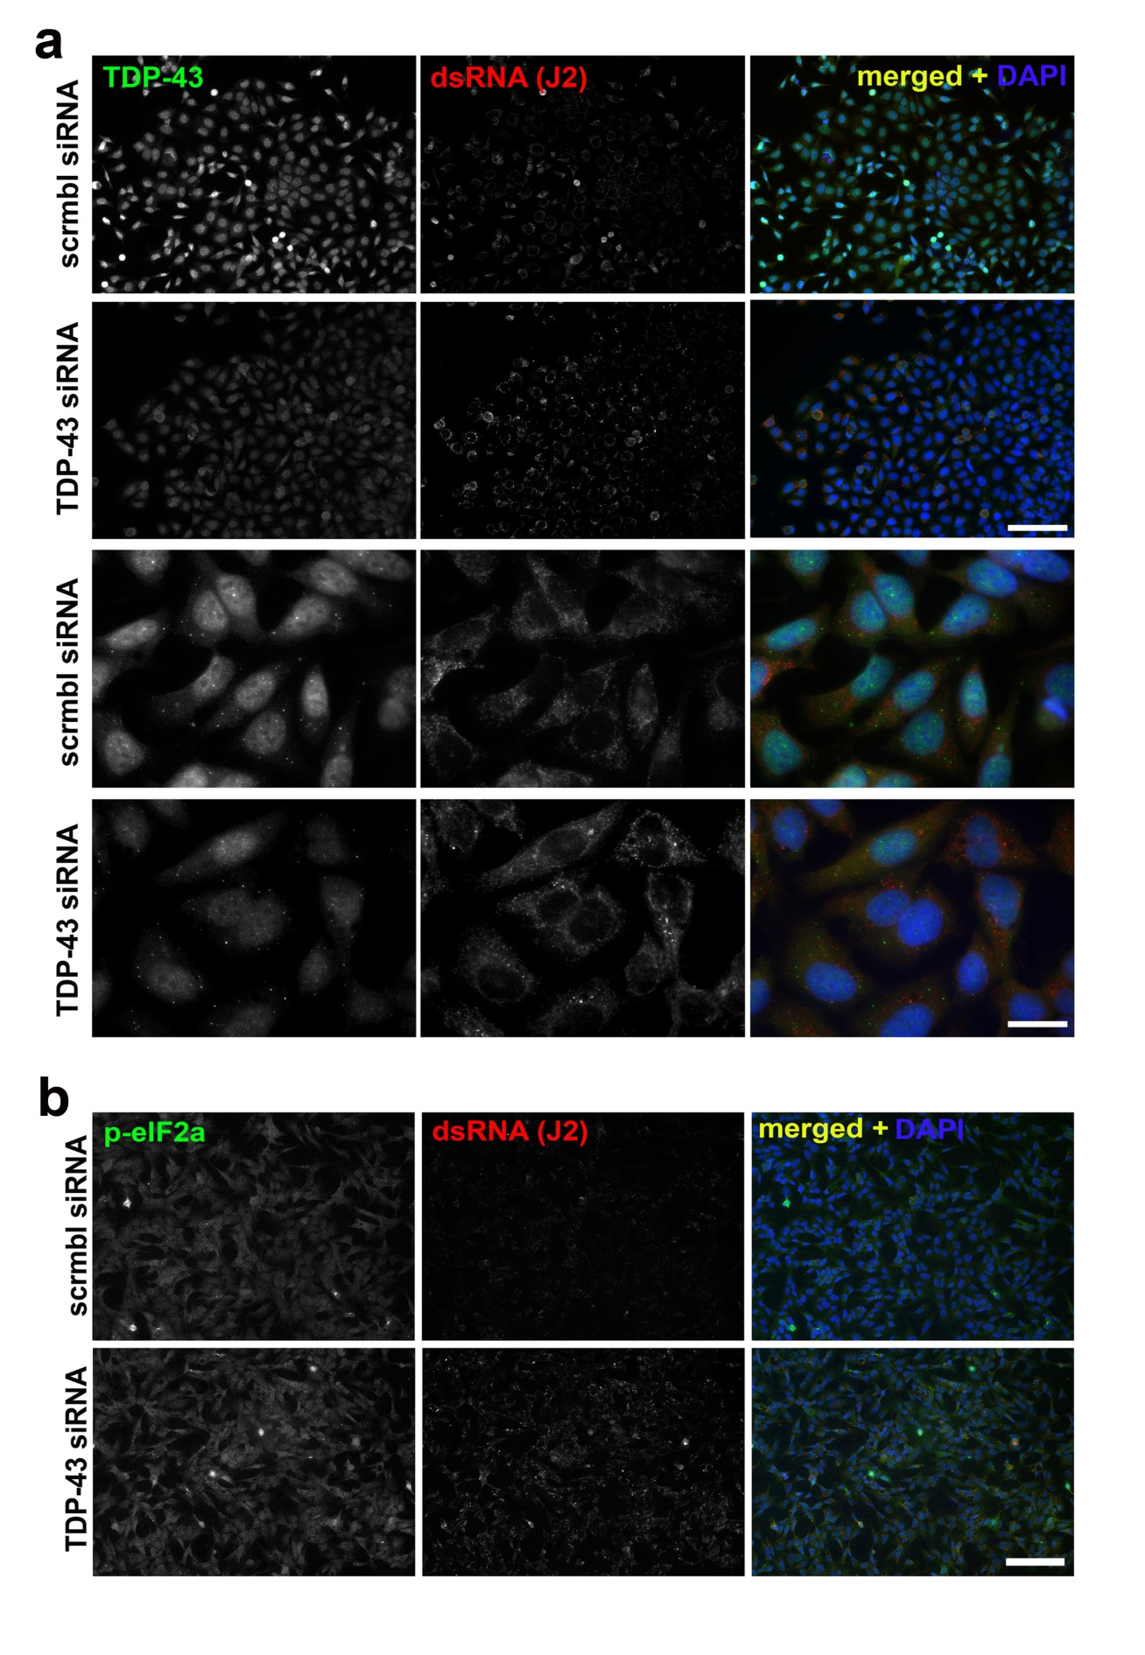
Additional file 3: Figure S3. Accumulation of dsRNA (a) and increased levels of p-eIF2α (b) in MCF7 cells depleted of TDP-43.
Cells were analysed 48 h post-transfection. Scale bars, 100 µm and 10 µm for general plane and close-up panels respectively.

