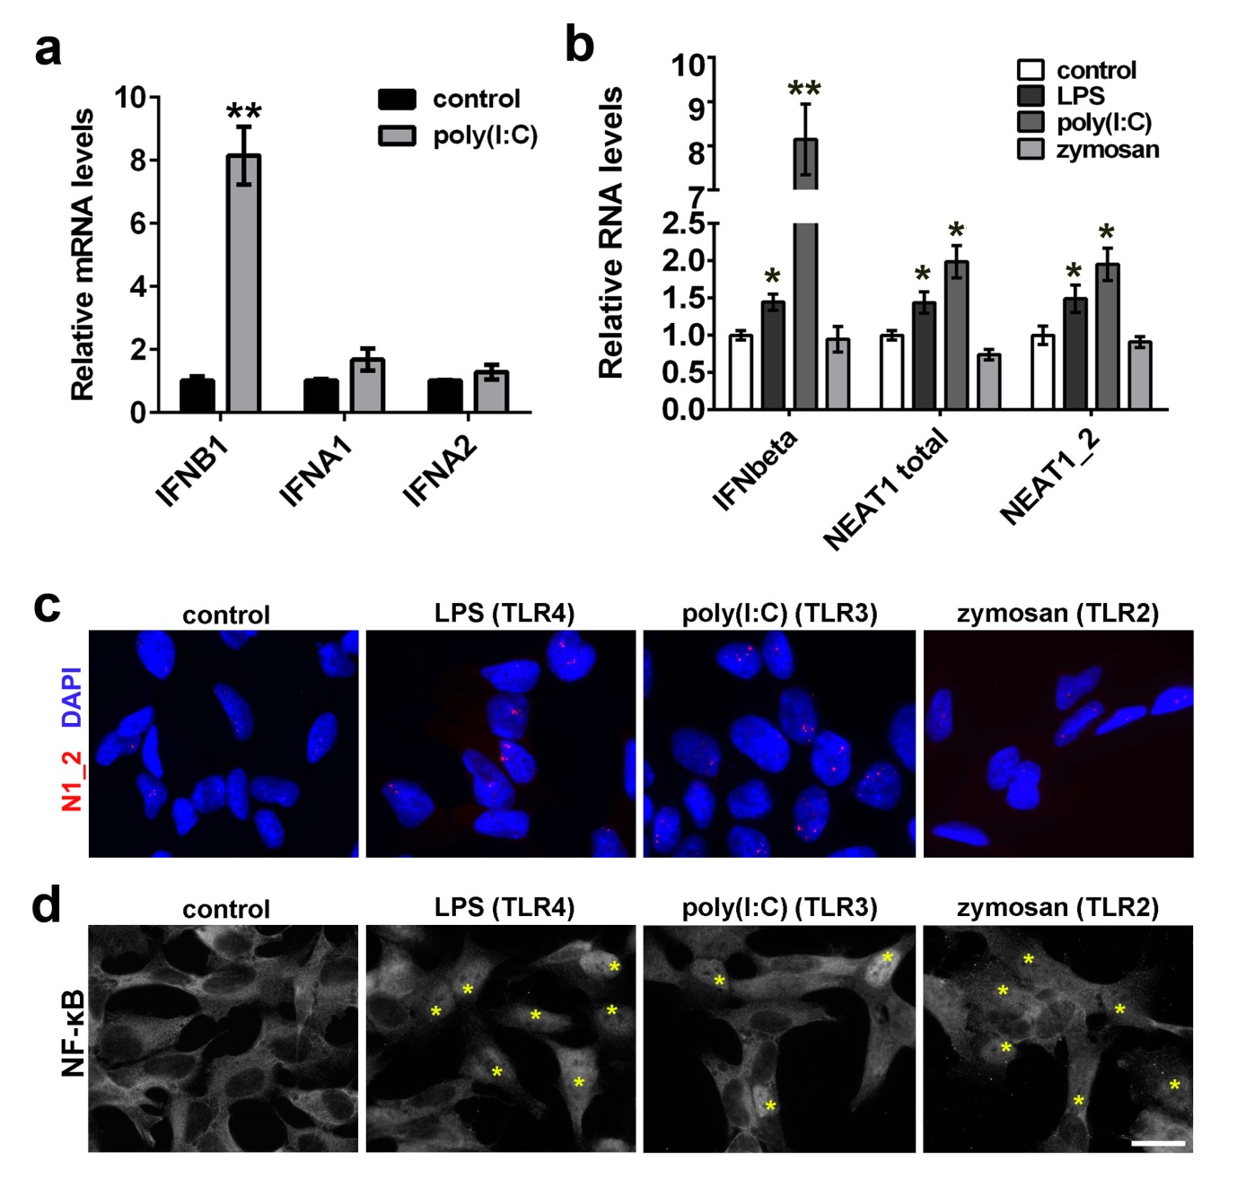
Additional file 4: Figure S4. The effect of IFN-inducing ligands on NEAT1 and paraspeckles.
a IFNbeta is robustly induced by poly(I:C) in neuroblastoma cells. Cells were analysed by qRT-PCR after 24 h of poly(I:C) stimulation (n=5). **p<0.01 (Mann-Whitney U-test).
b-d TLR3 and TLR4 ligands poly(I:C) and LPS, but not a TLR2 ligand zymosan, trigger IFNbeta response stimulating NEAT1 expression (b) and paraspeckle assembly (c). Cells were treated with poly(I:C), LPS or zymosan for 4 h and analysed by qRT-PCR (n=3 or 4). *p<0.05, **p<0.01. NF-κB nuclear translocation was examined in parallel to confirm the activity of the compounds (d, asterisks indicate cells with nuclear NF-κB). Scale bar, 10 µm.

