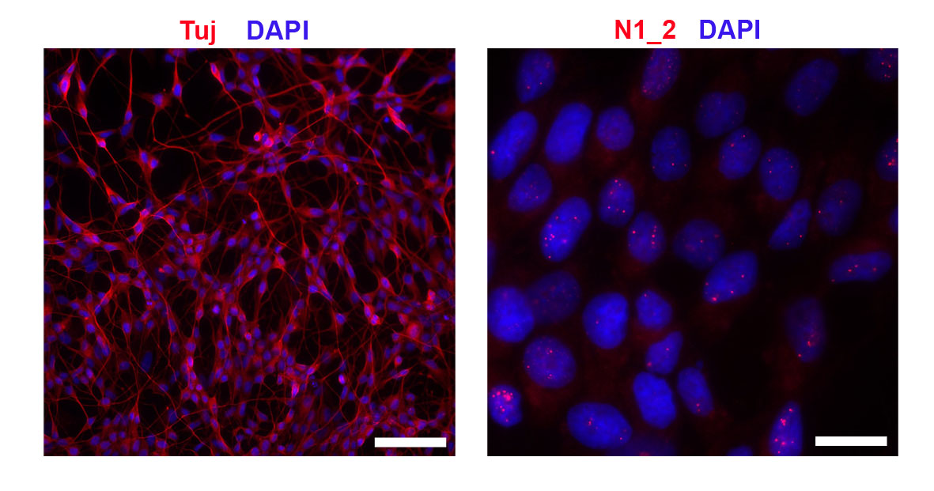
Additional file 5: Figure S5. Differentiation of human neuroblastoma cells into neuron-like cells does not lead to the loss of paraspeckles.
Differentiated SH-SY5Y cells develop extensive neurite network and are uniformly positive for a neuronal marker Tuj 1 (left panel) but preserve their ability to form paraspeckles (right panel). SH-SY5Y cells were induced to differentiate into neuron-like cells using retinoic acid/BDNF and analysed 6 days into differentiation by immunocytochemitry and NEAT1_2 RNA-FISH. Representative images are shown. Scale bars, 100 µm (left panel) and 10 µm (right panel).

