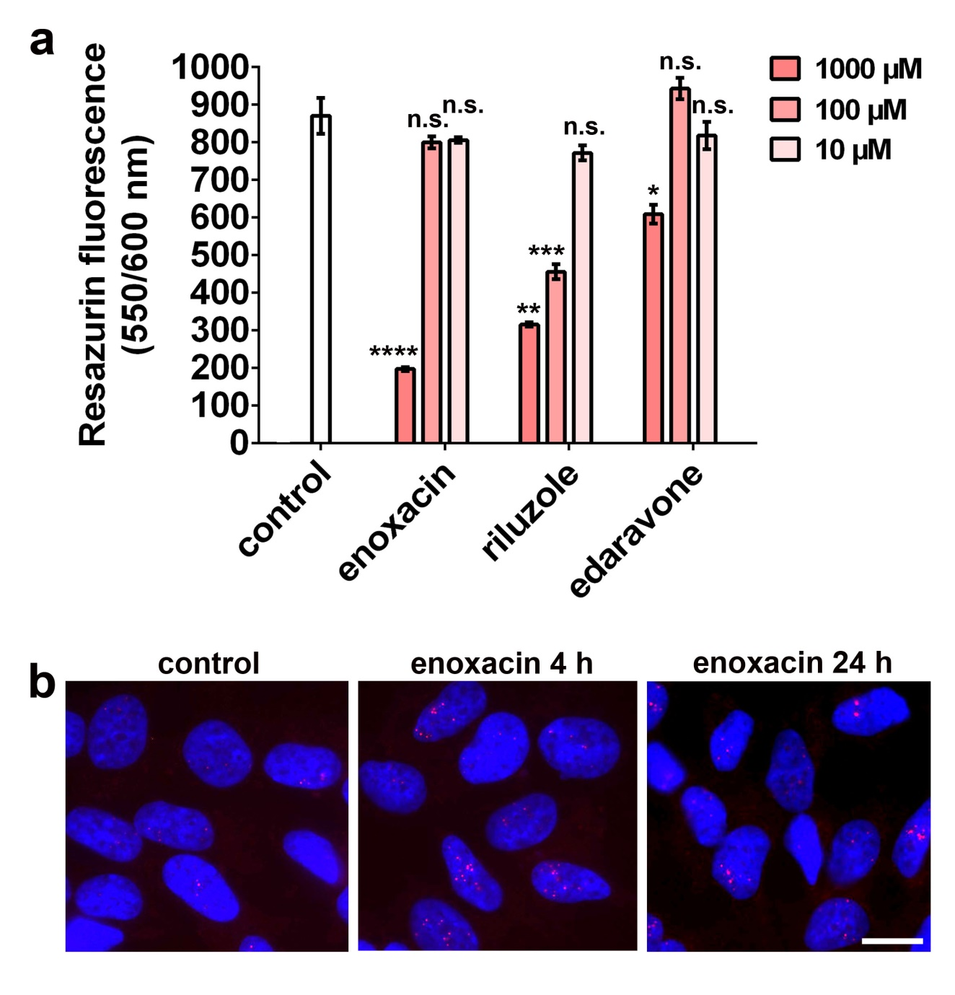
Additional file 6: Figure S6. Dose-dependent toxicity of enoxacin, edaravone and riluzole.
a SH-SY5Y cells were treated with corresponding doses of compounds for 24 hours, and toxicity was assessed using CellTiter Blue® Cell Viability Assay. *p<0.05, **p<0.01, ***p<0.001, ****p<0.0001 as compared to control (non-treated) cells (Kruskal-Wallis test with Dunn’s correction for multiple comparisons).
b Enoxacin enhances paraspeckle assembly both with short (4 h) and prolonged (24 h) treatment at a non-toxic concentration of 50 µM. Representative images are shown.

