Additional file

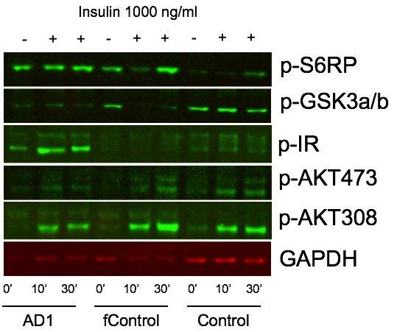

Figure S1. Western blots of iPSC-derived basal cholinergic neuroprecursors cell lines. Cells were insulin deprived overnight before the addition 1000 ng/ml of insulin (insulin was not added to time 0’). Lysates were collected at 0, 10, or 30-minute exposure. Quantified western blot data was normalized over Gapdh and expressed as fold change of 0 ng/ml dose. An effect on concentration response was detected by 2-way ANOVA if indicated. These data correspond to results of three independent experiments. ** P<0.01; *** P<.001. (H) Representative blots from a single experiment showing three of the lines.

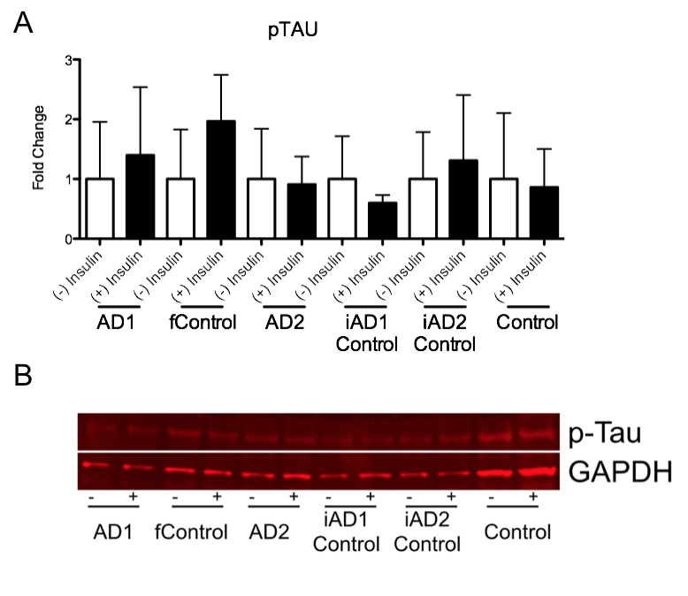

Figure S2. (A) Western blot quantification of iPSC derived basal cholinergic neurons (two independent experiments). Cells (DIV 34) were insulin deprived for 3 days or given 1000ng/mL every 24 hours for 3 days. (B) Representative blots from a single experiment.

