Additional file 1
Table S1.
 | Controls (n = 6) | AD (n = 6)
Gender (M/F) | (3/3) | (2/4)
Braak stage | 0 (1), 1 (2), II (2), III (1) | III (1), IV (1), V (3), V-VI (3)
CERAD | Negative (6/6) | Frequent (6/6)
Vascular risk factors | 6/6 | 4/6
APOE genotypes | ε3/ε3 (2), ε3/ε4 (4) | ε3/ε3(2), ε3/ε4 (3), ε4/ε4 (1)
Age of death | 76 ± 11 | 83 ± 6
Demographic and clinical features of human subjects used in this study. Abbreviations:
CERAD = Consortium to Establish a Registry for Alzheimer’s Disease. Mean ± SD.

Figure S1. Aβ deposition in microvessels in AD patients and APP ^{Swe} mice
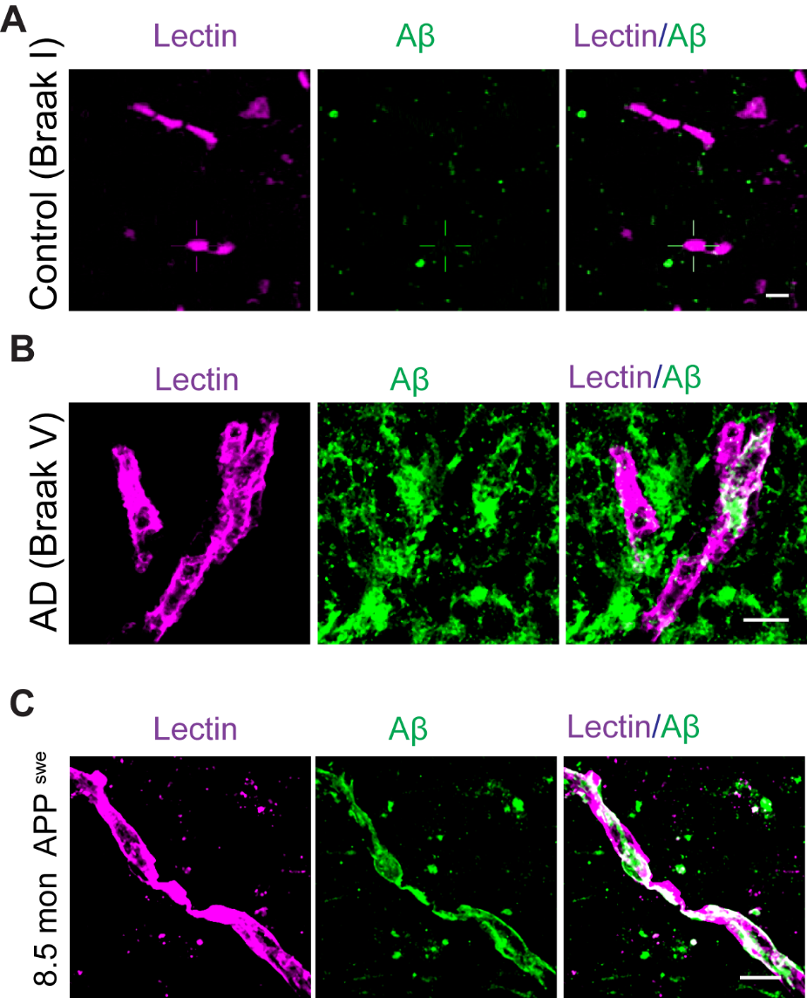
(A-C) Representative high resolution confocal microscopy analysis showing Aβ deposition (green) in Lectin-positive brain microvessels (magenta) in human control and AD patient (A, B), and 8.5 months old APP ^{sw/0} mice (C). Colocalization is shown as white. Scale bar: 10 µm.
Figure S2.

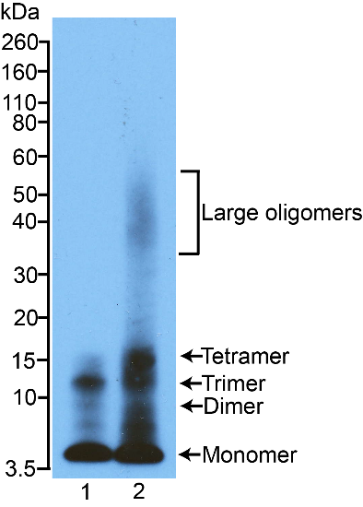
Western blot analyses of Aβ42 aggregates separated on a 4-12% Bis-Tris nonreducing SDS-PAGE and probed with the β-amyloid (D54D2) XP rabbit monoclonal antibody (Cat #8243S, Cell Signaling) recognizing the amino terminus of human Aβ. 1 µM Aβ42 in serum-free pericyte culture medium (freshly prepared, lane 1) and after 2 h incubation at 37°C (lane 2).

Figure S3. Cy3-Aβ42 cellular uptake in wild type mouse brain slices within 30 min.
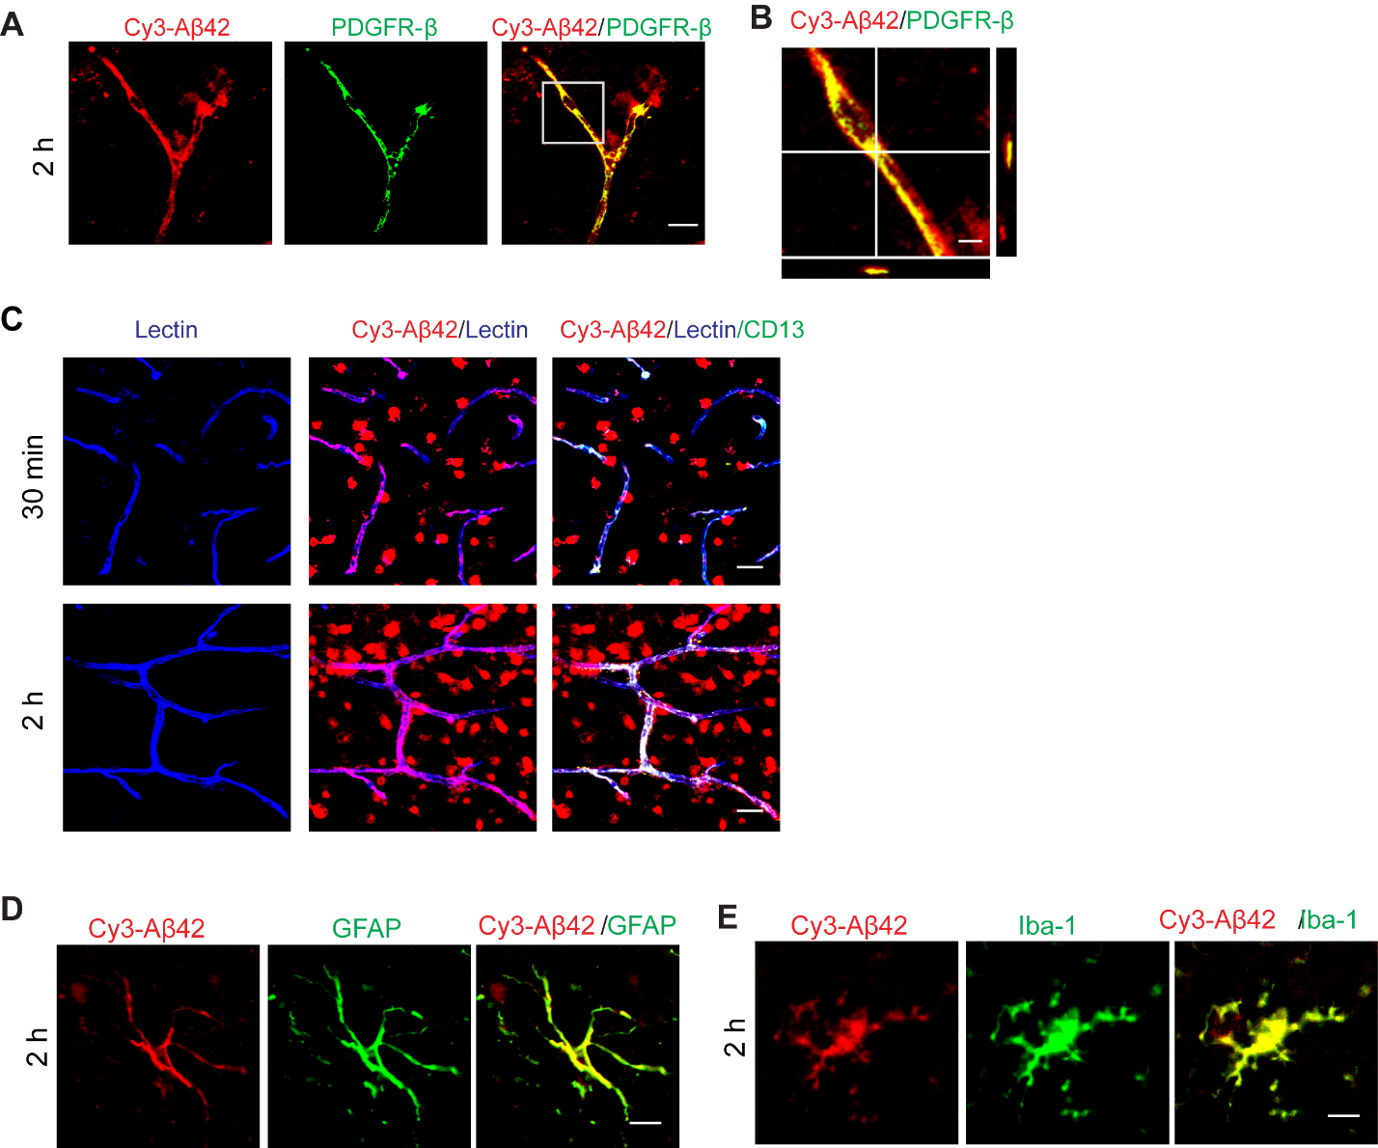
(A) Representative high resolution confocal microscopy images showing Cy3-Aβ42 (red) uptake by PDGFRβ-positive pericytes (green) in murine brain slices within 30 min in the presence of 5 µg/ml Cy3-Aβ42. Mouse brain slices were prepared as in Fig 5. Scale bar: 5 µm (B) Orthogonal views showing Cy3-Aβ42 (red) accumulation inside of a PDGFR-β-positive pericyte (green). Merge: yellow. (C) Representative high resolution confocal microscopy images showing Cy3-Aβ42 (red) uptake by lectin-positive endothelial cells (green) in murine brain slices 30 min or 2 h after 5 µg/ml Cy3-Aβ42 treatment. Scale bar: 20 µm. (D, E) Representative images showing Cy3-Aβ42 uptake by GFAP-positive astrocyte (C) and Iba-1-positive microglia (D). Scale bar: 20 µm.

Figure S4. Pericyte coverages in Lrp1^{lox/lox} and Lrp1^{lox/lox}; Cspg4-Cre mice.
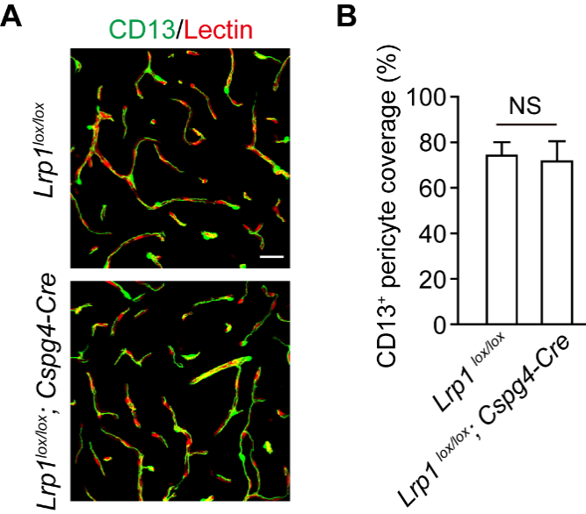
Figure S4. (A) Representative confocal images showing CD13-positive pericytes and lectin-positive endothelium in the cortex of Lrp1^{lox/lox} and Lrp1^{lox/lox}; Cspg4-Cre mice, as used in Figure 3. Bar = 25 µm. (B) Quantification of CD13+ pericyte coverage over lectin+ endothelial profiles. N = 3 mice per group; mean ± s.e.m.; NS, not significant, by Student’s t-test.

Figure S5. LRP1 and apoE suppression with siRNA

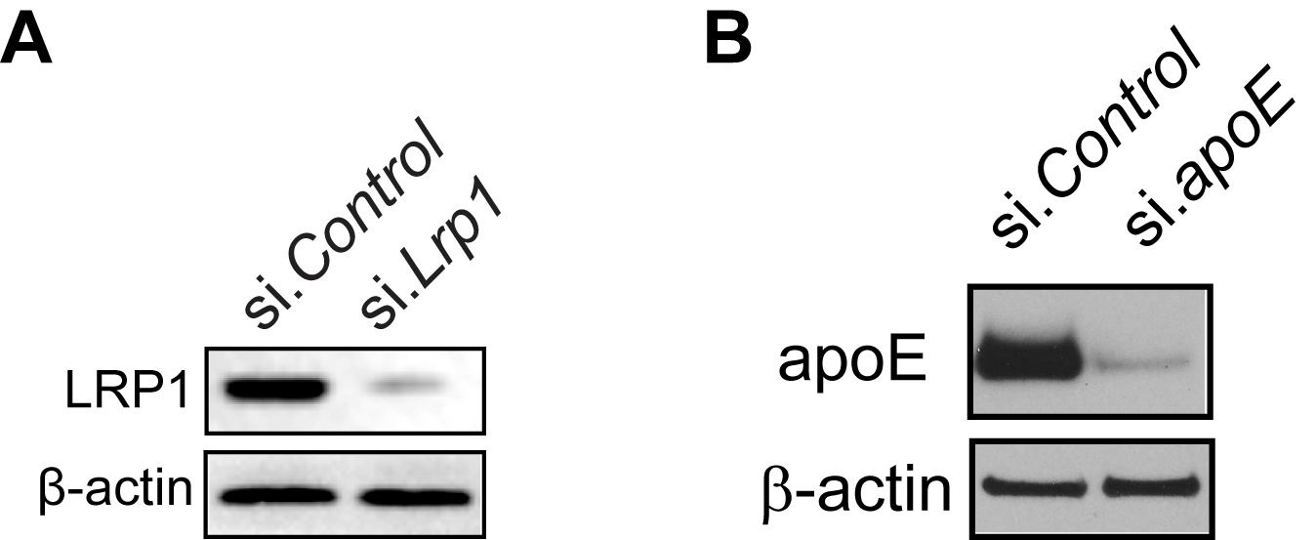

(A) Western blot of LRP1 level in cultured pericytes at 24 h after si.Control or si.Lrp1 transfection. Actin is used as a loading control. (B) Western blot of apoE in cultured pericytes at 24 h after si.Control or si.apoE transfection. Actin is used as a loading control.

