Figure S1
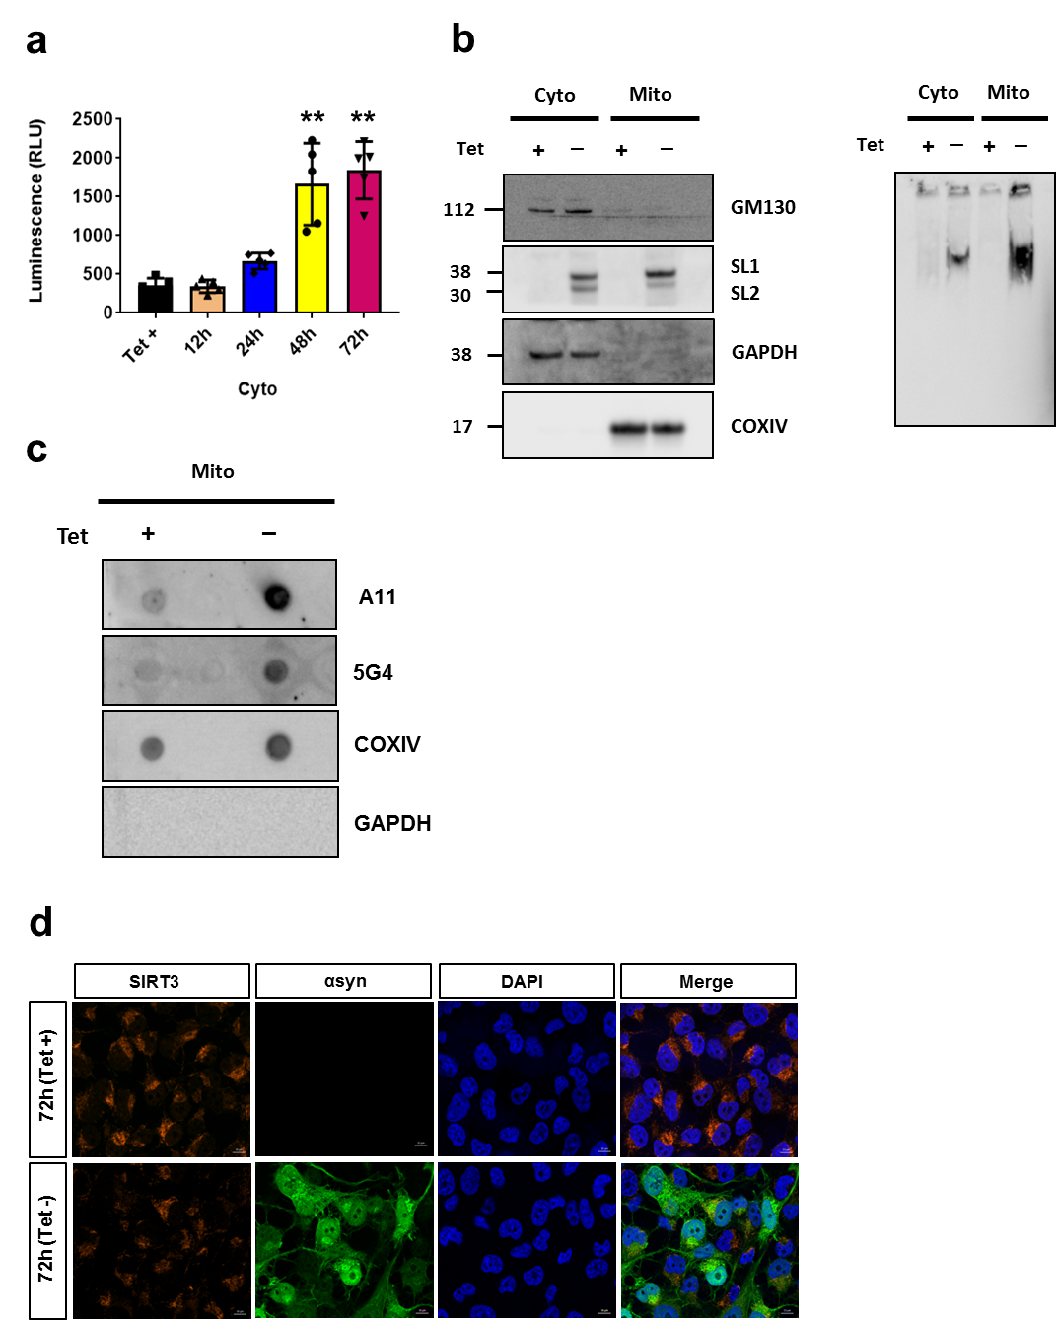

Figure S1: (a) Luciferase activity in cytosolic fractions of H4 SL1&SL2 cells over time, n=5 (b) Representative cropped western blots western blots of denaturing SDS-page (n=4) and native-page performed at 72h to confirm the purity of the mitochondrial-enriched fractions, the lysates were probed for the golgi marker (GM130), inner mitochondrial membrane marker (COXIV), GAPDH, total αsyn levels, and αsyn oligomers in cytosol and mitochondria from H4 SL1&SL2 cells. (c) Representative image of α-syn oligomer dot-blot assay at 72h with amyloid-specific antibody A11 and αsyn disease-associated 5G4 antibody. (d) SIRT3 expression was detected by immunofluorescence in mitochondria. SIRT3 expression is decreased at 72h in cells overexpressing αsyn. Representative image from 3 experiments. DAPI (nucleus; blue); αsyn (green); SIRT3 (mitochondria; orange); merged images (yellow). Scale bar = 10 μm. Error bars represent the mean ± SD (n = 3-5). **p < 0.01.

