Figure S3

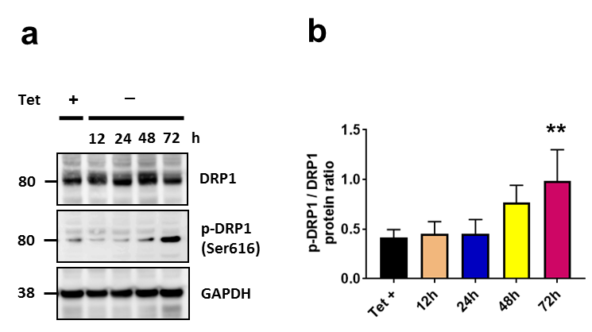

Figure S3: (a) Representative cropped western blot from showing DRP1 and p-DRP1 (Ser 616) in whole cells lysates from H4 SL1&SL2 cells over time (n=4). Removal of tet leads to significantly increased p-DRP1 by 72h. (b) Quantification of p-DRP1/DRP1 protein ratio in whole cell lysates. Error bars represent the mean ± SD. **p < 0.01.

