Figure S4
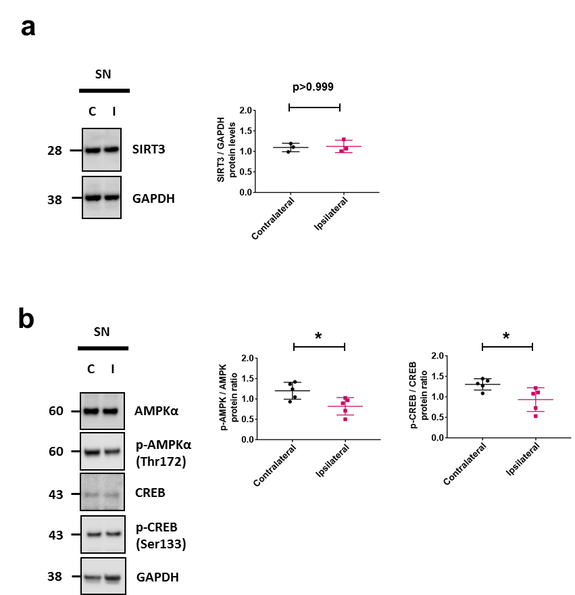

Figure S4: (a) Representative cropped western blot of lysates from dissected substantia nigra/midbrain (SN) of three rats injected unilaterally with control virus, AAV8-Hgluc (gaussia luciferase) demonstrates no change in SIRT3 protein levels when contralateral (C) uninjected SN is compared to ipsilateral (I) injected SN (b) Representative cropped western blot of AMPKα, p-AMPKα (Thr 172), CREB, and p-CREB (Ser 133) in SN lysate of AAV8-SL1&SL2 injected rat. αSyn expression leads to decreased p-AMPK and p-CREB protein levels in ipsilateral (I) injected SN compared to contralateral (C) uninjected SN, n=5 rats total. Error bars represent the mean ± SD. *p < 0.05, **p < 0.01.

