ADDITIONAL FILE 13:
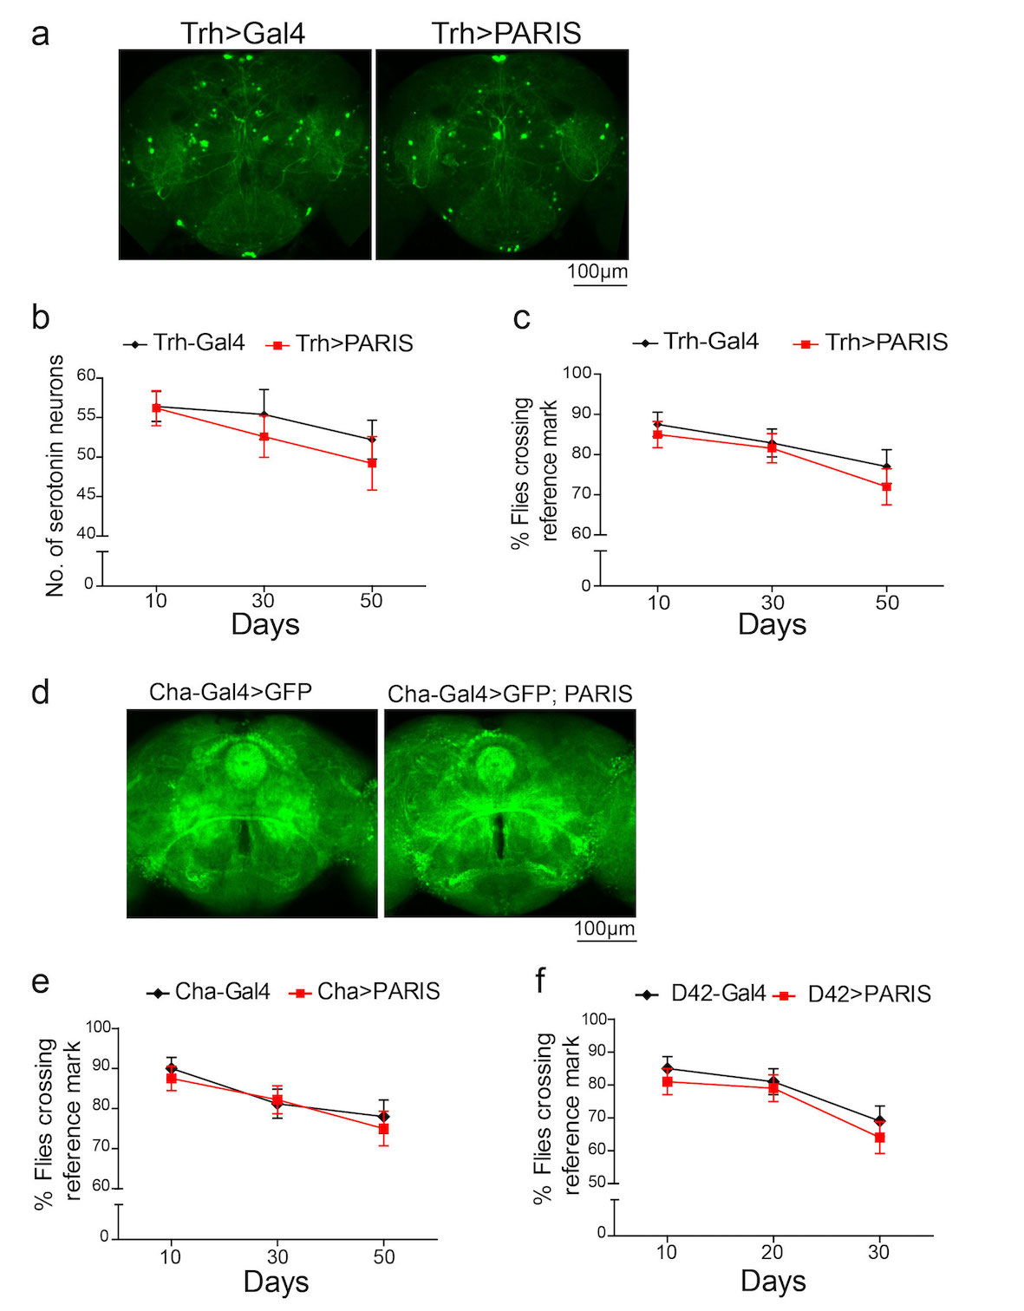
Figure S3. Specific expression of PARIS in Drosophila 5-HT or cholinergic neurons does not cause neuron loss and climbing defects. (a) Representative confocal images showing location of 5-HT neurons in adult Drosophila brain visualized by GFP immunofluorescence in 20-day old flies of the indicated genotype (b) Serotonergic expression of PARIS using Trh-Gal4 does not cause progressive loss of 5-HT neurons compared to control (Trh-Gal4>GFP). N=10 flies per indicated genotype. (c) Trh-Gal4 mediated expression of PARIS in 5-HT neurons does not cause progressive decline in climbing performance. N=80 flies per indicated genotype. (d) Representative confocal images of cholinergic neurons visualized by GFP immunofluorescence show overall neuron number unaffected in flies expressing PARIS under the control of Cha-Gal4 driver compared to control flies (Cha-Gal4>GFP). (e) Cha-Gal4 mediated expression of PARIS in cholinergic neurons does not cause age-related climbing defects. N=80 flies per indicated genotype. (f) D42-Gal4 mediated expression of PARIS in motor neurons has no discernible effect on climbing performance compared to control flies (D42-Gal4/+). N=80 flies per indicated genotype. Quantitative data = mean ± SEM. Unpaired two-tailed Student’s t test, p>0.05. (TIFF)

