ADDITIONAL FILE 15:
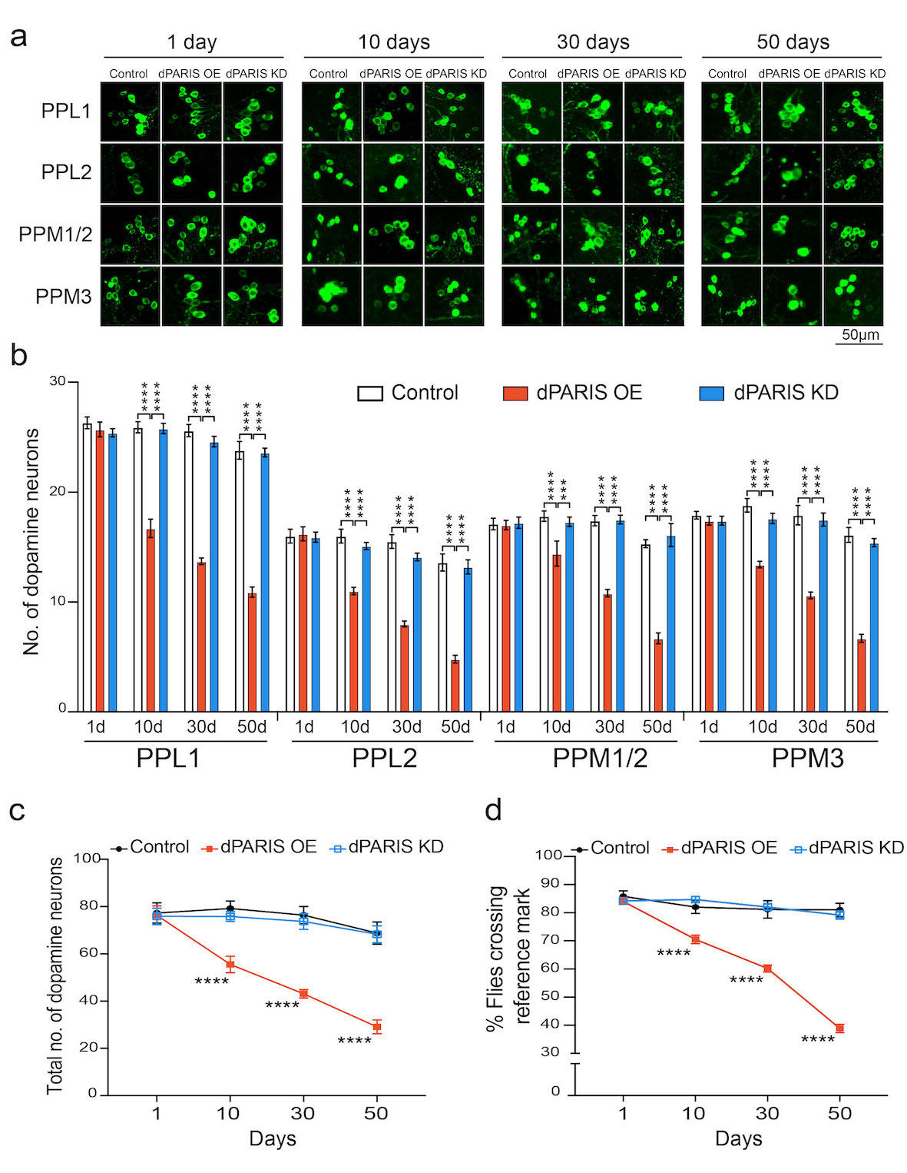
Figure S5. Drosophila homolog of PARIS causes age-dependent loss of DA neurons and climbing defects. (a) Representative confocal images of individual DA neurons in PPL1, PPL2, PPM1/2, and PPM3 DA neuron clusters in the indicated genotypes on 1, 10, 30- and 50-days post eclosion. Scale 50 μm. (b) Quantification of DA neuron numbers in PPL1, PPL2, PPM1/2, and PPM3 clusters for the indicated genotypes at the different time points, N=10 flies per genotype. Quantitative data = mean ± SEM. One-way ANOVA ***p < 0.001, ****p < 0.0001. (c) Quantification of total number of DA neurons at the indicated time points show progressive loss of DA neurons in flies expressing dPARIS under the control of TH-Gal4 driver. TH-Gal4 driven knockdown (KD) of dPARIS exhibits neuron loss comparable to control (TH-Gal4/+). N=10 flies per indicated genotype. Quantitative data = mean ± SD. One-way ANOVA ****p < 0.0001. (d) Climbing performance in TH>dPARIS flies shows age-dependent decline compared to TH>dPARIS KD and control flies (TH-Gal4/+). N=60 flies per indicated genotype. Quantitative data = mean ± SEM. One-way ANOVA ****p < 0.0001. (TIFF)

