Supplementary Figure 1: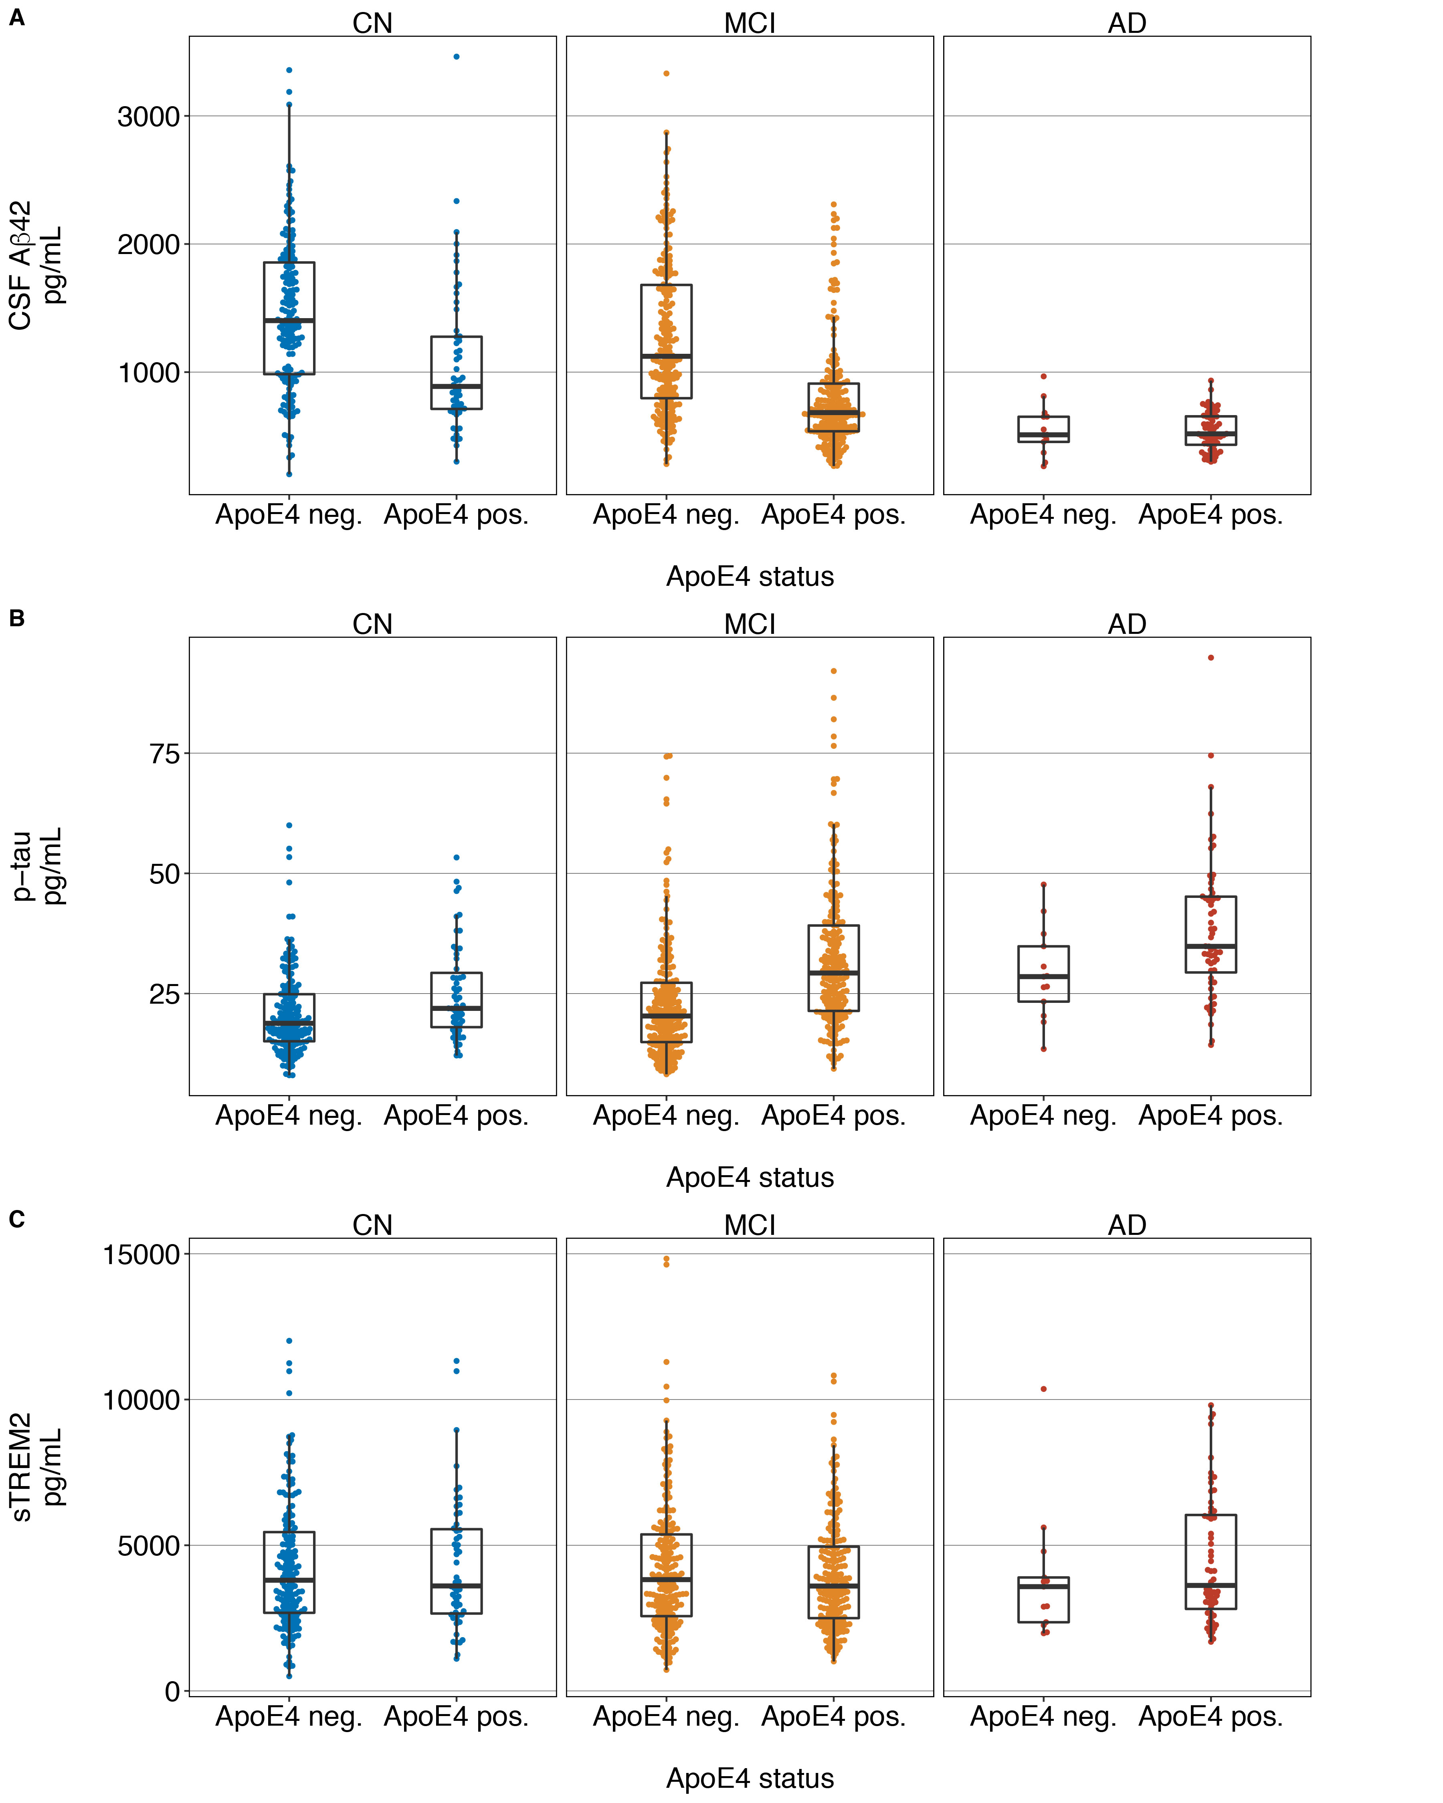
Associations between ApoE4-status, baseline AD biomarkers ((A) Aβ₁₋₄₂, (B) p-tau₁₈₁) and (C) baseline sTREM2 stratified by diagnostic groups
Supplementary Figure 2:
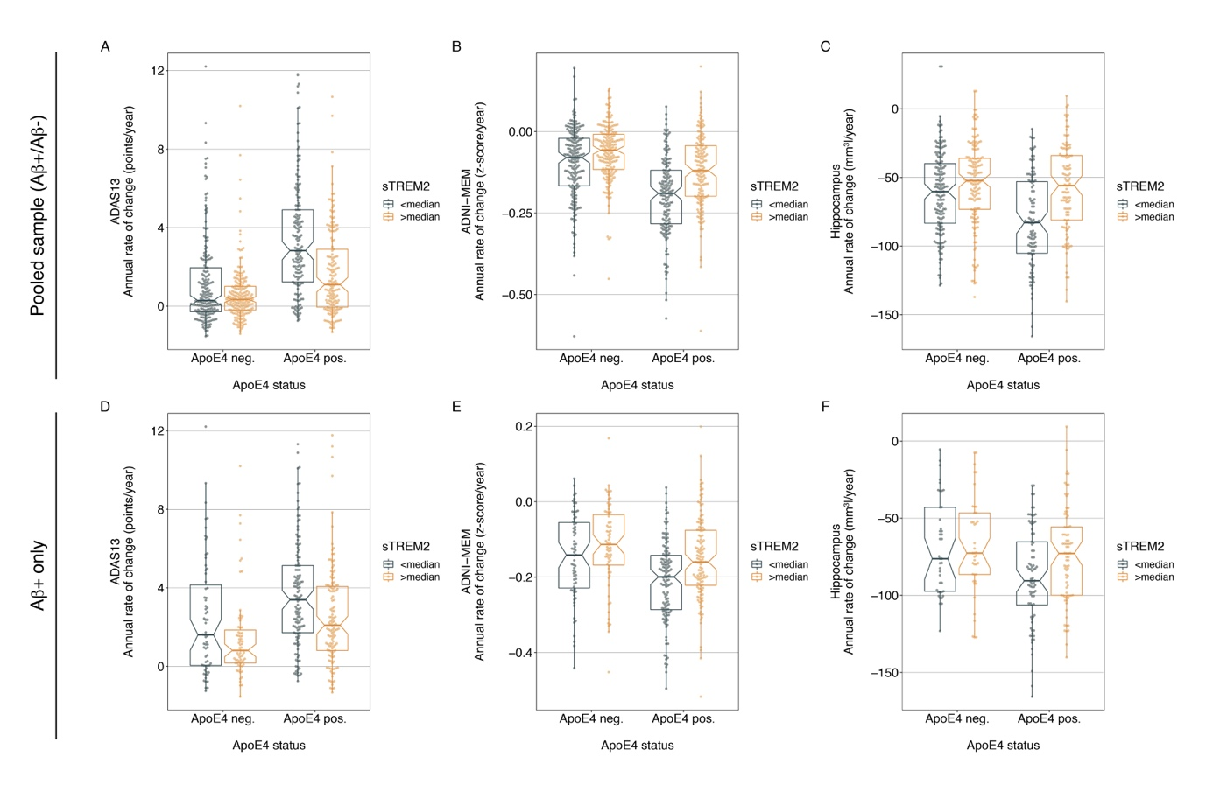
Panels A-C illustrate the interaction effect of sTREM2 on longitudinal ApoE4-related changes in global cognition (A), memory (B) and hippocampal volume changes (C) in the pooled Aβ+/Aβ- sample using raw cognitive change rates. For illustrational purposes, the sTREM2 levels are split at the median for ApoE4 negative and ApoE4 positive subjects. Statistics were, however, computed using continuous sTREM2 measures. Panels D-F illustrate the same interaction effects of sTREM2 on longitudinal ApoE4-related changes restricted to Aβ+ subjects.

