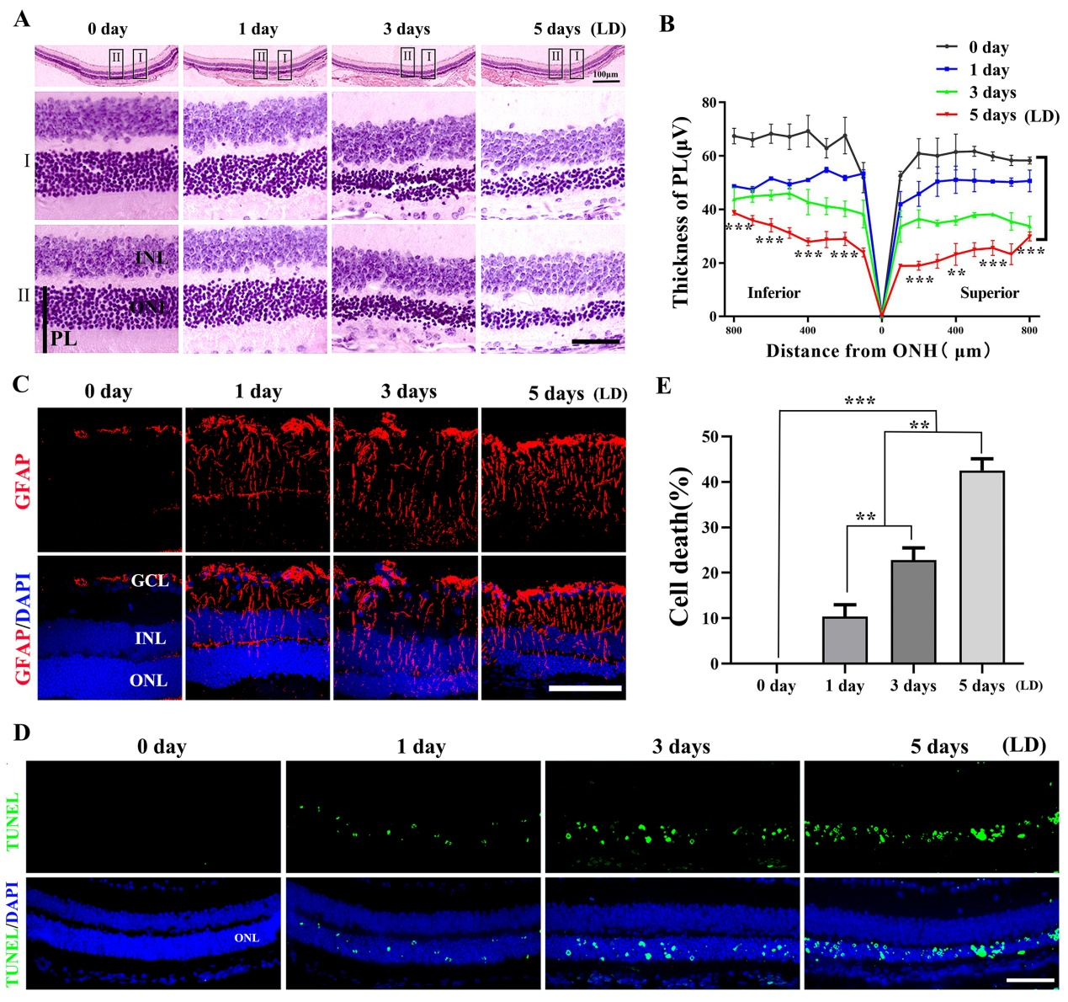
Additional file 1:
Figure S1. Photoreceptor degeneration is aggravated with increasing duration of light exposure. (A) Representative histological H&E staining of retinas from the 2-month-old albino mice exposed to LD. (B) The curve diagram shows the thickness of PL of mice kept under the indicated conditions (Error bars: SD; n=6, one-way ANOVA). (C) Representative immunostaining images for GFAP in retinas from albino mice exposed to high-intensity light for the indicated times. (D) Representative images of TUNEL assays of retinas of albino mice exposed to high-intensity light for the indicated times. (E) Quantification of cell death in the ONL of the retinas from albino mice kept under the indicated conditions (Error bars: SD; n=3, one-way ANOVA). GCL, ganglion cell layer; INL, inner nuclear layer; ONL, outer nuclear layer; PL, photoreceptor layer. * or ** or *** indicates p<0.05 or p<0.01 or p<0.001. Scale bar: 50 μm.

