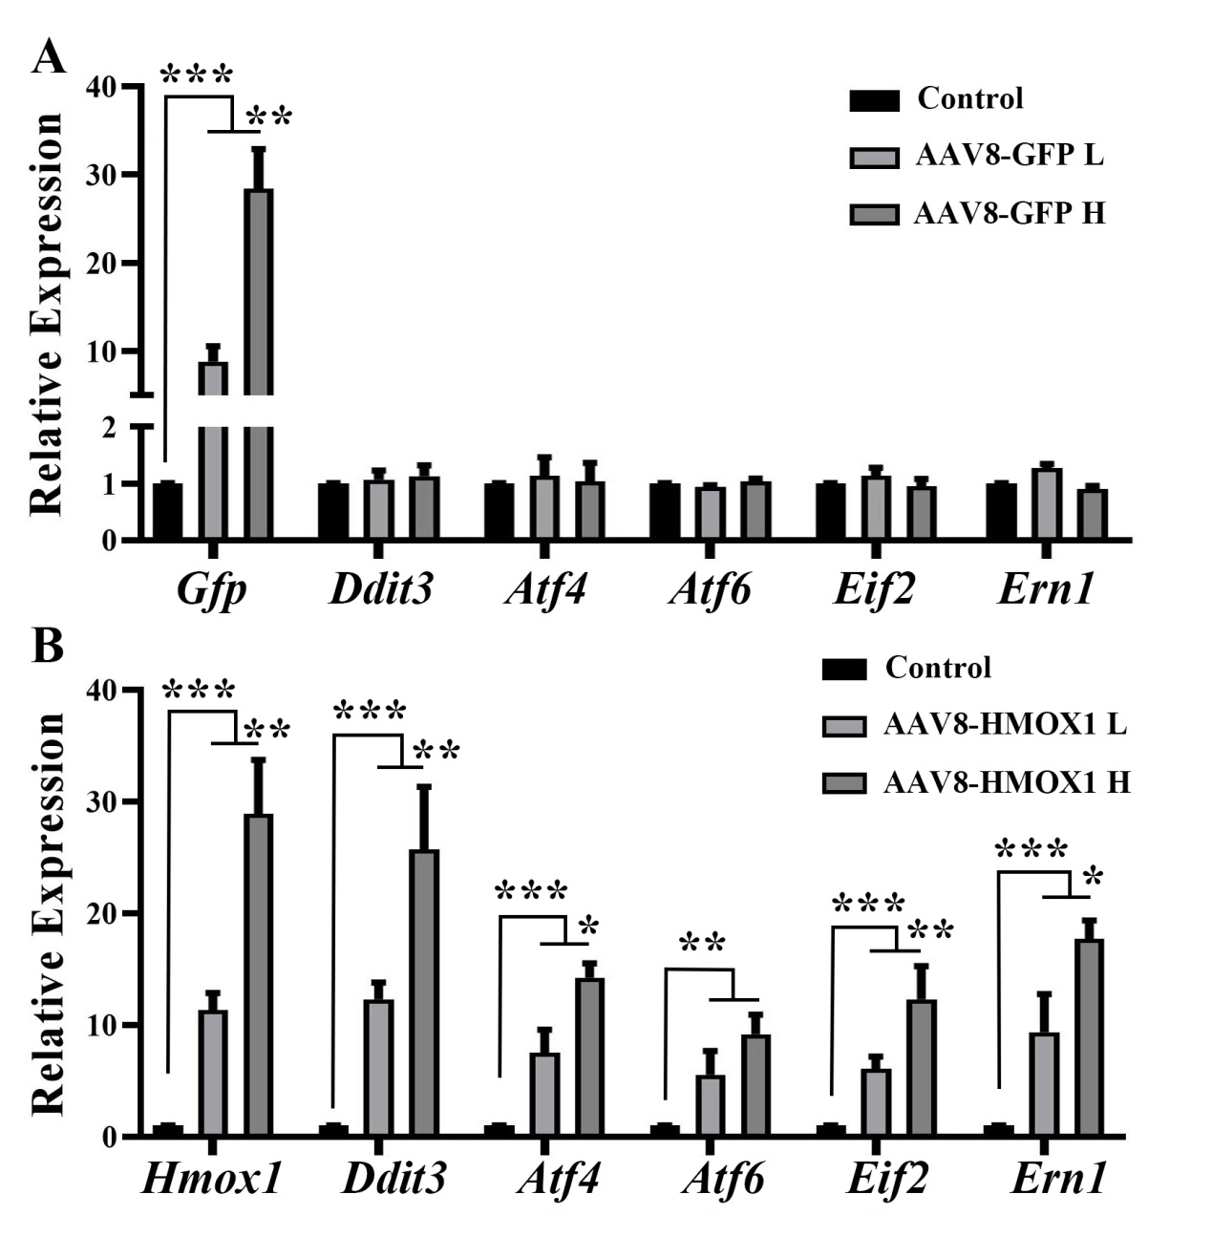
Additional file 3:
Figure S3. AAV8-HMOX1 up-regulates expressions of ER stress-related genes. 2-month-old albino mice were infected by the indicated virus and after two weeks subjected to gene expression analysis. (A) Quantification of q-RT-PCR shows expression of Gfp and other ER stress-related genes in the retinas infected with the low or the high dose of AAV8-GFP (Error bars: SD; n=3, one-way ANOVA). (B) Quantification of q-RT-PCR shows expression of Hmox1 and ER stress-related genes in retinas infected by the low or the high dose of AAV8-HMOX1 after 2 weeks (Error bars: SD; n=3, one-way ANOVA). Note that upregulation of ER stress-related genes by AAV8-HMOX1 is dose-dependent. * or ** or *** indicates p<0.05 or p<0.01 or p<0.001.

