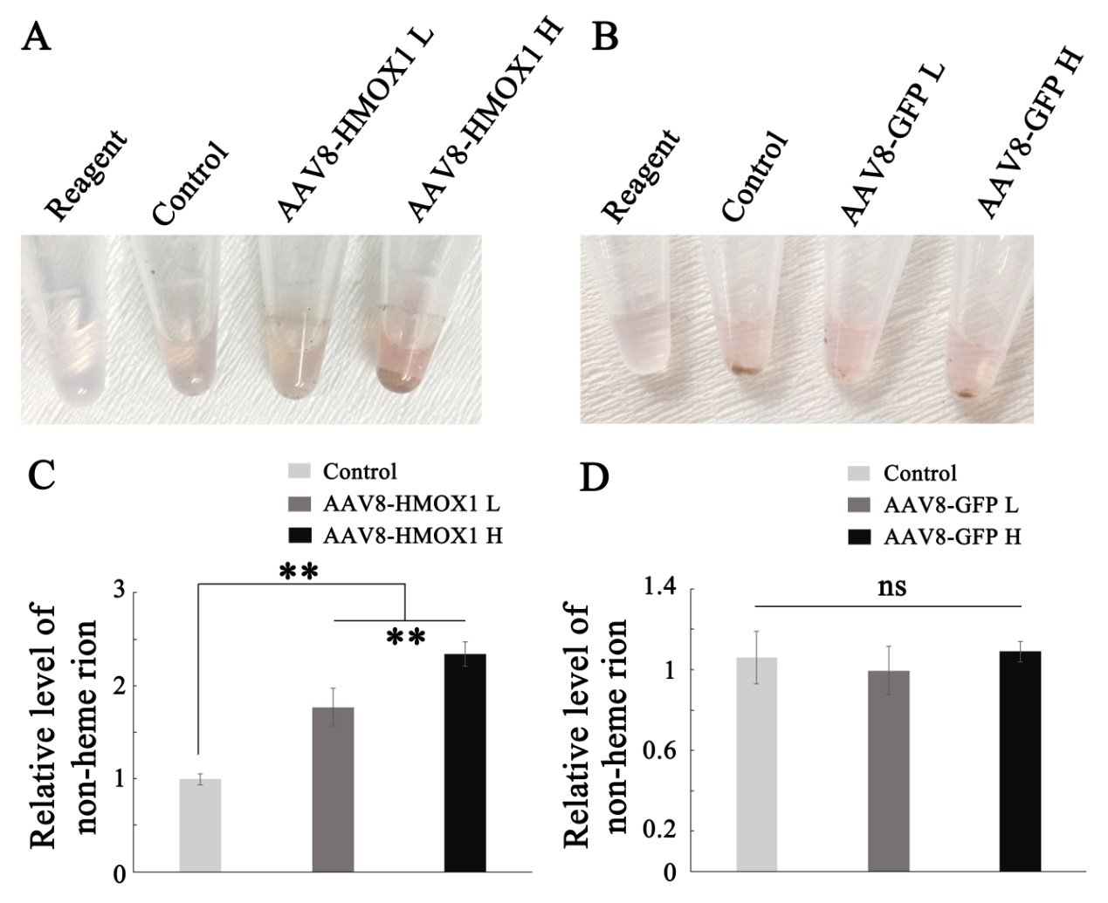
Additional file 4:
Figure S4. AAV8-HMOX1 increases the level of non-heme iron in neural retinas. 2-month-old albino mice were infected with the indicated virus and after two weeks subjected to non-heme iron examination. (A, B) Images of chromogenic reaction solution from retinas infected with a low or high dose of AAV8-HMOX1 (A) or AAV8-GFP (B). “Reagent” corresponds to the reaction solution, and “Control” to the result obtained with neural retinas without virus infection. (C, D) Quantification of the relative level of non-heme iron in the retinas infected with the low or the high dose of AAV8-HMOX1 (C) or AAV8-GFP (D) (Error bars: SD; n=5, one-way ANOVA). Note that increase of non-heme iron by AAV8-HMOX1 is dose-dependent. ** indicates p<0.01.

