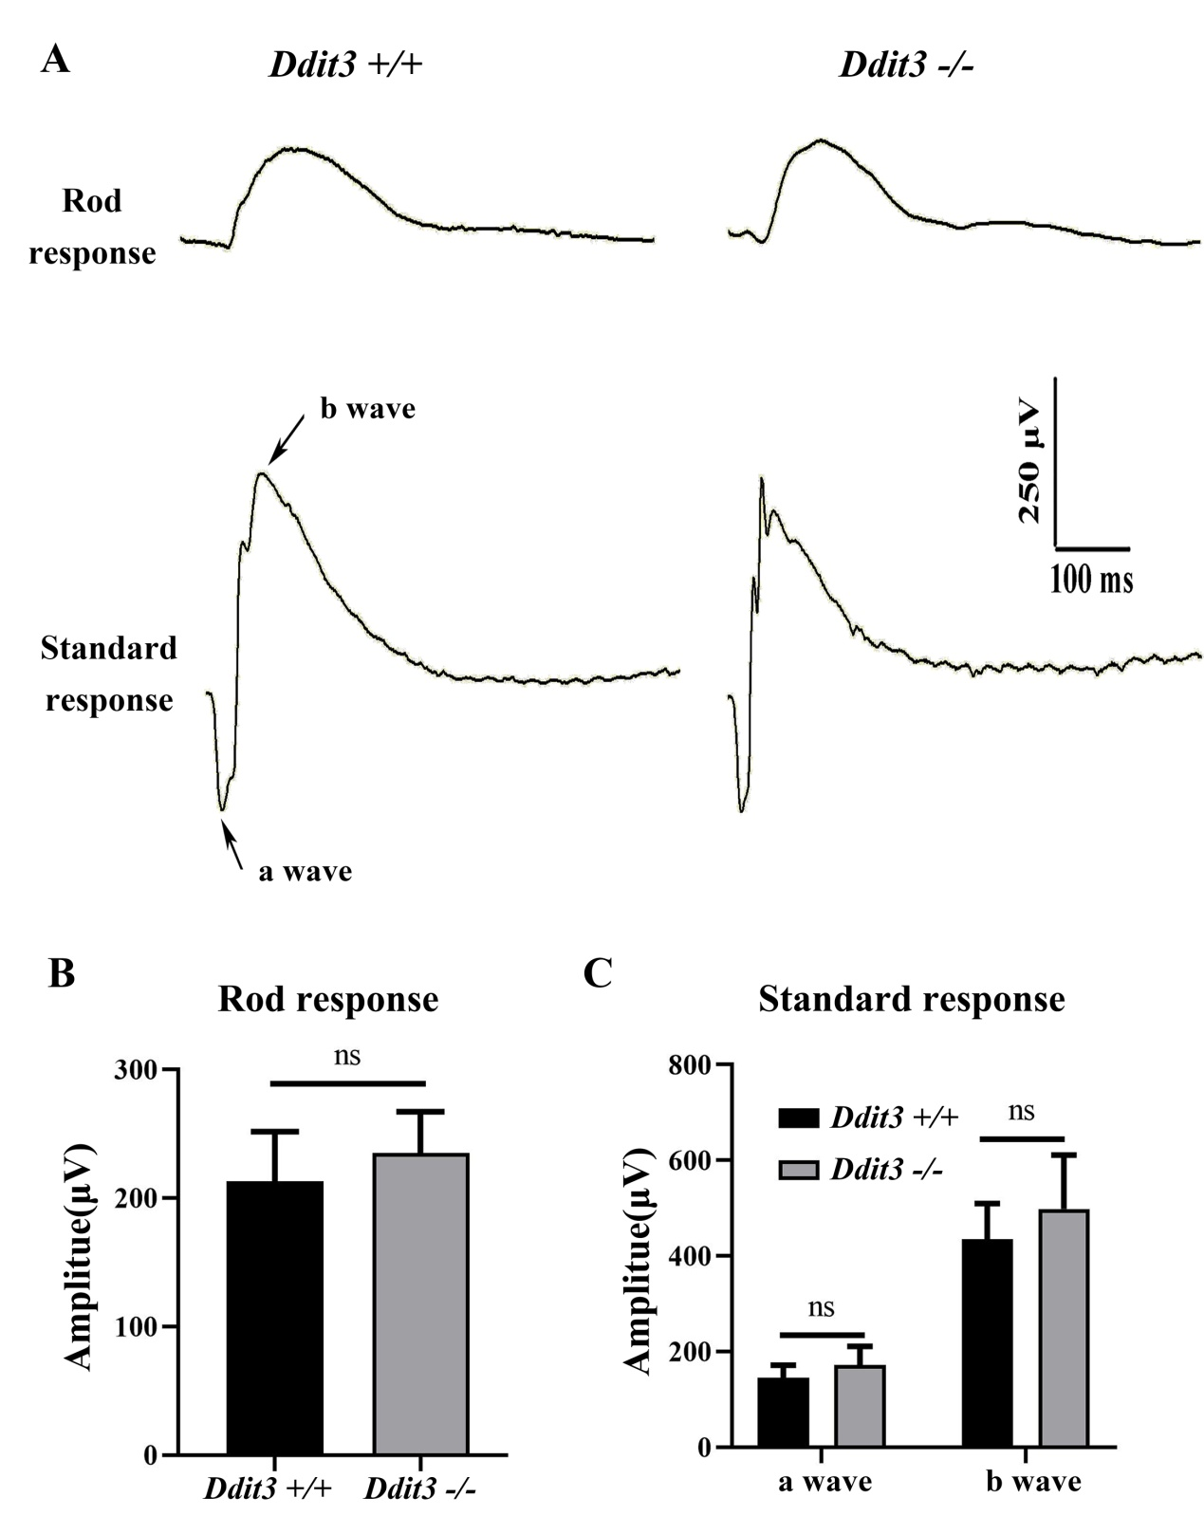
Additional file 6:
Figure S6. Deletion of Ddit3 does not disrupt retinal function. (A) ERG traces of 2-month-old Ddit3+/+ (left panels) and Ddit3-/- mice (right panels) in rod response and standard response. (B, C) Quantification of ERG amplitudes in rod response (B) and standard response (C) according to the results form B (Error bars: SD; n=4, Student T-test).

