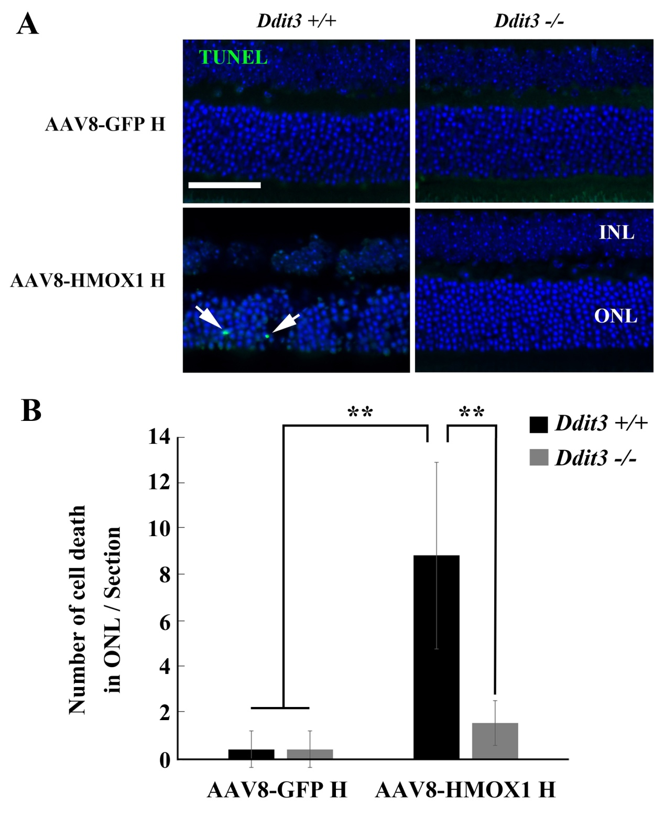
Additional file 7:
Figure S7. Deletion of Ddit3 prevents photoreceptor cell death induced by the AAV8-mediated high dose of HMOX1. (A) Representative images of TUNEL assays from 2-month-old Ddit3+/+ (left panels) and Ddit3-/- (right panels) retinas 2 weeks after infection with the high dose of AAV8-GFP (upper panels) or of AAV8-HMOX1 (lower panels). (B) Quantification of cell death in the ONL of the Ddit3+/+ and Ddit3-/- retinas infected with the high dose of AAV8-GFP or of AAV8-HMOX1 (Error bars: SD; n=4, one-way ANOVA). Note that deletion of Ddit3 rescues photoreceptor cell death caused by the high dose of AAV8-HMOX1. INL, inner nuclear layer; ONL, outer nuclear layer. ** indicates p<0.01. Scale bar: 50 μm.

