Supplemental Material

Top features | Cluster 1 | Cluster 2 | Cluster 3 | Cluster 4 | Cluster 5 | Cluster 6 | Cluster 7 | Cluster 8
1 | Agt | Lhx2 | Dclk1 | Agt | Gnao1 | 6330403K07Rik | Gm28437 | Gm10925
2 | Sparc | Pantr1 | Cspg5 | Sparc | Fam13c | Fxyd6 | CT010467.1 | Gm28661
3 | lgsf1 | Rgcc | Mfge8 | Lrig1 | Clmn | Meg3 | Gm10800 | Gm28437
4 | Slc6a11 | Bmyc | Gnao1 | Trpm3 | Cadm1 | Slc38a1 | Atp1a2 | Kif5a
5 | ltih3 | Hopx | Atp1b1 | Chl1 | Hapln1 | Gfap | Ddx17 | Gm29216
6 | A330076C08Rik | Ppp1r3g | Fjx1 | Plce1 | Dclk1 | Basp1 | Lars2 | Bcas1
7 | Cd81 | Cbr3 | Pde10a | A330076C08Rik | Chrdl1 | Bex4 | Col11a2 | Gm13339
8 | Nkx6-2 | Gnao1 | Slco1c1 | Slc6a11 | Dio2 | Rtn1 | Gm26917 | Fth1
9 | Sfrp5 | Ddah1 | Chst2 | lgsf1 | Slco1c1 | Slc6a6 | Nsmf | Mobp
10 | Etnppl | Ezr | Cadm1 | ltih3 | Chst2 | Bex1 | Rapgef3 | Rapgef4
11 | Cit | Chst2 | Lhx2 | Spon1 | Mertk | Ndn | Gm13339 | CT010467.1
12 | Rdh5 | ld4 | Hopx | Gm42583 | Atp1b1 | App | Fgfr3 | Mbp
13 | Nkain4 | Ptn | Gria2 | Ptch1 | St6galnac5 | Map1b | Gm21738 | Rplp1
14 | lrx5 | Atp1b1 | Pantr1 | Gria1 | Ezr | Tmsb10 | Grin2c | Kif5c
15 | Plce1 | Crip2 | Sat1 | Kcnd2 | Frmd4a | Vim | Syne1 | Nrsn1
16 | Spon1 | Fjx1 | Kcnk1 | Lgi1 | Lhx2 | Stmn3 | Fam193b | Gng13
17 | Cd38 | Rbp1 | Fam171b | ltpkb | Lrrc8c | Nsg2 | Sned1 | Gm28439
18 | Marcks | Fam171b | St6galnac5 | Etnppl | Grm3 | Marcksl1 | Xist | Gm20594
19 | Gria1 | Lix1 | Ppp1r3g | Cd38 | 4930488L21Rik | Sept3 | Macf1 | Rps29
20 | Gm42899 | Ugp2 | Mgll | 5031439G07Rik | Swap70 | Pink1 | Gm10719 | Rims1
21 | Paqr6 | Mgll | Ezr | Slc4a4 | Gria2 | Pcsk1n | Fads2 | Rps21
22 | Mgat4c | Slc9a3r1 | Oaf | Fry | Pde10a | lgfbp5 | Agrn | Rph3a
23 | Ptch1 | Hes5 | Pmp22 | Erbb4 | Fam171b | Thbs4 | Grik5 | Scrt1
24 | Mpp6 | Cspg5 | Rgcc | Ntrk3 | Pou3f3 | Atp1a1 | C4b | Rps19
25 | Apoc1 | Naaa | Bmyc | Sfrp5 | Gm44895 | Pafah1b3 | Plxnb1 | Nrgn

Supplemental Table 1. Top 25 genes classifying the eight distinct astrocyte clusters identified in scRNAseq analysis of E3 and E4 mouse brains (clusters visualized in Fig. 1e)

 | Age |  | Sex (N) |  | APOE Genotype (N)
 | Average Age (SD) | P | Male | Female | APOE 2/3 | APOE 3/3 | APOE 2/4 | APOE 3/4 | APOE 4/4
Young
Ε4 Non-carriers (E4-) | 24.91  (4.84) | 0.486 | 13 | 33 | 8 | 38 | 0 | 0 | 0
Ε4 Carriers (E4+) | 25.84  (6.08) | 0.486 | 5 | 20 | 0 | 0 | 2 | 21 | 2
Middle-age
Ε4 Non-carriers (E4-) | 51.18  (7.79) | 0.233 | 4 | 11 | 2 | 13 | 0 | 0 | 0
Ε4 Carriers (E4+) | 55.5  (8.78) | 0.233 | 1 | 7 | 0 | 0 | 0 | 7 | 1

Supplemental Table 2. Age, sex, and APOE genotype of cognitively normal individuals according to Ε4 carriage and age cohort (young=18-39, middle-aged=40-65). Values represent means +/- (SD).

 | Race (N) |  |  |  | Vitals
 | Ca | AA | His | A | BMI (kg/m²) | P | Waist/  Hip Ratio | P | Systolic (mmHg) | P | Diastolic (mmHg) | P | Lean Body Mass (kg) | P
Young
E4- | 34 | 4 | 3 | 4 | 25.15  (3.83) | 0.93 | 0.86  (0.1) | 0.56 | 123.2  (21.2) | 0.79 | 72.3  (14.4) | 0.9 | 48.2  (7.3) | 0.33
E4+ | 22 | 3 | 0 | 0 | 25.06  (4.72) | 0.93 | 0.87  (0.1) | 0.56 | 121.8  (18.5) | 0.79 | 72.1  (12.1) | 0.9 | 46.4  (7.2) | 0.33
Middle-age
E4- | 12 | 3 | 1 | 0 | 25.83  (6.07) | 0.45 | 0.9  (0.1) | 0.14 | 123.4  (17.6) | 0.76 | 74.2  (8.7) | 0.6 | 47.1  (7.7) | 0.63
E4+ | 7 | 0 | 1 | 0 | 27.92  (6.73) | 0.45 | 0.81  (0.2) | 0.14 | 126  (23.1) | 0.76 | 76.8  (15.9) | 0.6 | 48.9  (9.2) | 0.63

Supplemental Table 3. Clinical characteristics of cognitively unimpaired individuals according to Ε4 carriage and age cohort (young=18-39, middle-aged=40-65). Values represent means +/- (SD). Ca, Caucasian; AA, African American; His, Hispanic; A, Asian; BMI, body mass index.

(all comparisons shown are E4+ vs E4-) |  | Pre-glucose challenge |  | Post-glucose challenge
Metabolite | HMDB ID | Ratio | FDR | Ratio | FDR
beta-alanine | HMDB0000056 | 1.059 | 0.797 | 1.179 | 0.314
cholesterol | HMDB0000067 | 1.176 | 0.541 | 1.084 | 0.699
citrate | HMDB0000094 | 1.258 | 0.273 | 1.276 | 0.152
GABA | HMDB0000112 | 1.203 | 0.532 | 1.419 | 0.096
glyoxylic acid | HMDB0000119 | 0.822 | 0.489 | 0.891 | 0.542
glycine | HMDB0000123 | 1.102 | 0.717 | 1.098 | 0.546
glycerol 3-phosphate | HMDB0000126 | 1.002 | 0.994 | 0.853 | 0.542
fumaric acid | HMDB0000134 | 0.940 | 0.797 | 0.822 | 0.314
glyceric acid | HMDB0000139 | 1.243 | 0.193 | 1.310 | 0.034
glutamic acid | HMDB0000148 | 1.427 | 0.066 | 1.757 | 0.011
ethanolamine | HMDB0000149 | 1.141 | 0.532 | 1.160 | 0.291
tyrosine | HMDB0000158 | 1.072 | 0.797 | 1.331 | 0.153
phenylalanine | HMDB0000159 | 0.999 | 0.994 | 1.141 | 0.354
maltose | HMDB0000163 | 1.143 | 0.775 | 1.681 | 0.028
threonine | HMDB0000167 | 0.597 | 0.107 | 0.897 | 0.546
isoleucine | HMDB0000172 | 1.063 | 0.798 | 1.183 | 0.299
lysine | HMDB0000182 | 0.929 | 0.797 | 1.197 | 0.216
lactose | HMDB0000186 | 1.218 | 0.466 | 1.471 | 0.057
serine | HMDB0000187 | 1.025 | 0.919 | 1.277 | 0.118
lactate | HMDB0000190 | 1.519 | 0.001 | 1.264 | 0.013
oleic acid | HMDB0000207 | 0.722 | 0.294 | 0.991 | 0.957
α-ketoglutarate | HMDB0000208 | 1.084 | 0.775 | 1.057 | 0.715
myo-inositol | HMDB0000211 | 1.149 | 0.532 | 1.508 | 0.028
n-acetylgalactosamine | HMDB0000212 | 1.507 | 0.054 | 1.359 | 0.275
palmitic acid (polar lipids) | HMDB0000220 | 1.074 | 0.797 | 1.341 | 0.098
n-acetyl-neuraminic acid | HMDB0000230 | 1.026 | 0.919 | 1.676 | 0.013
pyruvate | HMDB0000243 | 1.128 | 0.532 | 1.108 | 0.464
sucrose | HMDB0000258 | 0.817 | 0.649 | 0.791 | 0.326
serotonin | HMDB0000259 | 0.757 | 0.242 | 1.032 | 0.861
pyroglutamic acid | HMDB0000267 | 1.256 | 0.312 | 1.336 | 0.153
ribose | HMDB0000283 | 0.9659 | 0.894 | 1.102 | 0.546
urea | HMDB0000294 | 1.1415 | 0.621 | 1.117 | 0.441
creatinine | HMDB0000562 | 0.7535 | 0.445 | 0.701 | 0.098
fructose | HMDB0000660 | 1.212 | 0.489 | 1.429 | 0.028
linoleic acid polar | HMDB0000673 | 0.914 | 0.797 | 1.066 | 0.750
methionine | HMDB0000696 | 1.268 | 0.358 | 1.205 | 0.313
homoserine | HMDB0000719 | 0.857 | 0.647 | 0.688 | 0.098
malic acid | HMDB0000744 | 1.185 | 0.441 | 1.185 | 0.247
3-phosphoglyceric acid | HMDB0000807 | 1.306 | 0.0843 | 1.398 | 0.018
stearic acid | HMDB0000827 | 1.156 | 0.532 | 1.317 | 0.143
valine | HMDB0000883 | 1.174 | 0.533 | 1.217 | 0.284
tryptophan | HMDB0000929 | 0.957 | 0.822 | 1.105 | 0.54
threonic acid | HMDB0000943 | 1.464 | 0.065 | 1.977 | 0.0013
F16BP | HMDB0001058 | 0.783 | 0.242 | 0.927 | 0.584
glucosamine-1-phosphate | HMDB0001109 | 0.739 | 0.193 | 0.883 | 0.527
alanine | HMDB0001310 | 1.018 | 0.919 | 1.192 | 0.244
guanosine-5-phosphate | HMDB0001397 | 1.063 | 0.797 | 0.848 | 0.353
glucosamine | HMDB0001514 | 1.531 | 0.066 | 1.724 | 0.002
oxalic acid | HMDB0002329 | 1.024 | 0.919 | 0.929 | 0.715
threose | HMDB0002649 | 0.772 | 0.414 | 1.043 | 0.772
n-acetyl-tryptophan | HMDB0013713 | 1.076 | 0.797 | 1.220 | 0.354
acetohydroxamic acid | HMDB0014691 | 1.186 | 0.532 | 1.187 | 0.353
aspartyl-glutamate | HMDB0028752 | 0.581 | 0.162 | 0.576 | 0.096
leucine | HMDB00687 | 1.077 | 0.797 | 1.265 | 0.152

Supplemental Table 4. Plasma metabolites of study participants analyzed by gas chromatography – before and after a dietary glucose challenge.

Pre-Existing Symptoms Checklist | INSTRUCTIONS: Review this list at each visit. If any symptom is present at Baseline, be sure to report it on the on medical history
Symptom | Yes No | Comments
1. pregnant or breastfeeding | Yes No
2. have a bleeding disorder | Yes No
3. allergy to the local anesthetic lidocaine | Yes No
4. history of stroke, seizures, Parkinson’s disease, history of head injury with loss of consciousness, or other dementing disorder | Yes No
5. history of alcoholism or drug abuse | Yes No
6. History of schizophrenia or currently suffer from bipolar disorder or major depression. | Yes No
7. vision or hearing loss severe enough to interfere with cognitive testing | Yes No
8. Taking Beta Blockers (ex. Sectral, Tenormin, Zebeta, Lopressor, Corgard, Bystolic, Inderal LA, InnoPran XL) | Yes No
9. Taking Neuroleptics (ex. Clozaril, Saphris, Zeprexa, Seroquel) | Yes No
10. Taking Narcotic Analgesics (ex. Codeine, Zohydro ER, Oxycodone, Methadone, Hydromorphone, Morphine, Fentanyl) | Yes No
11. Taking Anti-Parkinsonian Agents (ex. Sinemet, Symmetrel, Artane, Cogentin, Elderpryl, Azliect, Comtan) | Yes No
12. Taking CNS-Active antihypertensive agents (ex. Catapres, Kapvay, Intuniv, Tenex) | Yes No
Information obtained by:

Supplemental Table 5. Pre-screening checklist. A response of “yes” to any of the following resulted in exclusion from the study.

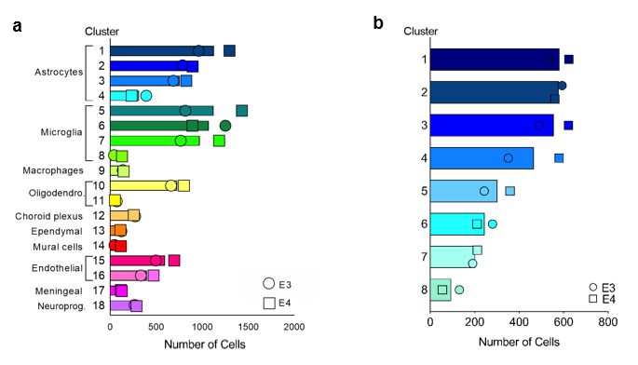

Supplemental Fig. 1 Cluster cell counts. Number of cells in each graph-based cluster from all cells (a), and astrocytes only (b). Bars represent mean number of cells in each cluster, with the number of E3 cells (circles) and E4 cells (squares) noted by symbols.

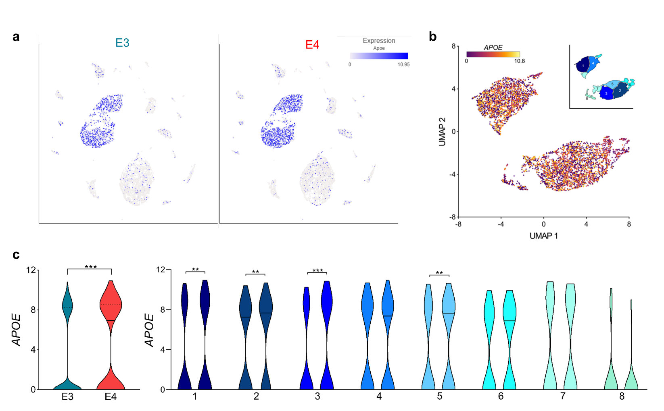

Supplemental Fig. 2 APOE expression in single-cells and specific astrocyte clusters. (a) UMAP visualization of E3 (left) and E4 (right) cells showing expression of APOE. APOE expression is primarily limited to cells identified as astrocytes. (b) Expression of APOE in astrocyte-only UMAP (Aldoc+ cells). Inset shows the 8 distinct astrocyte clusters. (c) Violin plots showing expression of APOE in all astrocytes (left) and within each astrocyte cluster (right). (**P<0.01, ***P<0.001, unpaired t-test, two-tailed)

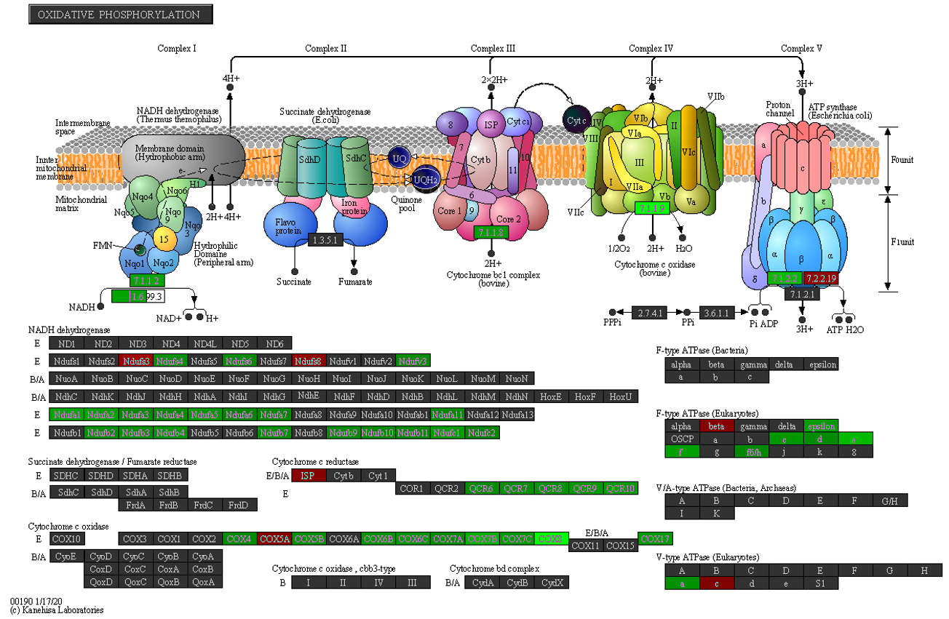
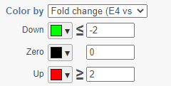

Supplemental Fig. 3 E4 is associated with decreases in many genes of the oxidative phosphorylation KEGG pathway. Pathway map for KEGG pathway “Oxidative Phosphorylation” showing genes differentially expressed between E3 and E4 astrocytes. Genes highlighted in green are downregulated in E4, genes in red are upregulated in E4.

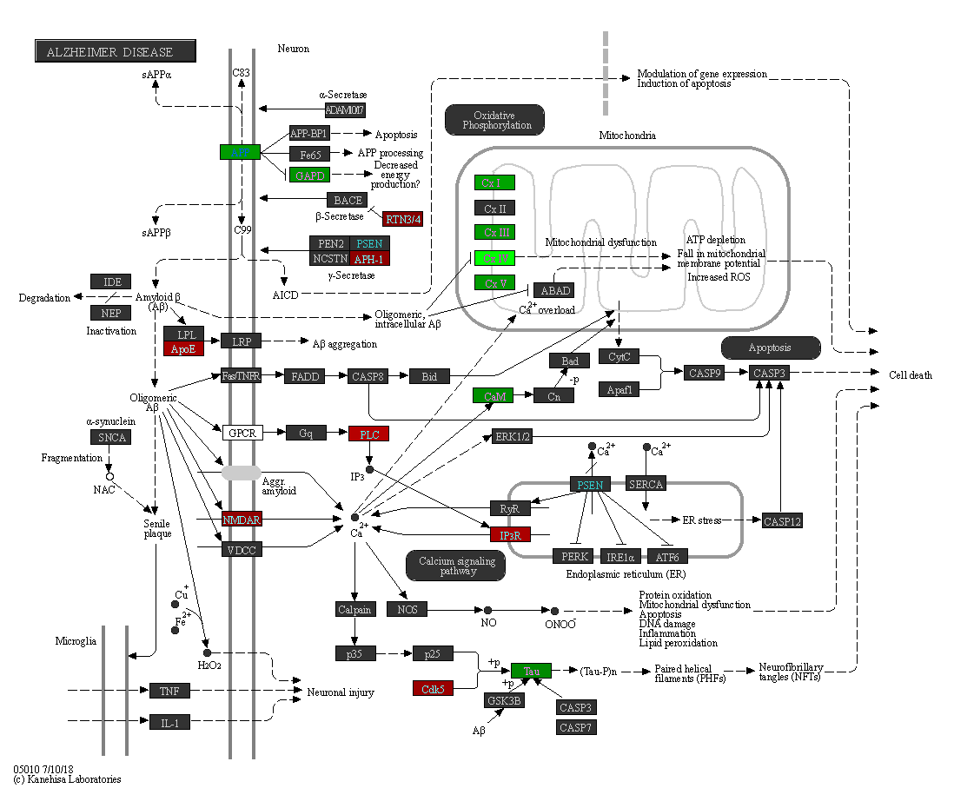

Supplemental Fig. 4 E4 is associated with decreases in many genes of the “Alzheimer’s disease” KEGG pathway. Pathway map for KEGG pathway “Oxidative Phosphorylation” showing genes differentially expressed between E3 and E4 astrocytes. Genes highlighted in green are downregulated in E4, genes in red are upregulated in E4.

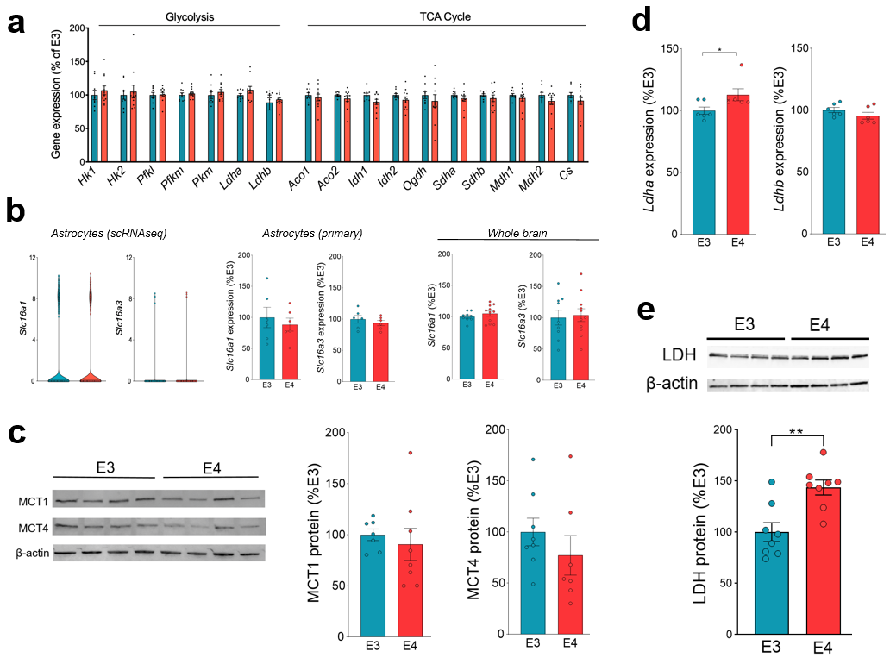

Supplemental Fig. 5 LDH expression is increased in E4 astrocytes; MCT expression is unchanged. (a) Gene expression of critical enzymes in glycolysis and TCA cycle in whole brain homogenates from female E3 and E4 mice. Hk, hexokinase; Pfk, phosphofructokinase; Ldh, lactate dehydrogenase; Aco, aconitase; Idh, isocitrate dehydrogenase; Ogdh, oxoglutarate dehydrogenase; Sdh, succinate dehydrogenase; Mdh, malate dehydrogenase; Cs, citrate synthase. Data analyzed by multiple t-tests with Sidak multiple comparison correction. (b) Slc16a1 and Slc16a3 gene expression in astrocytes from the scRNAseq data from Figure 1 (left), in primary astrocytes isolated from E3 or E4 mice (middle), and in whole brain homogenates from female E3 or E4 mice (right). (c) MCT1 and MCT4 expression was quantified in brain tissue from mice expressing E3 or E4 via western blot (n=7-8). MCT expression normalized to β-actin loading control and expressed as a percent of E3 (value/mean E3). (d) Ldha and Ldhb gene expression in primary astrocytes. All gene expression values expressed as a percent of E3 (value/mean E3). *P<0.05, **P<0.01, t-test. (e) LDH protein expression was measured via western blot in primary astrocytes expressing E3 or E4 (n=8). LDH expression normalized to β-actin loading control and expressed as a percent of E3 (value/mean E3). *p<0.05, t-test.

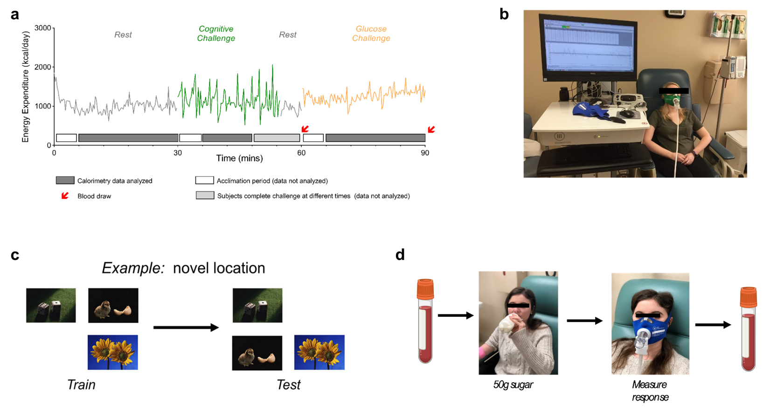

Supplemental Fig. 6 Human indirect calorimetry study design. (a) Representative time course of energy expenditure (EE) measures during the three periods of the study (rest in gray, cognitive challenge in green, and glucose challenge in orange). Data was only analyzed during the last 25 minutes of the resting and glucose periods and during a common 5-15 minute span during the cognitive challenge in which all 100 subjects were actively engaged in the task – denoted by grey bar on x axis. Blood was drawn immediately prior and after the glucose challenge. (b) Representative photo of a participant during the resting challenge connected to the Ultima MGX indirect calorimetry (IC) system. (c) Example slides from the Novel Image Novel Location test used as a cognitive challenge. (d) The glucose challenge consisted of a blood draw, followed by ingestion of the 50g sugar drink (all subjects consumed drink within 90 seconds), followed by IC measurement, and a second blood draw.

Supplemental Fig. 7 Respiratory Exchange Ratio (RER) does not differ by APOE genotype. Respiratory exchange ratio (RER) (VCO₂/VO₂) was not significantly different between APOE genotypes across any of the three periods tested.
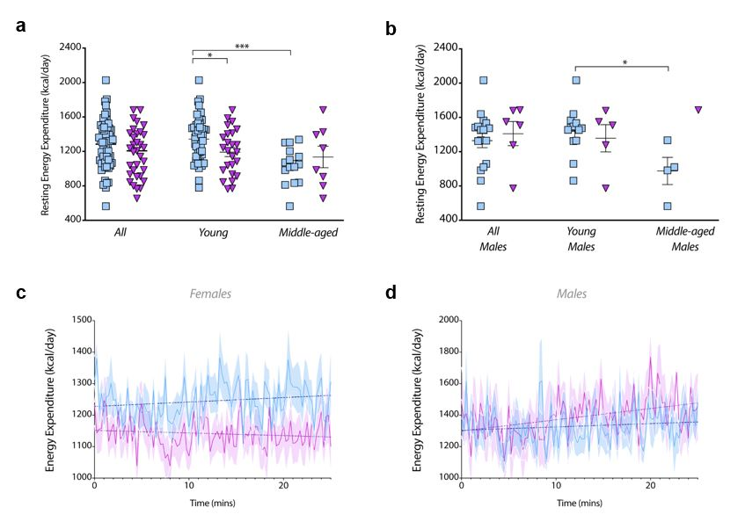

Supplemental Fig. 8 E4 effect on resting energy expenditure (a) E4 non-carriers’ (n=61; blue) and E4 carriers’ (n=33; purple) average resting energy expenditures were determined and stratified by young and middle-aged. (*P<0.05, ***P<0.001, unpaired t-test, two-tailed). (b) This was repeated for only male participants (*P<0.05, unpaired t-test, two-tailed; E4- total n=17, young n=13, middle-aged n=4; E4+ total n=6, young n=5, middle-aged n=1). (c) Average EE was plotted over the resting period for females and (d) males. Dotted lines indicate liner regression results and shaded area are SEMs.

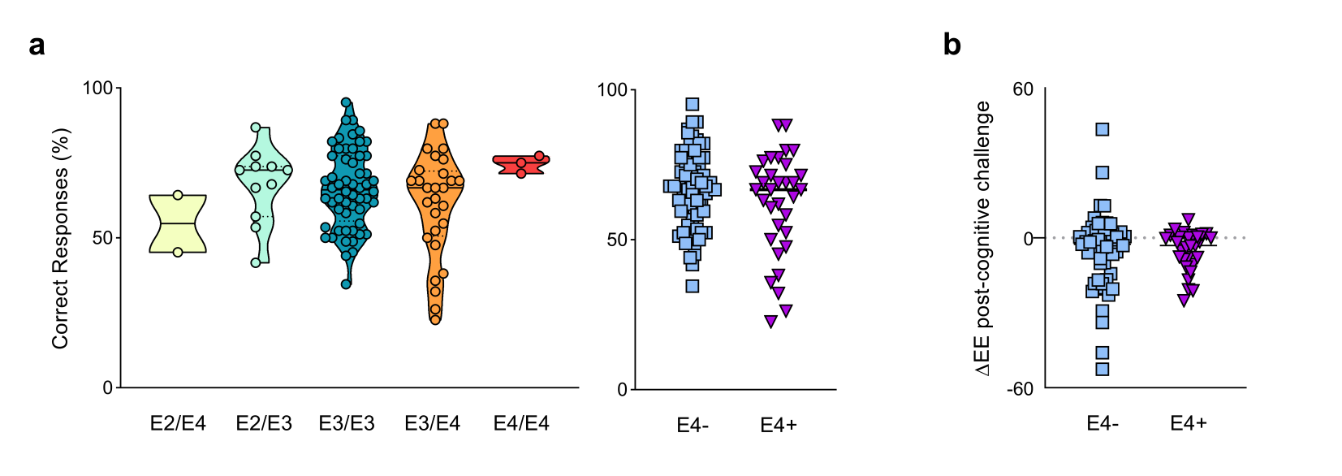

Supplemental Fig. 9 Novel image novel location object recognition test response accuracy by APOE genotype. (a) The novel-image-novel-location (NINL) object recognition test contains 7 sets of 12 slides. Each slide has 3 images and 4 possible locations. Each slide is viewed for eight seconds in the order as follows: See Set A, See Set B. Test Set A, See Set C, Test Set B, See Set D, Test Set C, etc. To be considered correct, subjects must identify both the type of change and in which quadrant the change has occurred. The test is designed so that on average subjects answer 60-80% of questions correctly. Total percent correct was calculated for each genotype (b) and stratified by E4 carriage. (c) Individual slopes of EE after the cognitive challenge showing an average decrease in EE after the challenge.

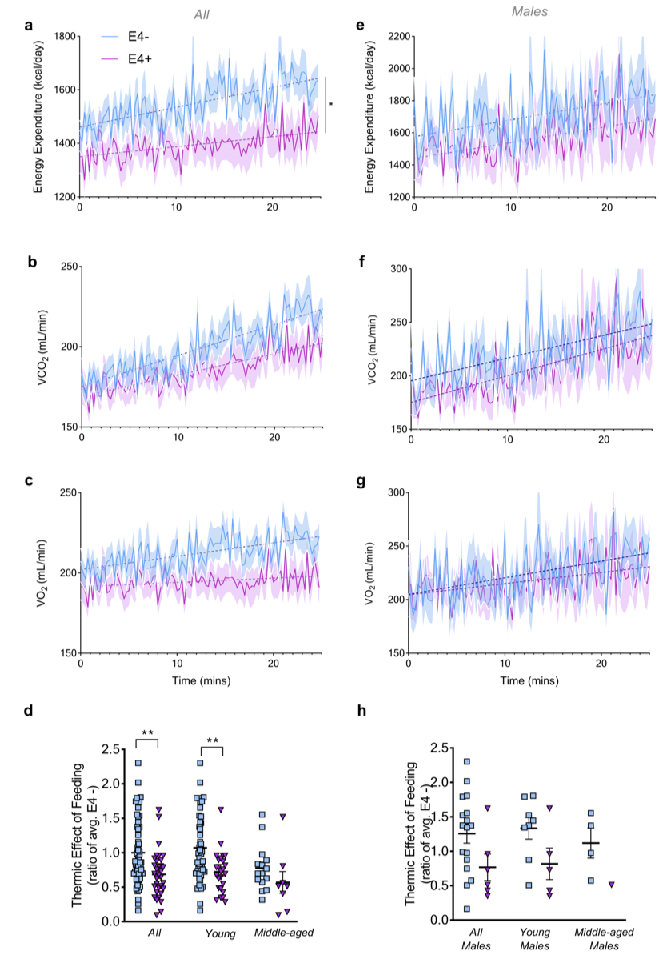
Supplemental Fig. 10. E4 effect on energy expenditure during glucose challenge in all subjects (left column), and in males only (right column) (a) Energy expenditure (b) VCO₂ and (c) VO₂ was plotted over the glucose challenge period in all E4- (n=61; blue) and E4+ (n=33; purple) participants. (*P<0.05, Two-way ANOVA repeated measures). (d) Thermic effect of feeding was determined as a ratio of E4 non-carriers in all, young, and middle-aged participants. (**P<0.01, unpaired t-test, two-tailed) (e) Energy expenditure (f) VCO₂ and (g) VO₂ was plotted over the glucose challenge period in male participants (E4- n=17; E4+ n=6). Dotted lines show linear regression trend line, shaded areas refer to SEM. (h) Thermic effect of feeding was determined as a ratio of E4 non-carriers in all, young, and middle-aged male participants.

Supplemental Fig. 11 VCO₂ values during the glucose challenge period. (a) Time course of average VCO2 values of Ε4- and Ε4+ females during the glucose challenge period. Dashed lines refer to linear regression result. (b) AUC of VCO₂ for all participants. (a, Two-way ANOVA repeated measures; b, One-way ANOVA)

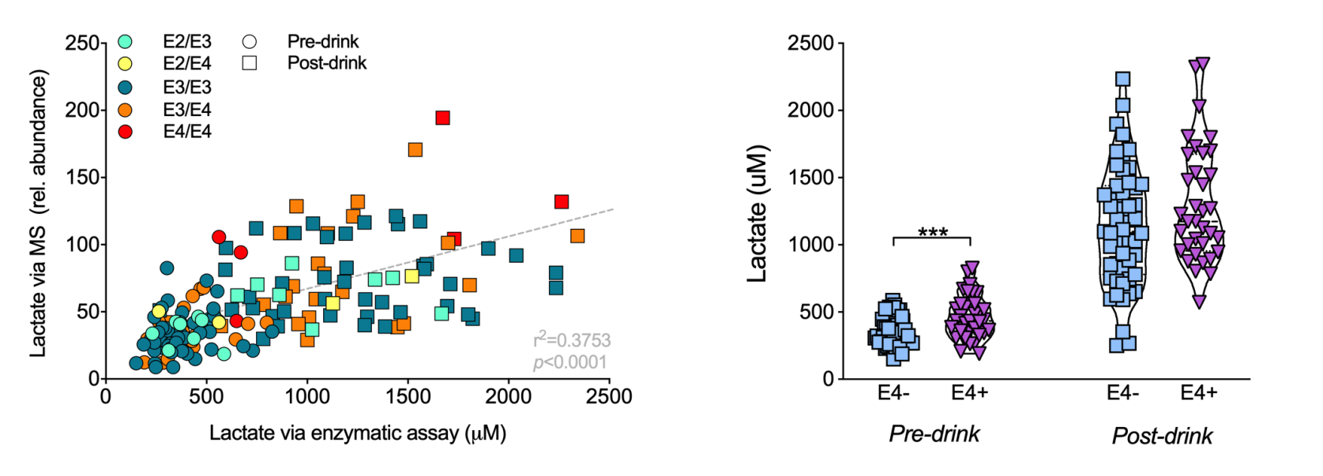

Supplemental Fig. 12 Plasma lactate assessed via enzymatic assay. (a) Lactate values quantified by GCMS (relative abundance, y-axis) strongly correlate with lactate values (uM) assessed via enzymatic assay. (b) E4 carriers had higher plasma lactate pre-drink and a trend toward higher lactate post-drink (p=0.09) compared to non-carriers, as measured via enzymatic assay.

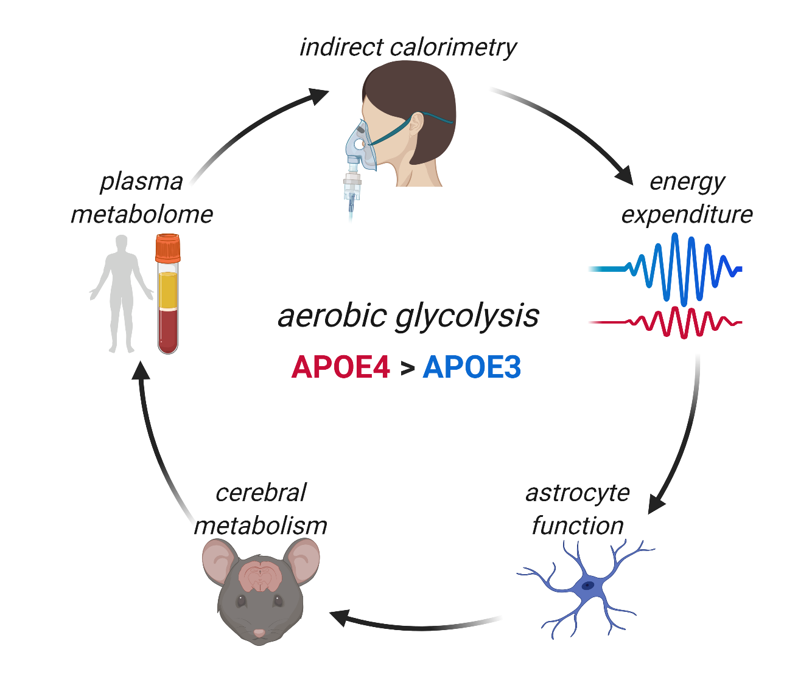

Summary Figure

