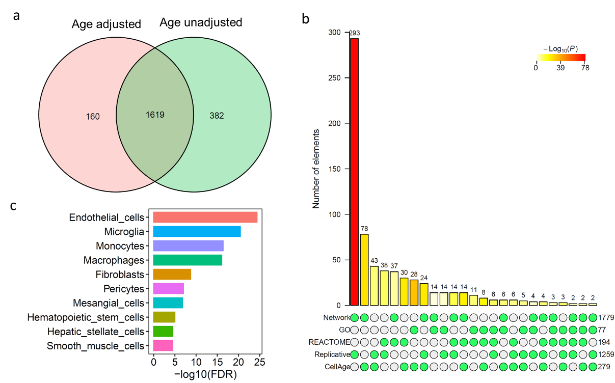

Fig. S1. The cell-type enrichment of aggregated SnG network with age adjustment. a) Aggregated network genes with age-adjusted and unadjusted datasets. b) Comparison of the age-adjusted aggregated network with four SnG annotation datasets. c) Barplot showing the top 10 cell types enriched (FRD < 0.05) for the age-adjusted aggregated network genes.

