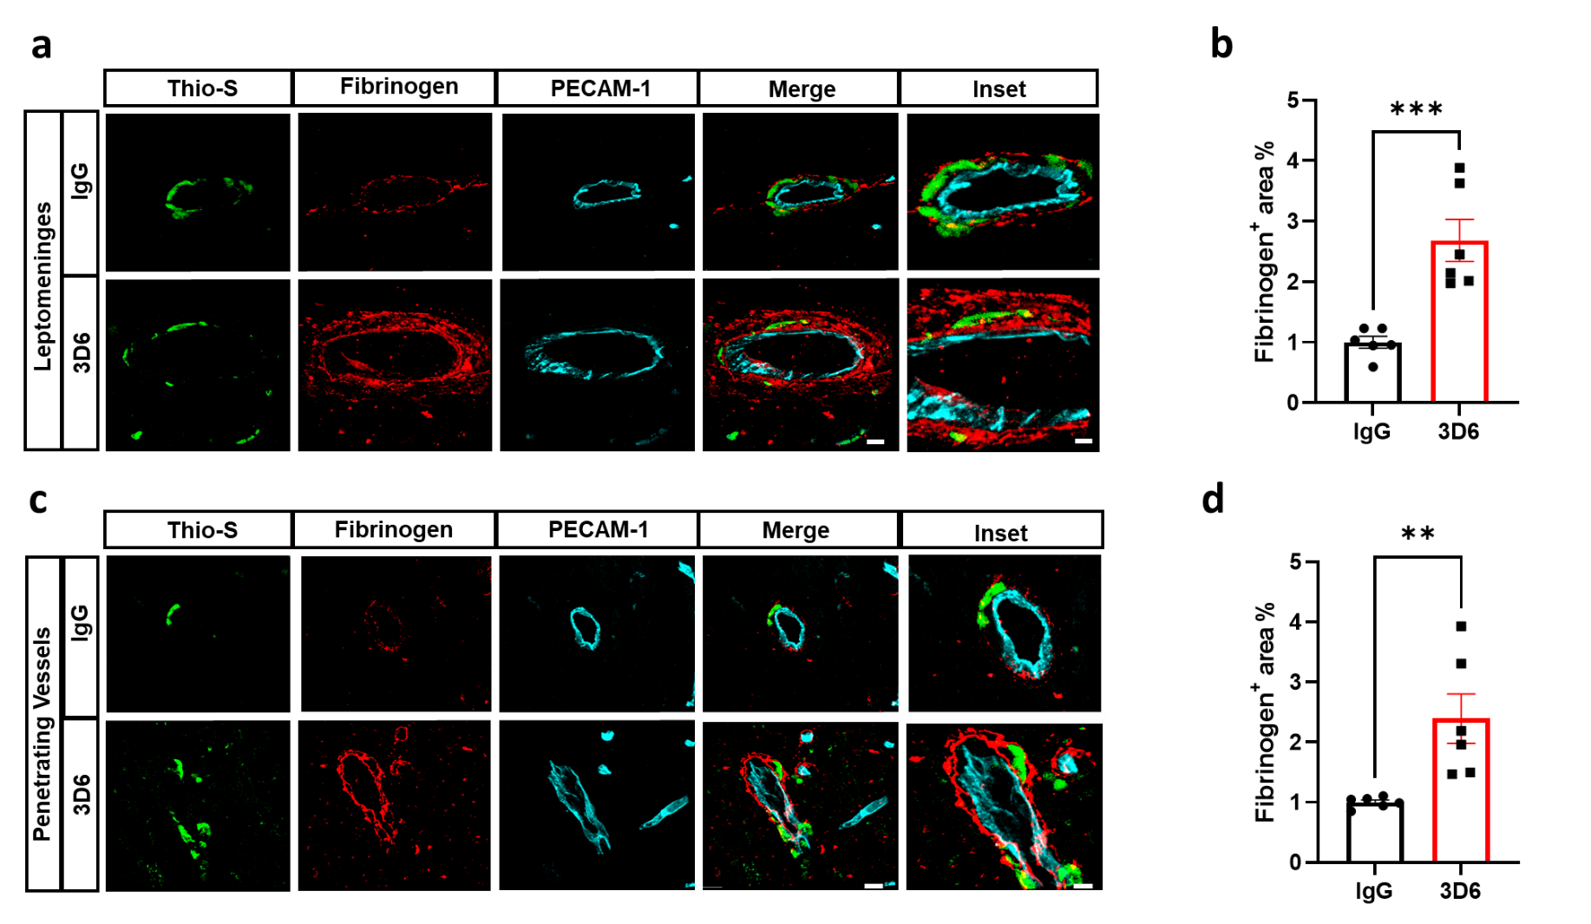
Supplemental Figure 10. Increased fibrinogen around vascular amyloid deposits in 3D6 treated PDAPP Mice. (a) Triple immunofluorescence of amyloid (Thio-S, green), fibrinogen (red) and endothelial cells (PECAM-1, cyan) in the leptomeninges of PDAPP mice treated with 3D6 or IgG control. Thio-S, fibrinogen, and endothelial cells (PECAM-1, cyan) immunoreactivity overlay (Merge). (b) Quantification of fibrinogen⁺ area (%) of IgG or 3D6 treated mice. (c) Triple immunofluorescence of amyloid (Thio-S, green), fibrinogen (red) and endothelial cells (PECAM-1, cyan) of penetrating vessels PDAPP mice treated with 3D6 or IgG control. Thio-S, fibrinogen, and PECAM-1 immunoreactivity overlay (Merge). (d) Quantification of fibrinogen⁺ area (%) of IgG or 3D6 treated mice. The number of vascular amyloid deposits analyzed was 8-10 per animal. Results are shown as ± SEM of n =6 (mice). Asterisks indicate significant differences, where ** p < .01 and ***p < 0.001 by unpaired Student's t test. Scale bar 5 μm merge or 10 μm inset, respectively.

