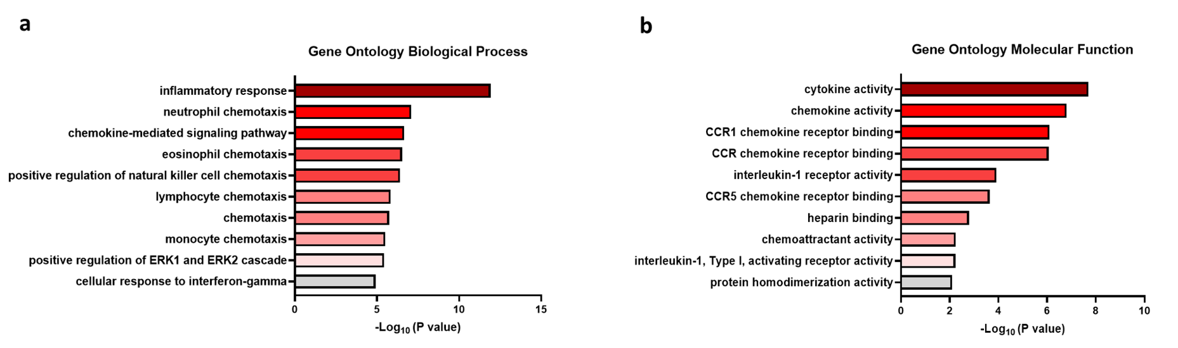
Supplemental Figure 11. Macrophages activated by Fc receptor signaling have biological processes and molecular functions enriched in chemotactic signaling. (a,b) DAVID bioinformatics gene ontology enrichment analysis of differentially expressed genes upregulated in bone marrow-derived macrophages activated by Fc receptor signaling.

