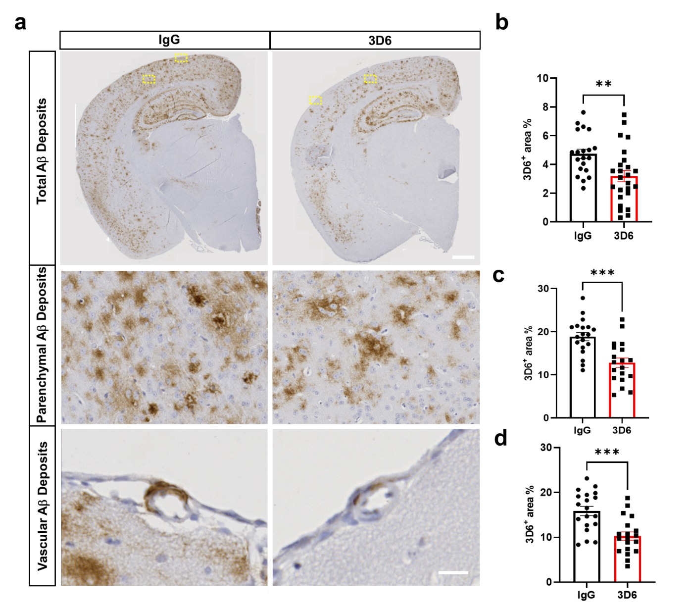Supplemental Figure 1. Reduced 3D6 immunoreactivity in anti-amyloid immunotherapy treated PDAPP mice. (a) Parenchymal and vascular amyloid Aβ deposits (brown, 3D6) across coronal sections of PDAPP mice treated with IgG or 3D6. (b) Quantification of 3D6⁺ area (%) in brain coronal sections of IgG or 3D6-treated mice. (c) Parenchymal Aβ deposits quantification of 3D6⁺ area (%) in brain coronal sections of IgG or 3D6-treated mice. (d) Vascular Aβ deposits quantification of 3D6⁺ area (%) in brain coronal sections of IgG or 3D6-treated mice. Each data point indicates an animal n=20-25 (mice). All are representative images of 26-month-old PDAPP mice. Results are shown as ± SEM, asterisks indicate significant differences, where **p < 0.01 and *** p<0.001 by unpaired Student's t test. Scale bar 20 or 500 μm, respectively.

