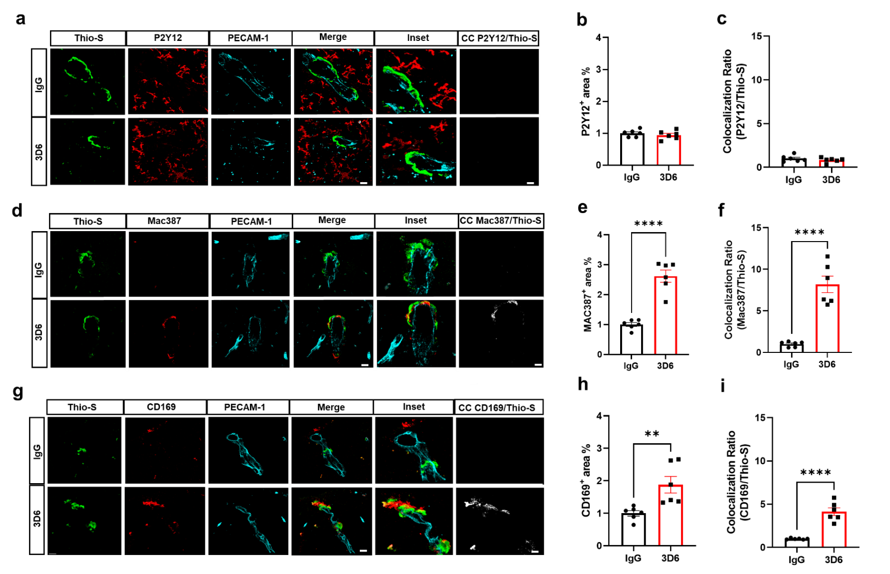
Supplemental Figure 2. Perivascular macrophages are highly associated with vascular amyloid of penetrating vessels 3D6 treated PDAPP Mice. (a) Triple immunofluorescence of amyloid (Thio-S, green), microglia (P2Y12, red) and endothelial cells (PECAM-1, cyan) in PDAPP mice treated with 3D6 or IgG control. Thio-S, P2Y12 and PECAM-1 immunoreactivity overlay (Merge). Colocalization analysis (white). (b) Quantification of P2Y12⁺ area (%) of IgG or 3D6 treated mice. (c) Quantification of colocalization ratio of Thio-S and P2Y12. (d) Triple immunofluorescence of amyloid (Thio-S, green), macrophages (Mac387, red) and endothelial cells (PECAM-1, cyan) in PDAPP mice treated with 3D6 or IgG control. Thio-S, Mac387 and PECAM-1 immunoreactivity overlay (Merge). Colocalization analysis (white). (e) Quantification of Mac387⁺ area (%) of IgG or 3D6 treated mice. (f) Quantification of colocalization ratio of Thio-S and Mac387. (g) Triple immunofluorescence of amyloid (Thio-S, green), perivascular macrophages (CD169, red) and endothelial cells (PECAM-1, cyan) in PDAPP mice treated with 3D6 or IgG control. Thio-S, CD169 and PECAM-1 immunoreactivity overlay (Merge). Colocalization analysis (white). (h) Quantification of CD169⁺ area (%) of IgG or 3D6 treated mice. (i) Quantification of colocalization ratio of Thio-S and CD169. The number of vascular amyloid deposits analyzed was 8-10 per animal. Results are shown as ± SEM of n = 6 (mice). Asterisks indicate significant differences, where **p < 0.01 and ****p < 0.0001 by unpaired Student's t test. Scale bar 5 μm CC or 10 μm merge, respectively.

