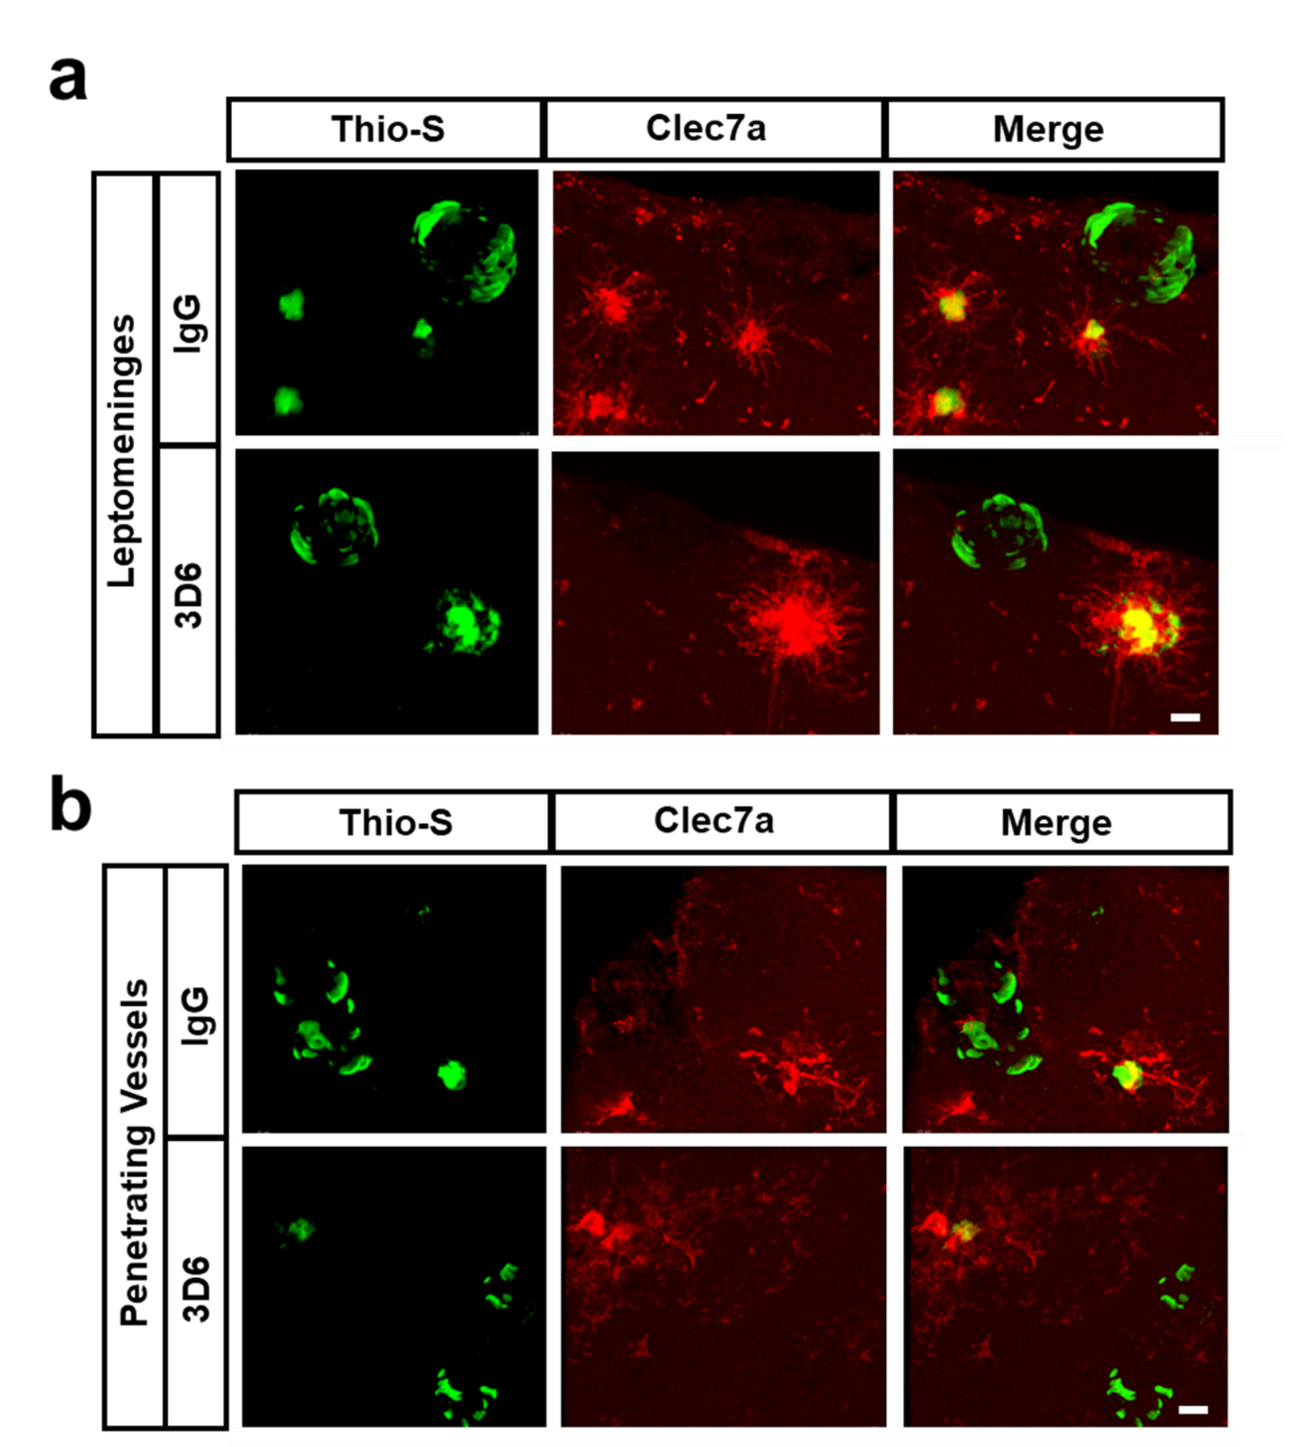
Supplemental Figure 3. Clec7a⁺ microglia are not associated with vascular amyloid. (a) Double immunofluorescence of amyloid (Thio-S, green), and activated microglia (Clec7a, red) in leptomeninges of PDAPP mice treated with 3D6 or IgG control. Thio-S and Clec7a immunoreactivity overlay (Merge). (b) Double immunofluocrescence of amyloid (Thio-S, green), and activated microglia (Clec7a, red) in penetrating vessels of PDAPP mice treated with 3D6 or IgG control. Thio-S and Clec7a immunoreactivity overlay (Merge). Scale bar 10 μm.

