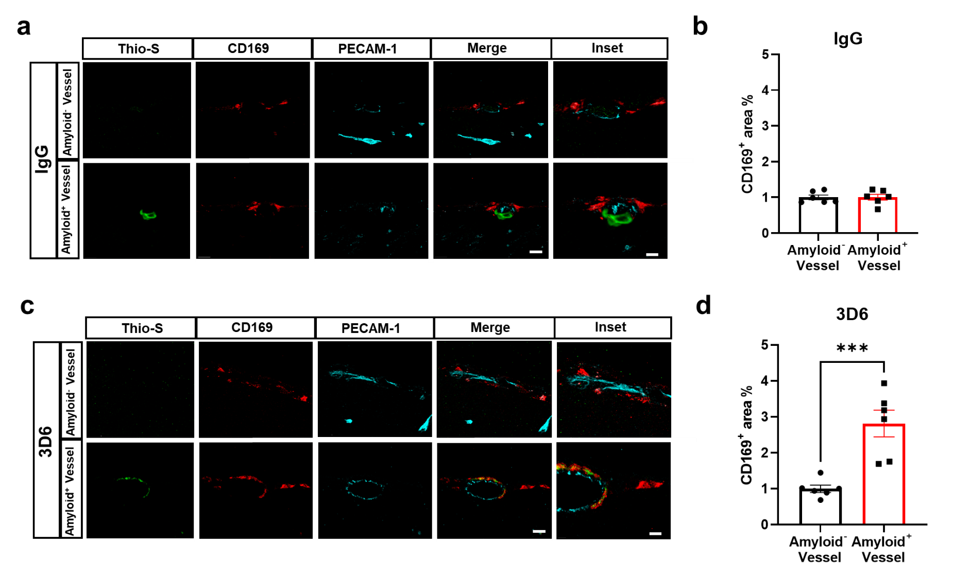
Supplemental Figure 4. Perivascular macrophages exhibit enrichment exclusively with amyloid⁺ vessels in 3D6 treated PDAPP Mice. (a) Triple immunofluorescence of amyloid⁺ (Thio-S, green) or amyloid⁻ vessels, perivascular macrophage (CD169, red) and endothelial cells (PECAM-1, cyan) in PDAPP mice treated with IgG control. Thio-S, CD169 and PECAM-1 immunoreactivity overlay (Merge). (b) Quantification of CD169⁺ area (%) of IgG in amyloid⁺ or amyloid⁻ vessels. (c) Triple immunofluorescence of amyloid⁺ (Thio-S, green) or amyloid⁻ vessels, perivascular macrophage (CD169, red) and endothelial cells (PECAM-1, cyan) in PDAPP mice treated with 3D6. Thio-S, CD169 and PECAM-1 immunoreactivity overlay (Merge). (d) Quantification of CD169⁺ area (%) of 3D6 in amyloid⁺ or amyloid⁻ vessels. The number of vessels analyzed was 8-10 per animal. Results are shown as ± SEM of n = 6 (mice). Asterisks indicate significant differences, where ***p < 0.001 by unpaired Student's t test. Scale bar 10 μm merge or 5 μm inset, respectively.

