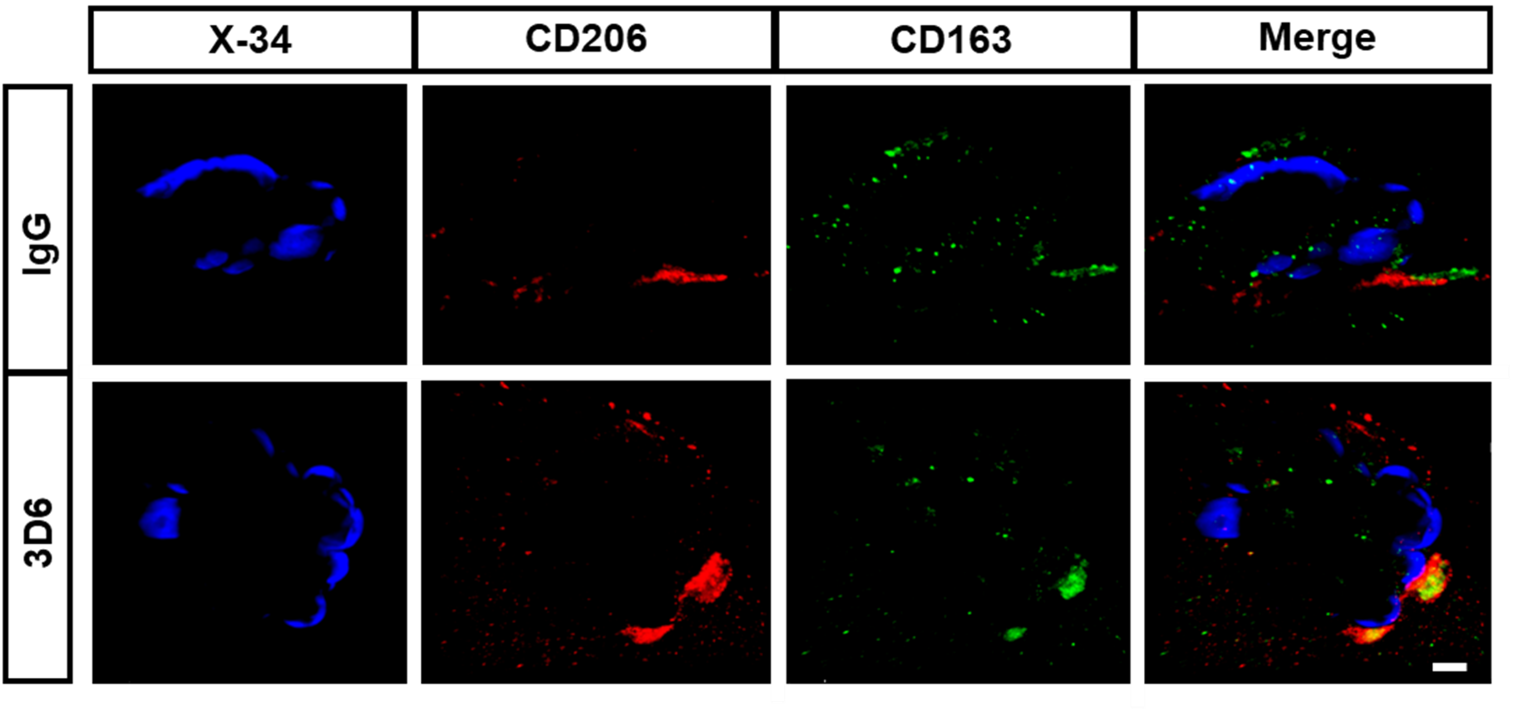
Supplemental Figure 5. Perivascular macrophages associated with vascular amyloid are CD206 and CD163 positive. Triple immunofluorescence of amyloid (X-34, blue), perivascular macrophages (CD206, red) (CD163, green) in PDAPP mice treated with 3D6 or IgG control. X-34, CD206 and CD163 immunoreactivity overlay (Merge). Scale bar 5 μm.

